Types of Data

**Variables**

Data is typically represented using variables. A ***variable*** is an item that can have different ("varying") values. Ex: A person's age is a variable and can have the value 10, 33, 99, or other values. Variables are often considered as being of two possible types:

* A ***quantitative variable*** can take on a numeric value (quantitative data) that can be measured and ordered. Ex: A person's age, the outside temperature, and a meal's price are quantitative variables. Example numeric values are an age of 33 or 99 years, a temperature of 40 or 45 degrees, and a price of 12 or 15 dollars.
* A ***categorical variable*** can take on the value (usually a label) of one of several categories. Ex: A person's gender, seasons, and U.S. companies are categorical variables. Gender can be male or female, seasons can be fall, winter, spring, or summer, and U.S. companies can be Wal-Mart, McDonalds, UPS, etc. A categorical variable is often called a ***qualitative variable*** (known by qualities, rather than quantities).

#### Types of categorical variables

Two types of categorical variables are often distinguished:

* A ***nominal variable***'s categories have no ordering, existing in name only, like apples, oranges, and grapes. ("Nominal" means "in name only").
* An ***ordinal variable***'s categories have an ordering, like disagree, neutral, and agree.

#### Types of quantitative variables

Two types of quantitative variables are often distinguished:

* A ***continuous variable***'s values are infinite along a continuum of values within a range, typically real numbers. Continuous variables usually represent measurements, like height (0.00104 meters) or temperature (98.6 degrees).
* A ***discrete variable***'s values are finite within a range, typically integers. Discrete variables usually represent countable items, like people in a family (5) or cars in a city (502,434). Generally, if "number of" can be added to the beginning, the variable is discrete, like "number of people in a family", but not "number of height". Note: "Discrete" means separate or distinct, not to be confused with "discreet" which means careful or unobtrusive.

Table 1.3.3: Common Python data visualization and analysis modules.

|  |  |  |  |
| --- | --- | --- | --- |
| Module name | Alias | Description | Link to documentation |
| numpy | np | Mathematical functions, required by other libraries | [Link](https://docs.scipy.org/doc/numpy/reference/) |
| scipy.stats | st | Statistical functions | [Link](https://docs.scipy.org/doc/scipy/reference/stats.html) |
| pandas | pd | Data frames, statistical functions | [Link](https://pandas.pydata.org/pandas-docs/stable/) |
| matplotlib.pyplot | plt | Data visualization | [Link](https://matplotlib.org/contents.html) |
| scikit-learn | sks | Machine learning and data analysis | [Link](http://scikit-learn.org/stable/documentation.html) |
| seaborn | sns | Data visualization | [Link](https://seaborn.pydata.org/) |
| quandl |  | Data analysis | [Link](https://www.quandl.com/tools/python) |

Python-Function 1.3.1: Unemployment rates.

The code below loads a dataset containing unemployment rates in the United States from 1980 to 2017 and plots the data as a line chart.

# imports the necessary libraries

**import** pandas as pd

**import** matplotlib.pyplot as plt

# loads the unemployment dataset

unemployment = pd.read_csv('http://data-analytics.zybooks.com/unemployment.csv')

# title

plt.title('U.S. unemployment rate', fontsize = 20)

# x and y axis labels

plt.xlabel('Year')

plt.ylabel('% of total labor force')

# plot

plt.plot(unemployment["Year"], unemployment["Value"])

# saves the image

plt.savefig("unemployment.png")

# shows the image

plt.show()

The resulting graph is shown below.

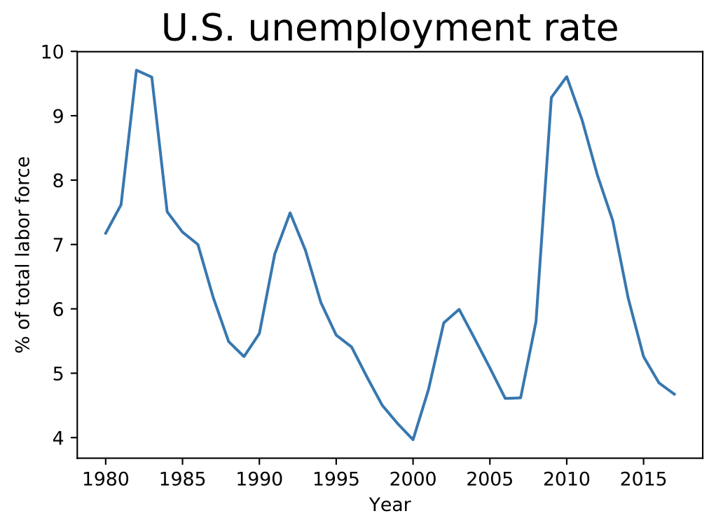

### pandas

***pandas*** is a Python library that allows a user to work with data frames by providing tools for reading, writing, subsetting, and reshaping data. pandas is especially useful when the dataset has missing and unaligned data, which is common in real-world applications.

To work with data using pandas, a file needs to be imported as a DataFrame object. Although DataFrame objects can be created, this material works with existing data. Sample code to import files of various types is shown below.

Figure 1.4.1: Importing files as DataFrame objects.

# imports the pandas library

**import** pandas as pd

# loads a file containing comma-separated values and assigns

# the data frame to variable DataFrame

data_frame1 = pd.read_csv('file.csv')

# loads text file where the values are separated by a space with no column labels

data_frame2= pd.read_csv('file.txt', sep = ' ', header = None)

# loads an excel file

data_frame3 = pd.read_excel('file.xlsx', sheetname='Sheet1')

Feedback?

An object in Python has attributes and methods. An ***attribute*** is a characteristic of an object. A ***method*** is a procedure associated with an object. Methods are followed by parentheses (). The tables below give a partial list of DataFrame methods and attributes. The full list can be obtained in the [pandas documentation](https://pandas.pydata.org/pandas-docs/stable/generated/pandas.DataFrame.html).

Table 1.4.1: DataFrame attributes.

|  |  |
| --- | --- |
| DataFrame.attribute | Description of output |
| axes | Index and column labels |
| columns | Column labels |
| dtypes | Data types of values in each column |
| index | Index labels |
| shape | Ordered pair that gives the number of rows and columns |
| size | Number of values in the DataFrame |
| values | Values in the DataFrame |

Feedback?

Table 1.4.2: DataFrame methods.

|  |  |
| --- | --- |
| DataFrame.method | Description of output |
| describe() | Summary statistics for numerical columns |
| head(), tail() | First/last 5 rows in the DataFrame |
| min(), max() | Minimum/maximum of values in a numerical column |
| mean(), median() | Mean/median of values in a numerical column |
| sample() | Random row |
| std() | Standard deviation of values in a numerical column |

Example 1.4.1: Titanic dataset.

A popular dataset for learning data exploration and analysis is the dataset containing various information about the passengers of the Titanic. titanic is one of the datasets included in the seaborn package and can be loaded using the code below.

# loads the seaborn library

**import** seaborn as sns

# loads the titanic dataset

titanic = sns.load_dataset("titanic")

What commands are needed to do find the following?

1. Number of rows
2. Column names
3. Data types of columns

**Solution**

1. To find the number of rows, the command titanic.shape can be used to find the number of rows and the number of columns. The output is the ordered pair (891, 15) where 891 is the number of rows and 15 is the number of columns.
2. To find the column names, the command titanic.columns is used, which gives the output
3. Index(['survived', 'pclass', 'sex', 'age', 'sibsp', 'parch', 'fare',
4. 'embarked', 'class', 'who', 'adult_male', 'deck', 'embark_town',
5. 'alive', 'alone'],

dtype='object')

1. To find the data types of the columns , the command titanic.dtypes is used, which gives the output
2. survived int64
3. pclass int64
4. sex object
5. age float64
6. sibsp int64
7. parch int64
8. fare float64
9. embarked object
10. class category
11. who object
12. adult_male bool
13. deck category
14. embark_town object
15. alive object
16. alone bool

dtype: object

In pandas, the data types int and float are int64 and float64 respectively. 64 is a reference to memory allocation, which is beyond the scope of this material. Similarly, the string data type is called object in pandas. bool stands for boolean, which can have a value of either true or false (equivalently, 1 or 0).

### Subsetting data

***Subsetting*** is the process of retrieving parts of a data frame. A data frame can be subset in a variety of ways, the most common of which involve selecting a range of rows and columns, or selecting columns by column label. Ex: In the Titanic data set, a data exploration project may involve finding the sex of people on deck B, so a data analyst would filter the rows for which the value of deck is B.

Python-Function 1.4.1: Selecting columns and rows.

To select a column or columns of a data frame, the command data_frame["column"] where data_frame is the DataFrame object and column is the name of the selected column. The column name is enclosed within single or double quotes. Alternatively, the command data_frame.column can be used as long as the column name is not the same as an existing method such as rank(). The data type of the output is a series, which can be thought of as a list with labels.

To select more than one column or make the output a data frame rather than a list, double brackets should be used with the command above. data_frame[["column1", "column2", ...]] returns a data frame with column1, column2, ... included.

The code below returns a data frame with only the columns sex and survived from the Titanic data set.

titanic[["sex","survived"]]

The first 5 rows of the resulting data frame are shown in the output below.

titanic[["sex","survived"]].head()

sex survived

0 male 0

1 female 1

2 female 1

3 female 1

4 male 0

To select a row by position, the command data_frame[a:b] where a and b - 1 are the initial and final rows included in the output.

The code below selects the first 5 rows of the titanic dataset and returns a data frame.

titanic[0:5]

survived pclass sex age sibsp parch fare embarked class \

0 0 3 male 22.0 1 0 7.2500 S Third

1 1 1 female 38.0 1 0 71.2833 C First

2 1 3 female 26.0 0 0 7.9250 S Third

3 1 1 female 35.0 1 0 53.1000 S First

4 0 3 male 35.0 0 0 8.0500 S Third

who adult_male deck embark_town alive alone

0 man True NaN Southampton no False

1 woman False C Cherbourg yes False

2 woman False NaN Southampton yes True

3 woman False C Southampton yes False

4 man True NaN Southampton no True

To select only the rows where one column has a particular value, the command data_frame[data_frame.column == x] is used, where x is the desired value in column.

The code below selects all the rows where the column pclass has a value of 3.

titanic[titanic.pclass == 3]

survived pclass sex age sibsp parch fare ... class who adult_male deck embark_town alive alone

0 0 3 male 22.0 1 0 7.2500 ... Third man True NaN Southampton no False

2 1 3 female 26.0 0 0 7.9250 ... Third woman False NaN Southampton yes True

4 0 3 male 35.0 0 0 8.0500 ... Third man True NaN Southampton no True

5 0 3 male NaN 0 0 8.4583 ... Third man True NaN Queenstown no True

7 0 3 male 2.0 3 1 21.0750 ... Third child False NaN Southampton no False

.. ... ... ... ... ... ... ... ... ... ... ... ... ... ... ...

882 0 3 female 22.0 0 0 10.5167 ... Third woman False NaN Southampton no True

884 0 3 male 25.0 0 0 7.0500 ... Third man True NaN Southampton no True

885 0 3 female 39.0 0 5 29.1250 ... Third woman False NaN Queenstown no False

888 0 3 female NaN 1 2 23.4500 ... Third woman False NaN Southampton no False

890 0 3 male 32.0 0 0 7.7500 ... Third man True NaN Queenstown no True

Similarly the comparison operators >, <, >=, and <= can be used to select rows where a column has values more or less than a given value.

The code below selects all the rows where the column fare has a value less than 10.0.

titanic[titanic.fare < 10.0]

survived pclass sex age sibsp parch fare ... class who adult_male deck embark_town alive alone

0 0 3 male 22.0 1 0 7.2500 ... Third man True NaN Southampton no False

2 1 3 female 26.0 0 0 7.9250 ... Third woman False NaN Southampton yes True

4 0 3 male 35.0 0 0 8.0500 ... Third man True NaN Southampton no True

5 0 3 male NaN 0 0 8.4583 ... Third man True NaN Queenstown no True

12 0 3 male 20.0 0 0 8.0500 ... Third man True NaN Southampton no True

.. ... ... ... ... ... ... ... ... ... ... ... ... ... ... ...

877 0 3 male 19.0 0 0 7.8958 ... Third man True NaN Southampton no True

878 0 3 male NaN 0 0 7.8958 ... Third man True NaN Southampton no True

881 0 3 male 33.0 0 0 7.8958 ... Third man True NaN Southampton no True

884 0 3 male 25.0 0 0 7.0500 ... Third man True NaN Southampton no True

890 0 3 male 32.0 0 0 7.7500 ... Third man True NaN Queenstown no True

[336 rows x 15 columns]

### Reshaping data

Two common forms of a data frame exist: long form and wide form. A data frame is in ***long form*** when each column is a variable and each row gives non-repeated data. A data frame in long form is also referred to as unstacked or in record form. A data frame is in ***wide form*** if each data variable is in a different column. A data frame in wide form is also referred to as stacked. ***Reshaping data*** involves converting a data frame from one form into the other. ***Pivoting*** converts a data frame from long form to wide form. ***Melting*** converts a data frame from wide form to long form.

Python-Function 1.4.3: pivot().

The command used to pivot the data frame, df, in the animation above is as follows.

pd.pivot(df, index = "Date", columns = "Student", values= "Score")

The index labels of the pivoted data frame are the unique values of the column Date. The columns of the pivoted data frame are the unique values of the column Student. The values of the pivoted data frame are the values from the column Score.

The code to generate the data frame in long form and the corresponding output are given below.

# Creates a data frame

df = pd.DataFrame({

...

... 'Student': {0: "Michael", 1: "Arushi", 2: "Roberta",

... 3: "Michael", 4: "Arushi", 5: "Roberta"},

... 'Score': {0: 90, 1: 98, 2: 92, 3: 90, 4: 98, 5: 92},

... 'Date': {0: "2018-01-03", 1: "2018-01-03", 2: "2018-01-03", 3: "2018-01-13",

... 4: "2018-01-13", 5: "2018-01-13"}},

... columns=['Date','Student','Score'])

Date Student Score

0 2018-01-03 Michael 90

1 2018-01-03 Arushi 98

2 2018-01-03 Roberta 92

3 2018-01-13 Michael 90

4 2018-01-13 Arushi 98

5 2018-01-13 Roberta 92

The output of the pivot() command is given below.

Student Arushi Michael Roberta

Date

2018-01-03 98 90 92

2018-01-13 98 90 92

Python-Function 1.4.4: melt().

The command used to melt the data frame df in the animation above is as follows.

pd.melt(df, id_vars = "Student", var_name = "Test", value_vars = ["SAT", "ACT"], value_name = "Scores")

The id_vars parameter indicates a string, tuple, or list to use as an identifier variable . The var_name parameter indicates the column label to use for the variable column. The parameter value_vars indicates the labels of the columns to unpivot. The value_name indicates the column label to use for the value column.

The code to generate the data frame in wide form and the corresponding output are given below.

df = pd.DataFrame({'Student': {0: "Michael", 1: "Arushi", 2: "Roberta"},

... 'SAT': {0: 1480, 1: 1520, 2: 1460},

... 'ACT': {0: 34, 1: 32, 2: 32}},

... columns=['Student','SAT','ACT'])

Student SAT ACT

0 Michael 1480 34

1 Arushi 1520 32

2 Roberta 1460 32

The output of the melt() command is given below.

Student Test Scores

0 Michael SAT 1480

1 Arushi SAT 1520

2 Roberta SAT 1460

3 Michael ACT 34

4 Arushi ACT 32

5 Roberta ACT 32

Python-Function 1.5.1: Bar charts.

The sns.countplot(x = "category", data = DataFrame, ...) function from the seaborn library plots categorical data with respect to different categories. For bar charts with a single category that do not include multiple groups, setting x equal to a category creates a vertical bar chart and setting y equal to a category creates a horizontal bar chart.

# loads the necessary modules

**import** pandas as pd

**import** matplotlib.pyplot as plt

**import** seaborn as sns

# loads the titanic dataset

titanic = sns.load_dataset("titanic")

# sets the style of the bar charts

sns.set(style="whitegrid", color_codes=True)

# title

plt.title('HMS Titanic passengers by class', fontsize=20)

# plots a vertical bar chart

sns.countplot(x="class", color="b", data=titanic);

# saves the image

plt.savefig("verticalbarchart.png")

# shows the image

plt.show()

The resulting vertical bar chart is shown below.

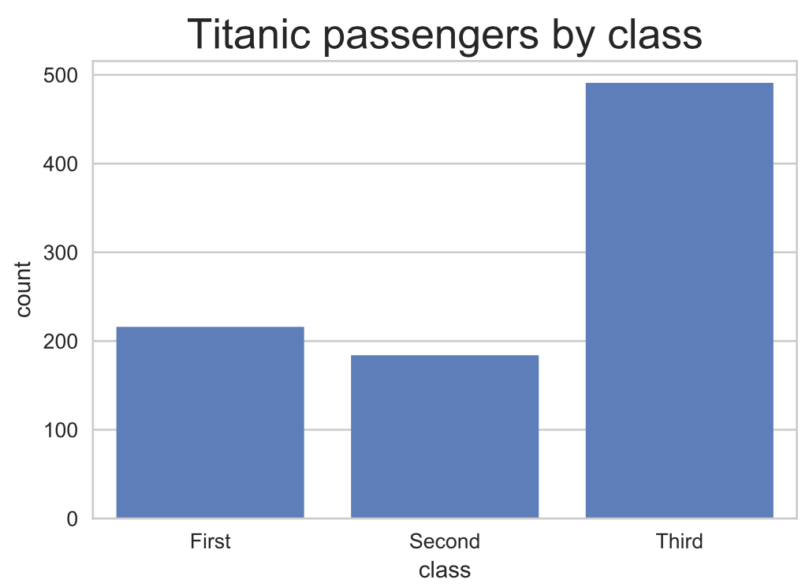

[Run example](https://rcoderunner.zybooks.com/index.html?code=%23%20loads%20the%20necessary%20libraries%0Aimport%20numpy%20as%20np%0Aimport%20pandas%20as%20pd%0Aimport%20matplotlib%20as%20mpl%0Aimport%20matplotlib.pyplot%20as%20plt%0Aimport%20seaborn%20as%20sns%0A%0A%23%20loads%20the%20titanic%20dataset%0Atitanic%20%3D%20sns.load_dataset(%22titanic%22)%0A%0A%23%20sets%20the%20style%20of%20the%20bar%20charts%0Asns.set(style%3D%22whitegrid%22%2C%20color_codes%3DTrue)%0A%0A%23%20title%0Aplt.title(%27Titanic%20passengers%20by%20class%27%2C%20fontsize%3D20)%0A%0A%23%20plots%20a%20vertical%20bar%20chart%0Asns.countplot(x%3D%22class%22%2C%20color%3D%22b%22%2C%20data%3Dtitanic)%3B%0A%0A%23%20saves%20the%20image%0Aplt.savefig(%22verticalbarchart.png%22)%0A%0A%23%20shows%20the%20image%0Aplt.show()%0A%0A&language=python)

The code below generates a horizontal bar chart.

# plots a horizontal bar chart

sns.countplot(y="class", color="b", data=titanic);

The resulting horizontal bar chart is shown below.

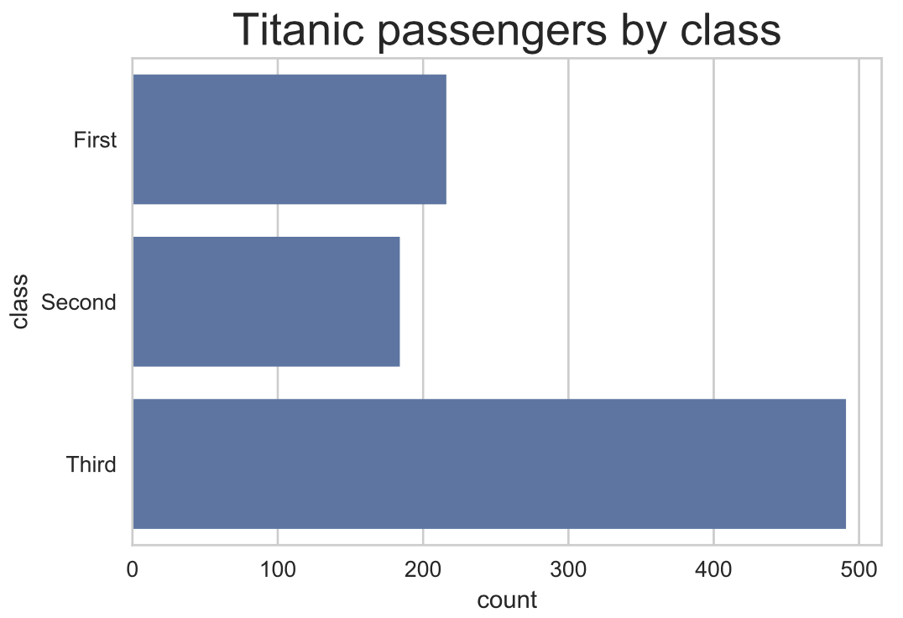

Example 1.5.1: Professional European soccer player birth months.

The following relative-frequency bar chart depicts the birth months for professional European soccer players. Most players were born in the first few months of the year. A possible explanation is the January 1 cutoff date for youth soccer leagues, meaning kids born in January are the oldest on their teams, while kids born in December are the youngest. Older kids are likely to be better players initially, causing coaches to give them more attention and playing time, and also causing those kids to enjoy playing and thus practicing more. 2

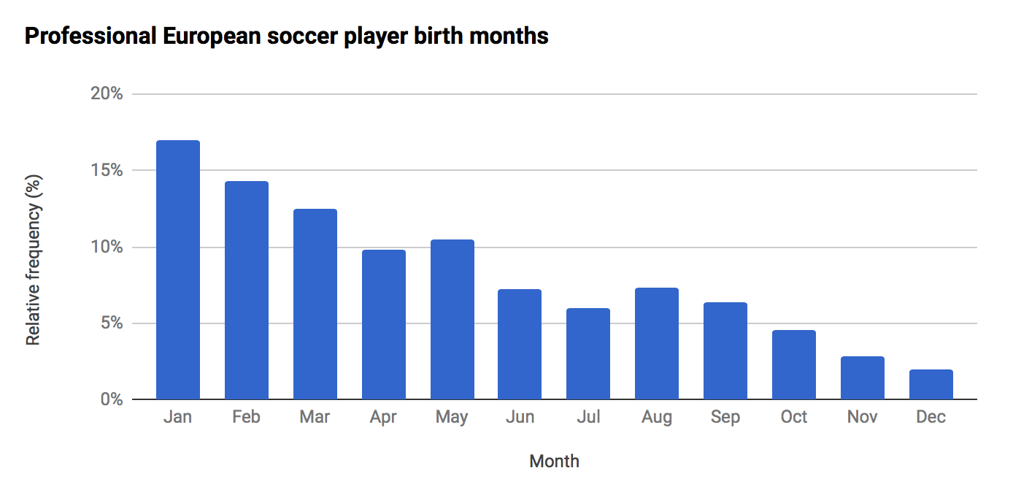

The above example illustrates the power of data analytics and data visualization. Having understood such data, many parents now choose to postpone their child's entry onto a sports team so that the child is not the youngest on the team. In fact, similar data exists for school kids: Kids born just after cutoff dates tend to be more successful in school (getting more attention from teachers, and causing those kids to feel smarter and enjoy school more), and thus many parents now delay their child's school enrollment by a year. 3

Python-Function 1.5.2: Grouped bar charts.

By setting the hue parameter equal to a group, a bar chart is created that counts the frequency of a category by group. Ex: The code that counts the number of people who survived and didn't survive the sinking of the Titanic by class is given below.

*# loads the necessary modules*

import pandas as pd

import matplotlib.pyplot as plt

import seaborn as sns

*# loads the titanic dataset*

titanic = pd.read_csv("https://static-resources.zybooks.com/static/titanic.csv")

*# sets the style of the bar charts*

sns.set(style="whitegrid", color_codes=TRUE)

*# title*

plt.title('Titanic survivors and deaths by class', fontsize=20)

*# generates a vertical bar chart*

sns.countplot(x="class", hue="survived", color="b", data=titanic);

*# saves the image*

plt.savefig("groupedbarchart.png")

*# shows the image*

plt.show()

The resulting grouped bar chart is shown below.

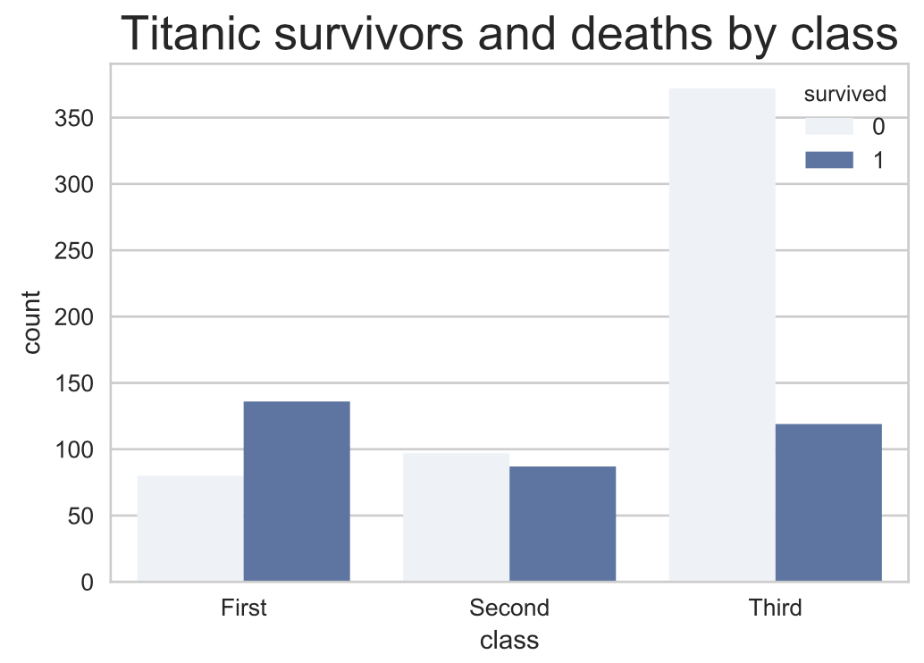

Python-Function 1.5.3: Stacked bar charts.

To create a stacked bar chart, the plt.subplots() of matplotlib is used. Multiple plots share the same set of axes. Ex: The code below plots the number of automobile collisions related to speeding and the total number of collisions in the same set of axes.

# loads the necessary modules

**import** pandas as pd

**import** matplotlib.pyplot as plt

**import** seaborn as sns

# intialize figure

f, ax = plt.subplots()

# load data frame

crashes = sns.load_dataset("car_crashes")

df = crashes.loc[range(5)]

# plot total crashes

sns.set_color_codes("pastel")

sns.barplot(x="total", y="abbrev", data=df,

label="Total", color="b")

# plot crashes related to speeding

sns.set_color_codes("muted")

sns.barplot(x="speeding", y="abbrev", data=df,

label="Speeding-related", color="b")

# title

plt.title('Speeding-related automobile collisions', fontsize=20)

# legend

ax.legend(ncol=1, loc="lower right")

ax.set(xlim=(0, 28), ylabel="State", xlabel="Automobile collisions (per billion miles)");

# saves the image

plt.savefig("stacked.png")

The resulting stacked bar chart is shown below.

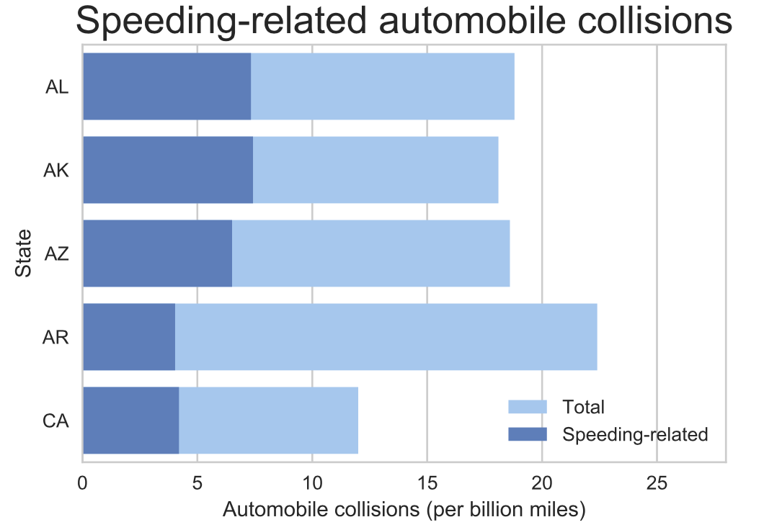

Python-Function 1.6.1: Pie charts.

A pie chart is creating by using the pie(sizes, labels, autopct='%1.1f%%')

function in matplotlib. sizes is a list parameter that consists of frequencies of each group or category. labels is also a list parameter than consists of names of each group and category. autopct is an optional parameter that indicates the number of decimal places of the percent labels. Ex: %1.1f%% means that the labels in the pie chart will have one decimal place with the percent symbol.

# loads the necessary libraries

**import** matplotlib.pyplot as plt

**import** seaborn as sns

# loads the titanic dataset

df = sns.load_dataset("titanic")

# counts the number of passengers for each class

a = df[df.pclass == 1]["pclass"].count()

b = df[df.pclass == 2]["pclass"].count()

c = df[df.pclass == 3]["pclass"].count()

# data to plot

labels = 'First', 'Second', 'Third'

sizes = [a, b, c]

# plot

plt.pie(sizes, labels=labels, autopct='%1.1f%%')

# title

plt.title('Titanic passengers by class', fontsize=20)

# legend

patches, texts = plt.pie(sizes)

plt.legend(patches, labels, loc="lower right")

# produces a perfectly circular chart

plt.axis('equal')

# saves the image

plt.savefig("piechart.png")

# shows the image

plt.show()

The resulting pie chart is shown below.

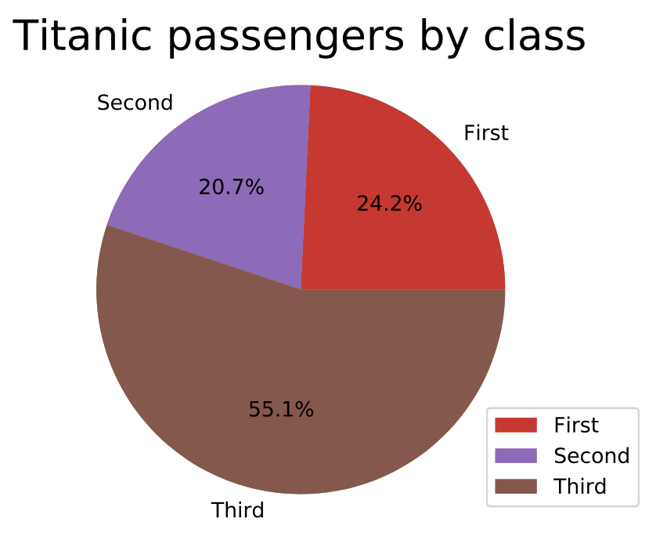

[Run example](https://trinket.io/library/trinkets/983b5066dd)

The counts, instead of the percentages, can be displayed by setting autopct equal to some function as shown in the code below

tot = sum(sizes)

autopct = lambda x: "%d" % round(x*tot/100,2)

plt.pie(sizes, labels=labels, autopct= autopct);

The result pie chart with counts is shown below.

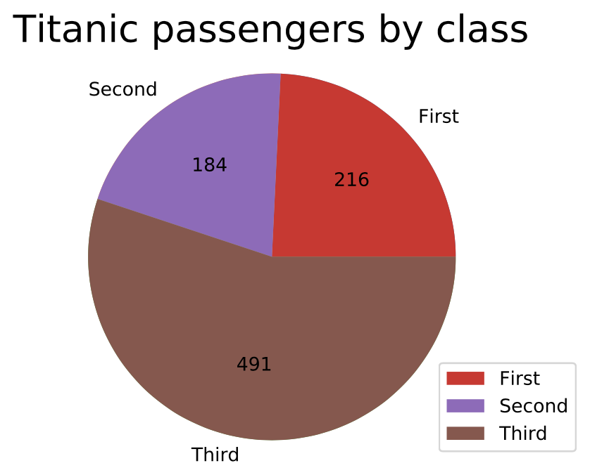

[Run example](https://trinket.io/library/trinkets/6908351785)

Python-Function 1.6.2: Exploded pie charts.

To explode one or more categories within a pie chart, the parameter explode of the pie is set to a tuple. Ex: In the tuple (0.1, 0.0), the category "Survived" is exploded by 0.1 units, while the category "Did not survive" is not exploded.

# data to plot

a = df[df.survived == 1]["survived"].count()

b = df[df.survived == 0]["survived"].count()

# creates a tuple of the categories

explodeTuple = (0.1, 0.0)

# data to plot

labels = 'Survived', 'Did not survive'

sizes = [a, b]

# plot

plt.pie(sizes, labels=labels, autopct='%1.1f%%', explode = explodeTuple)

# title

plt.title('Survivors of the Titanic', fontsize=20)

# produces a perfectly circular chart

plt.axis('equal')

# saves the image

plt.savefig("explodedpiechart.png")

# shows the image

plt.show()

The resulting exploded pie chart is shown below.



### Scatter plots with quantitative variables

A ***scatter plot*** depicts the relationship between two variables on a rectangular coordinate system, where each axis corresponds to one variable. Scatter plots are used for both quantitative and categorical data.

In data analytics, scatter plots are especially useful in visualizing the relationship between variables in a multi-dimensional dataset. Ex: A marketing manager for a beverage company may want to check the relationship between average temperature and revenue within a specific time period or between revenue and marketing budget.

Example 1.7.1: Number of engineering faculty versus school rank.

To inform a decision of whether to hire new engineering faculty, a dean collected data showing number of faculty versus engineering school rank (using the U.S. News and World Report ranking, lower rank is better), for eight University of California campuses (UC Berkeley, UCLA, etc.). A table of the data (2014) is shown below. For example, the school with 247 engineering faculty is ranked number 3 in the country, while the school with only 78 engineering faculty is ranked number 81.

|  |  |
| --- | --- |
| Engineering faculty | USNWR rank |
| 247 | 3 |
| 194 | 14 |
| 155 | 16 |
| 124 | 19 |
| 198 | 31 |
| 115 | 38 |
| 91 | 69 |
| 78 | 81 |

Below is a scatter plot showing engineering faculty size vs. engineering school rank in 2014 for the eight campuses in the University of California system. Each row in the above table becomes a coordinate, leading to the following scatter plot.

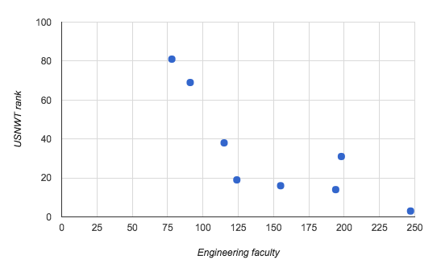

The scatter plot clearly shows the relationship between number of faculty and rank. The data suggests, but does not prove, that increasing the number of engineering faculty may be important to improving rank.

Python-Function 1.7.1: Scatter plots.

To graph a scatter plot, the sns.regplot(x,y, ci = None) function of the seaborn library is used, which takes in two arrays of equal size x and y. By default, the 95% confidence intervals are displayed, but the parameter ci can be set to None to disable confidence intervals.

# loads the necessary libraries

**import** matplotlib.pyplot as plt

**import** seaborn as sns

**import** numpy as np

# creates the data points

x = np.array([0, 5, 3, 4, 7, 8, 10])

y = np.array([5, 2, 5, 15, 27, 15, 31])

# plot

sns.regplot(x, y, ci=None)

# saves the image

plt.savefig("scatterplot.png")

# shows the image

plt.show()

The resulting scatter plot is shown below.

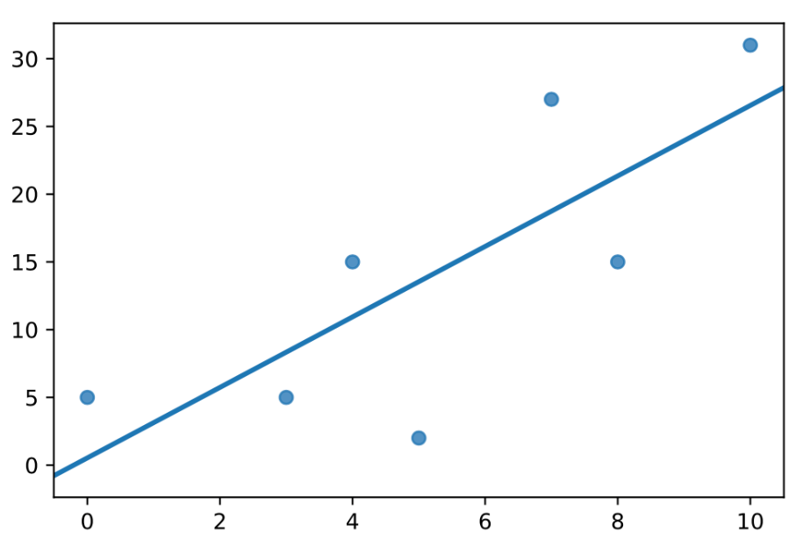

The regplot can also be used with data frames. Ex: Using the iris dataset, petal length is plotted with respect to petal width using the code below.

# loads the necessary modules

**import** matplotlib.pyplot as plt

**import** seaborn as sns

# loads the iris data set

df = sns.load_dataset("iris")

# title

plt.title('Petal length and width of iris', fontsize=20)

# plot

sns.regplot(df["petal_length"], df["petal_width"], ci=None, fit_reg=False);

# saves the image

plt.savefig("irisscatterplot.png")

# shows the image

plt.show()

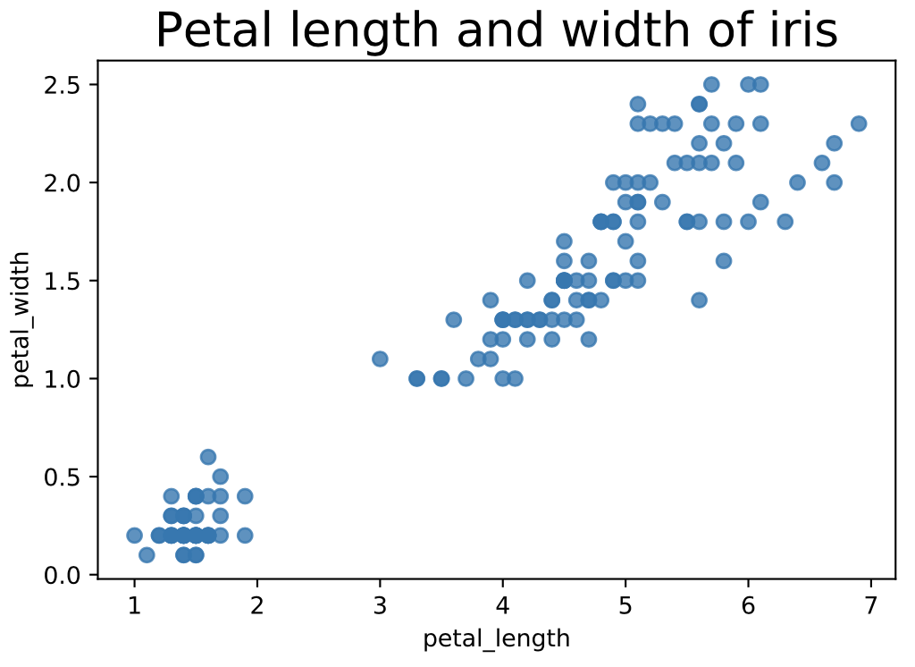

Figure 1.7.4: Strip plot for the sepal lengths of iris species.

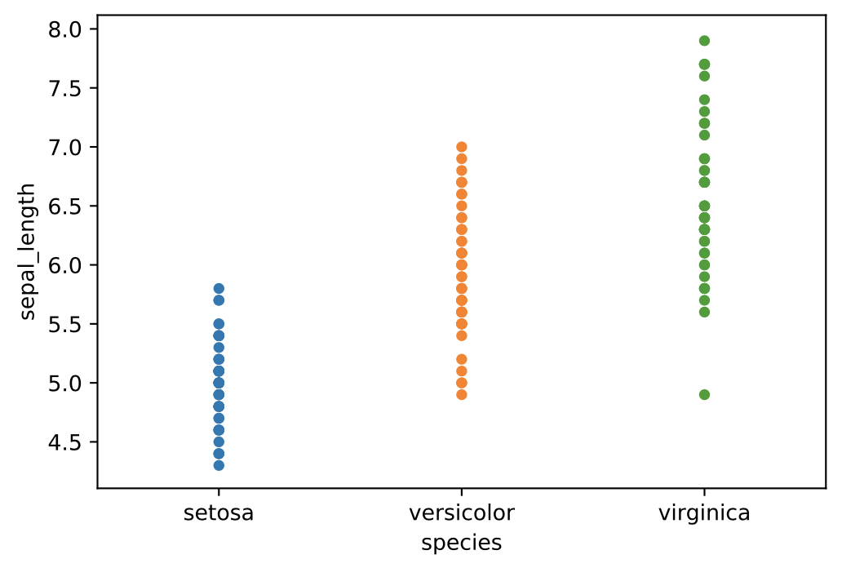

Feedback?

#### Jittered strip plots

Data points may overlap when the dataset is dense. Data points may share the same value or the marks may be too large compared to the plot's resolution. To get a better sense of the dataset, a data analyst might use scatter plot jittering. ***Jittering*** is the addition of random noise to the plot in order to prevent or minimize overlapping data points. Ex: The jittered strip plot below shows 6 samples of *Iris virginica* had sepal lengths between 7.5 cm and 8 cm, which is not clear from the strip plot above.

Figure 1.7.5: Jittered strip plot for the sepal lengths of iris species.

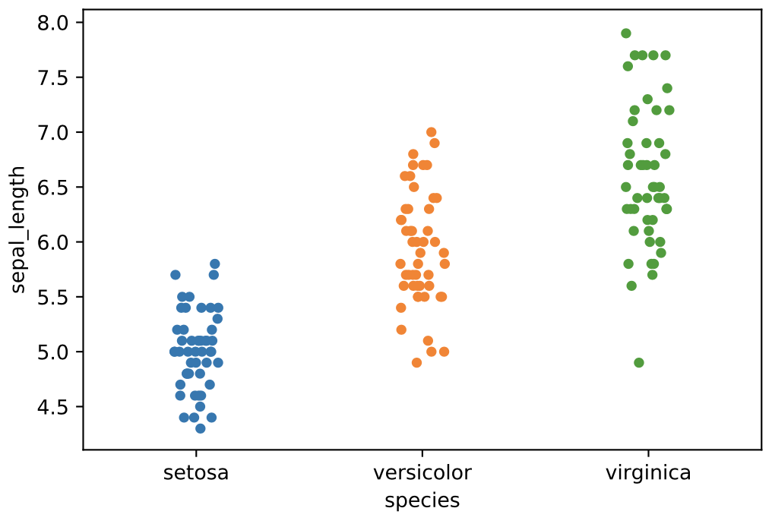

Feedback?

#### Swarm plots

Jittered plots do not entirely prevent overlapping. An alternative approach to jittering is to use a swarm plot. A ***swarm plot*** uses a random algorithm to set a minimum distance between points.

Figure 1.7.6: Swarm plot for the sepal lengths of iris species.

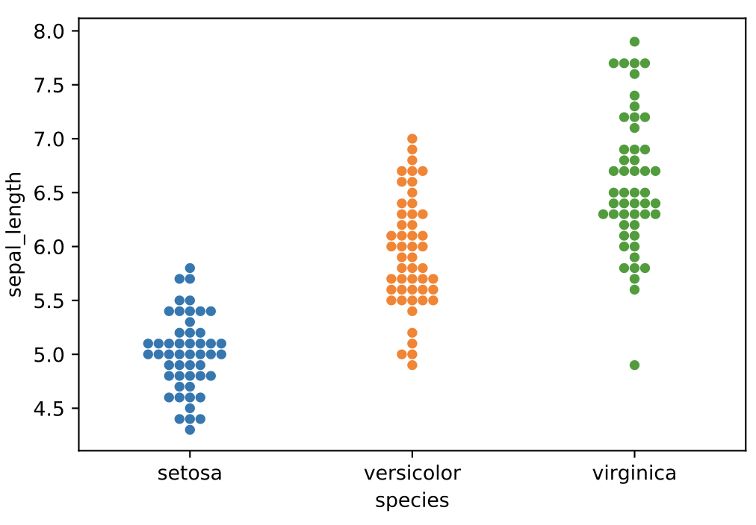

Python-Function 1.7.2: Strip and swarm plots.

A strip plot is created by using the sns.stripplot function of the seaborn library. Ex: The code below creates a strip plot where the horizontal axis is the deck to which a passenger of the Titanic is assigned and the vertical axis is the fare paid in dollars.

# loads the necessary libraries

**import** matplotlib.pyplot as plt

**import** seaborn as sns

**import** numpy as np

# loads the titanic dataset

titanic = sns.load_dataset("titanic")

# title

plt.title('Fares paid by passengers of the Titanic by deck', fontsize=20)

# plot

sns.stripplot(x="deck", y="fare", data=titanic);

# saves the image

plt.savefig("titanicstripplot.png")

# shows the image

plt.show()

The resulting strip plot is shown below.

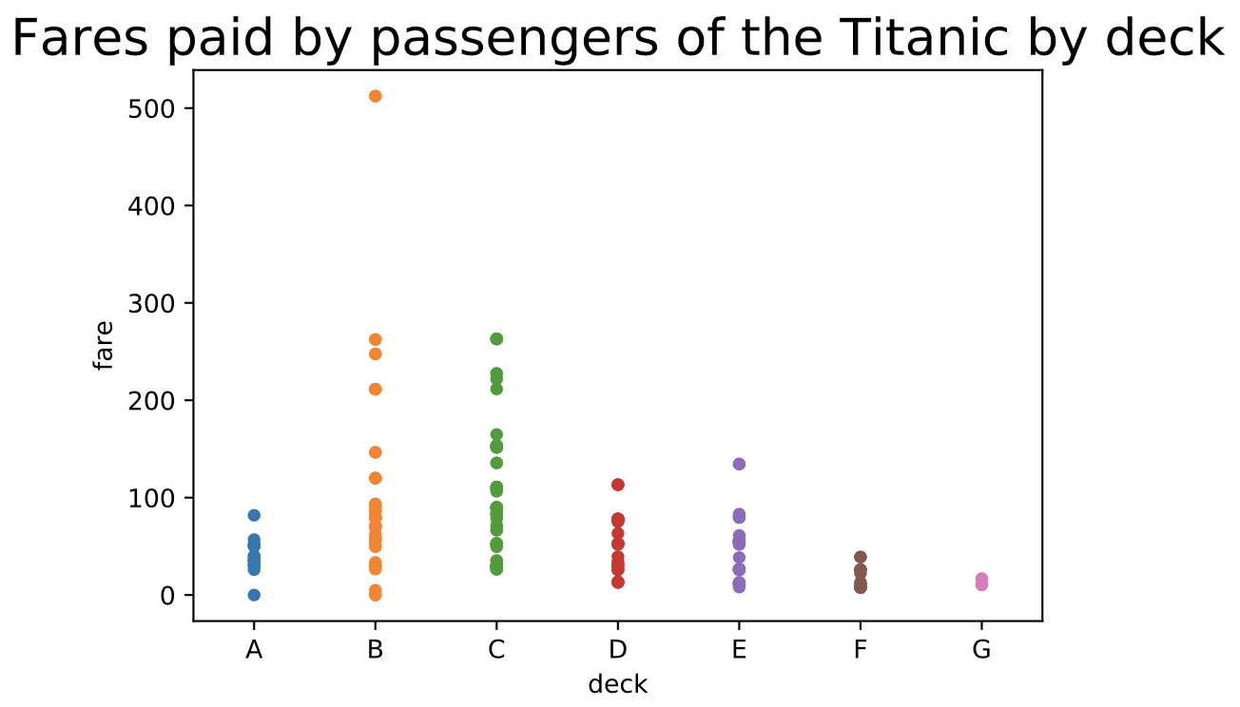

[Run example](https://rcoderunner.zybooks.com/index.html?code=%23%20loads%20the%20necessary%20libraries%0Aimport%20matplotlib.pyplot%20as%20plt%0Aimport%20seaborn%20as%20sns%0Aimport%20numpy%20as%20np%0A%0A%23%20loads%20the%20titanic%20dataset%0Atitanic%20%3D%20sns.load_dataset(%22titanic%22)%0A%0A%23%20title%0Aplt.title(%27Fares%20paid%20by%20passengers%20of%20the%20Titanic%20by%20deck%27%2C%20fontsize%3D20)%0A%0A%23%20plot%0Asns.stripplot(x%3D%22deck%22%2C%20y%3D%22fare%22%2C%20data%3Dtitanic)%3B%0A%0A%23%20saves%20the%20image%0Aplt.savefig(%22titanicstripplot.png%22)%0A%0A%23%20shows%20the%20image%0Aplt.show()%0A&language=python)

To add jittering to a strip plot, the parameter jitter should be set to true as shown below.

sns.stripplot(x="deck", y="fare", jitter= True, data=titanic);

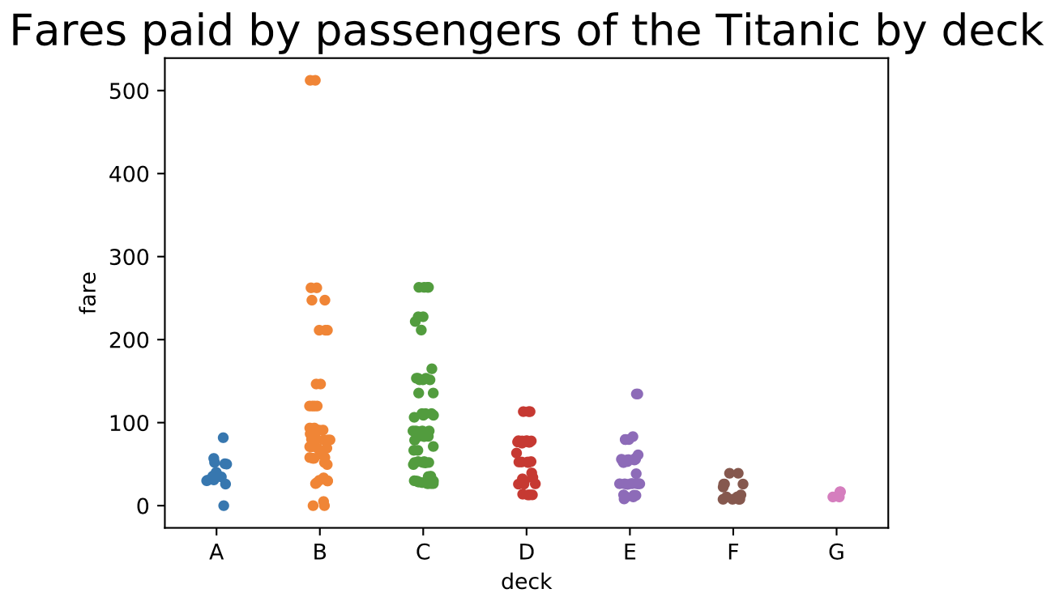

[Run example](https://rcoderunner.zybooks.com/index.html?code=%23%20loads%20the%20necessary%20libraries%0Aimport%20matplotlib.pyplot%20as%20plt%0Aimport%20seaborn%20as%20sns%0Aimport%20numpy%20as%20np%0A%0A%23%20loads%20the%20titanic%20dataset%0Atitanic%20%3D%20sns.load_dataset(%22titanic%22)%0A%0A%23%20title%0Aplt.title(%27Fares%20paid%20by%20passengers%20of%20the%20Titanic%20by%20deck%27%2C%20fontsize%3D20)%0A%0A%23%20plot%0Asns.stripplot(x%3D%22deck%22%2C%20y%3D%22fare%22%2C%20jitter%3D%20True%2C%20data%3Dtitanic)%3B%0A%0A%23%20saves%20the%20image%0Aplt.savefig(%22titanicstripplot.png%22)%0A%0A%23%20shows%20the%20image%0Aplt.show()%0A&language=python)

Python-Function 1.8.1: Line charts.

The code below loads the dataset containing unemployment rates in the United States from 1980 to 2017 and plots the data as a line chart.

# imports the necessary modules

**import** pandas as pd

**import** matplotlib.pyplot as plt

# loads the unemployment dataset

unemployment = pd.read_csv('http://data-analytics.zybooks.com/unemployment.csv')

# title

plt.title('U.S. unemployment rate', fontsize = 20)

# x and y axis labels

plt.xlabel('Year')

plt.ylabel('% of total labor force')

# plot

plt.plot(unemployment["Year"], unemployment["Value"])

# saves the image

plt.savefig("linechart.png")

# shows the image

plt.show()

The resulting line chart is shown below.



[Run example](https://rcoderunner.zybooks.com/index.html?code=%23%20imports%20the%20necessary%20modules%0Aimport%20pandas%20as%20pd%0Aimport%20matplotlib.pyplot%20as%20plt%0A%0A%23%20loads%20the%20unemployment%20dataset%0Aunemployment%20%3D%20pd.read_csv(%27http%3A%2F%2Fdata-analytics.zybooks.com%2Funemployment.csv%27)%0A%0A%23%20title%0Aplt.title(%27U.S.%20unemployment%20rate%27%2C%20fontsize%20%3D%2020)%0A%0A%23%20x%20and%20y%20axis%20labels%0Aplt.xlabel(%27Year%27)%0Aplt.ylabel(%27%25%20of%20total%20labor%20force%27)%0A%0A%23%20plot%0Aplt.plot(unemployment%5B%22Year%22%5D%2C%20unemployment%5B%22Value%22%5D)%0A%0A%23%20saves%20the%20image%0Aplt.savefig(%22linechart.png%22)%0A%0A%23%20shows%20the%20image%0Aplt.show()&language=python)

One of the most useful libraries that includes a multitude of economic data such as stock prices, futures, and unemployment rates is quandl. The quandl library allows users to preprocess, subset, and change the format of data frames, using a much more convenient syntax than pandas, and is especially suited for time series analysis. To use quandl, the library needs to be downloaded and installed by running pip install quandl from the command line.

For more information about the quandl library and specific methods, see the [documentation](https://github.com/quandl/quandl-python).

The code below creates a line chart for the closing stock prices of Target (TGT) since 1983.

# loads the necessary libraries

**import** quandl

**import** matplotlib.pyplot as plt

# creates a data frame containing TGT stock data

tgt = quandl.get('WIKI/TGT')

# title

plt.title('Target (TGT) closing stock prices', fontsize=20)

# x and y axis labels

plt.xlabel('Year');

plt.ylabel('Stock price (USD)');

# plot

plt.plot(tgt.index, tgt['Adj. Close'])

# saves the image

plt.savefig("tgtstocklinechart.png")

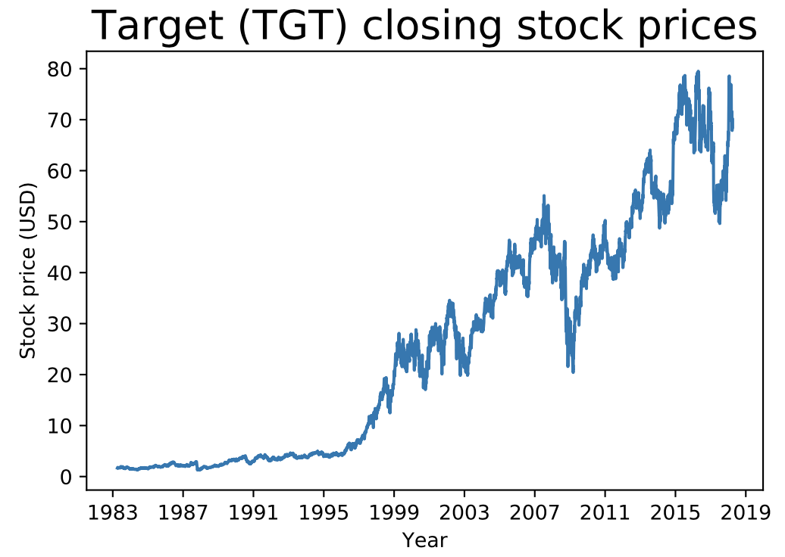

Python-Function 1.9.1: min(), max(), and range.

The DataFrame.min() function is used to find the minimum, and the DataFrame.max() function is used to find the maximum.

|  |  |
| --- | --- |
| **import** pandas as pd  scores = pd.read_csv('http://data-analytics.zybooks.com/ExamScores.csv')  # Prints the minimum score for each exam  **print**(scores.min())  # Prints the minimum score for Exam1 only  **print**(scores[['Exam1']].min())  # Prints the maximum score for each exam  **print**(scores.max())  # Prints the maximum score for Exam1 only  **print**(scores[['Exam1']].max()) | Exam1 59  Exam2 49  Exam3 18  Exam4 55  dtype: int64  Exam1 59  dtype: int64  Exam1 100  Exam2 100  Exam3 100  Exam4 100  dtype: int64  Exam1 100  dtype: int64 |

No pre-built function exists for finding the range. However, the range can be found by subtracting the minimum values from the maximum values. Alternatively, a new function can be defined if the range needs to be found repeatedly.

|  |  |
| --- | --- |
| **import** pandas as pd  scores = pd.read_csv('http://data-analytics.zybooks.com/ExamScores.csv')  # Calculating the range by subtracting the minimum from the maximum  score_range = scores.max() - scores.min()  **print**(score_range)  # Defining a function that can be used repeatedly  **def** range_of_scores(x):  **return** x.max() - x.min()  **print**(range_of_scores(scores))  **print**(range_of_scores(scores[['Exam1']]))  **print**(range_of_scores(scores[['Exam2']]))  **print**(range_of_scores(scores[['Exam4']])) | Exam1 41  Exam2 51  Exam3 82  Exam4 45  dtype: int64  Exam1 41  Exam2 51  Exam3 82  Exam4 45  dtype: int64  Exam1 41  dtype: int64  Exam2 51  dtype: int64  Exam4 45  dtype: int64 |

### Percentiles

The nth ***percentile*** of a dataset is the data value such that n percent of the data falls at or below that value. Three percentiles are particularly important.

* The ***first quartile*** (Q1) is the 25th percentile. One-quarter of the data fall at or below Q1. The first quartile is the median of the lower half of the data.
* The ***third quartile*** (Q3) is the 75th percentile. Three-quarters of the data fall at or below Q3. The third quartile is the median of the upper half of the data.
* Because half of the data fall at or below the median, the median is also the 50th percentile of a dataset.

Collectively, the minimum and maximum values, Q1, median, and Q3 form a set of descriptive statistics called the ***five-number summary***.

Example 1.9.2: Creating a five-number summary.

The number of receptions made by players on a certain American football team are given by the dataset 3,37,23,61,36,65,6,24,1,19,72,1,13,40,1. Create a five-number summary of this data.

#### Solution

First, the data should be sorted in ascending or descending order. In ascending order, the dataset is

1,1,1,3,6,13,19,23,24,36,37,40,61,65,72

Thus, the minimum is 1 and the maximum is 72. The dataset contains 15 values, so the median is the 15+12=8th value of 23. Thus, the lower half of the data is 1,1,1,3,6,13,19,23 and the upper half of the data 23,24,36,37,40,61,65,72 (the median belongs to both the upper and lower halves). The median of the lower half is 3+62=92=4.5 and the median of the upper half is 37+402=772=38.5.

The five-number summary is

|  |  |
| --- | --- |
| Minimum | 1 |
| Q1 (first quartile) | 4.5 |
| Median | 23 |
| Q3 (third quartile) | 38.5 |
| Maximum | 72 |

Feedback?

Python-Function 1.9.2: describe().

The DataFrame.describe() function generates a five-number summary. Q1, the 25th percentile, is shown as 25%, the median, the 50th percentile, is shown as 50%, and Q3, the 75th percentile, is shown as 75%.

|  |  |
| --- | --- |
| **import** pandas as pd  scores = pd.read_csv('http://data-analytics.zybooks.com/ExamScores.csv')  # Prints the summary for each exam  **print**(scores.describe())  # Prints the summary for Exam1 only  **print**(scores[['Exam1']].describe()) | Exam1 Exam2 Exam3 Exam4  count 50.000000 50.00000 50.000000 50.00000  mean 82.700000 79.40000 73.340000 76.50000  std 9.291756 14.33278 21.754296 8.05656  min 59.000000 49.00000 18.000000 55.00000  25% 77.250000 68.50000 59.000000 72.00000  50% 83.000000 79.50000 74.500000 75.00000  75% 88.500000 91.75000 94.500000 79.75000  max 100.000000 100.00000 100.000000 100.00000  Exam1  count 50.000000  mean 82.700000  std 9.291756  min 59.000000  25% 77.250000  50% 83.000000  75% 88.500000  max 100.000000 |

Python-Practice 1.9.1: Maximum, minimum, and range.

The [rent](http://www.data-analytics.zybooks.com/rent.csv) dataset is first imported.

|  |
| --- |
| **import** pandas as pd  rent = pd.read_csv('http://data-analytics.zybooks.com/rent.csv')  **print**(rent) |
| Santa Monica CA Boise ID Tucson AZ Detroit MI Pittsburgh PA Orlando FL  0 10230 1600 2495 3195 2480 2242  1 10000 1500 2200 2695 2435 2000  2 9000 1029 2150 2595 2405 1912  3 8500 1025 1800 2495 2350 1895  4 8250 980 1650 2495 2320 1800  5 8000 950 1600 1675 2316 1765  6 7000 950 1500 1525 2305 1685  7 6500 925 1500 1480 2290 1670  8 6000 925 1500 1410 2275 1665  9 5815 900 1500 1400 2265 1625 |

The maximum and minimum rent for all cities are found as follows.

|  |  |
| --- | --- |
| **print**(rent.max())  **print**(rent.min()) | Santa Monica CA 10230  Boise ID 1600  Tucson AZ 2495  Detroit MI 3195  Pittsburgh PA 2480  Orlando FL 2242  dtype: int64  Santa Monica CA 5815  Boise ID 900  Tucson AZ 1500  Detroit MI 1400  Pittsburgh PA 2265  Orlando FL 1625  dtype: int64 |

The range in rent for all cities is found by subtracting the minimum rents from the maximum rents.

|  |  |
| --- | --- |
| **print**(rent.max() - rent.min()) | Santa Monica CA 4415  Boise ID 700  Tucson AZ 995  Detroit MI 1795  Pittsburgh PA 215  Orlando FL 617  dtype: int64 |

Python-Function 1.9.3: Box plots.

The boxplot function of the seaborn creates a box plot.

# loads the necessary libraries

**import** matplotlib.pyplot as plt

**import** seaborn as sns

**import** pandas as pd

# loads the ExamScores dataset

scores = pd.read_csv('http://data-analytics.zybooks.com/ExamScores.csv')

# transforms the data

df = pd.melt(scores, value_name = "Score", var_name = "Exam")

# plot

sns.boxplot(x="Exam", y="Score", data=df);

# saves the image

plt.savefig("Examsboxplots.png")

# shows the image

plt.show()

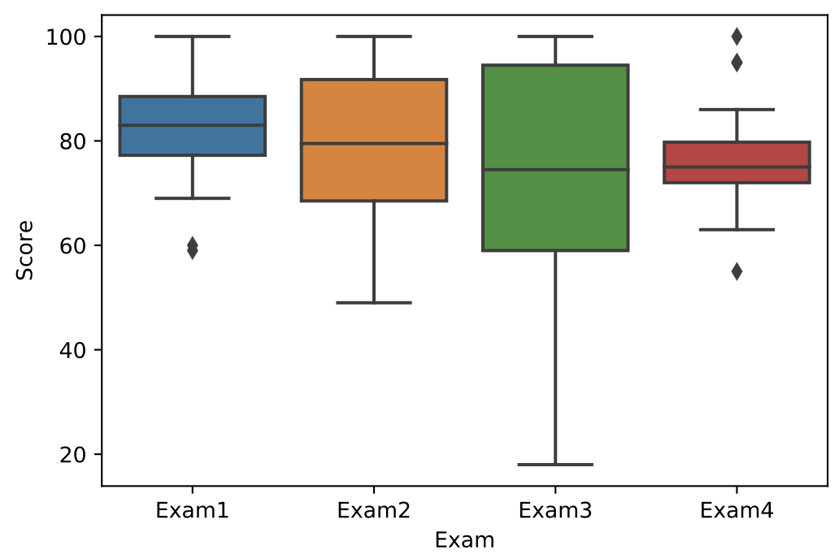

[Run example](https://trinket.io/library/trinkets/fd609fd775)

To create a box plot that does not identify the outliers, the parameter whis can be set to a high number such as 100. 1.5 is the default value for whis.

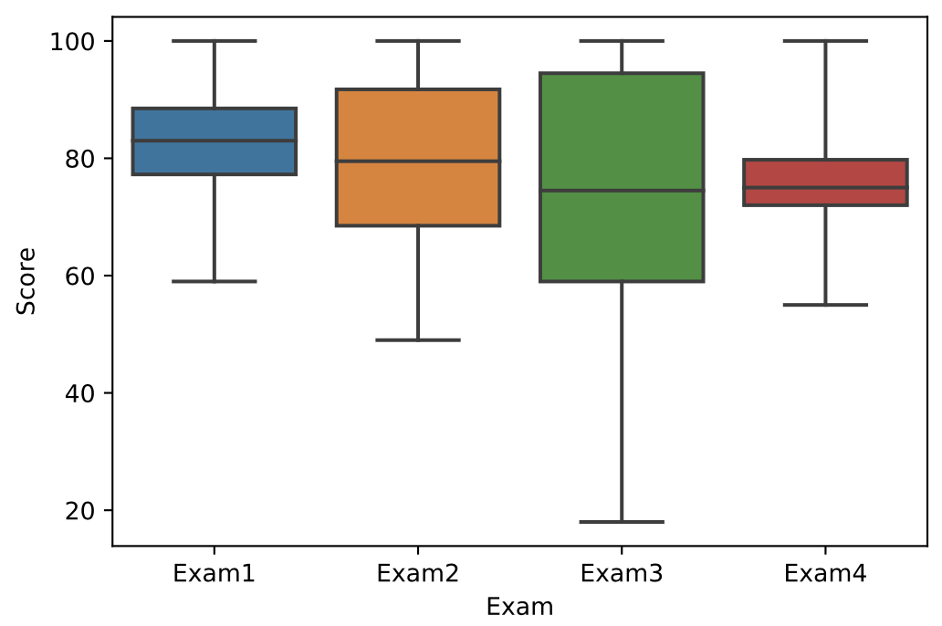

[Run example](https://trinket.io/library/trinkets/448a0b1af4)

### Detecting outliers

One way to detect outliers using a box plot is to determine how far each data element is from either Q1 or Q3. The ***interquartile range (IQR)*** of a dataset is the difference between Q3 and Q1 (Q3−Q1), or the length of the box in a box plot. A data value greater than Q3+1.5(IQR) or less than Q1−1.5(IQR) is considered an outlier. Often, an outlier is not included in either whisker and is instead represented in the plot as a marker such as an open circle or a triangle.

Example 1.9.3: The interquartile range.

For the dataset 3,37,23,61,36,65,6,24,1,19,72,1,13,40,1, Q1=4.5 and Q3=38.5. What is the IQR, and does the dataset contain any outliers?

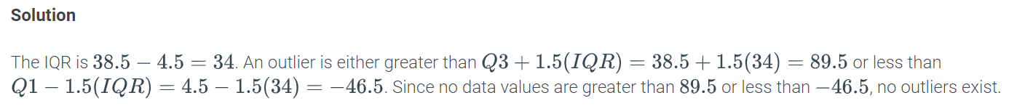

Python-Practice 1.9.2: Five-number summary and box plot.

[mtcars](http://data-analytics.zybooks.com/mtcars.csv) is a historical dataset from a 1974 issue of Motor Trend comparing the performance of 32 cars. The dataset should first be imported as a pandas DataFrame using the read_csv() function. To see the structure of the dataset, the head() function can be used to display the first few lines of the dataset.

|  |
| --- |
| **import** seaborn as sns  **import** pandas as pd  **import** matplotlib.pyplot as plt  # reads the mtcars.csv file into a dataframe called mtcars  mtcars = pd.read_csv("https://data-analytics.zybooks.com/mtcars.csv")  # prints the first few lines of mtcars  **print**(mtcars.head()) |
| Unnamed: 0 mpg cyl disp hp drat wt qsec vs am gear carb  0 Mazda RX4 21.0 6 160.0 110 3.90 2.620 16.46 0 1 4 4  1 Mazda RX4 Wag 21.0 6 160.0 110 3.90 2.875 17.02 0 1 4 4  2 Datsun 710 22.8 4 108.0 93 3.85 2.320 18.61 1 1 4 1  3 Hornet 4 Drive 21.4 6 258.0 110 3.08 3.215 19.44 1 0 3 1  4 Hornet Sportabout 18.7 8 360.0 175 3.15 3.440 17.02 0 0 3 2 |

The describe() function gives the five-number summary of the weight of the cars.

|  |  |
| --- | --- |
| mtcars.wt.describe() | count 32.000000  mean 3.217250  std 0.978457  min 1.513000  25% 2.581250  50% 3.325000  75% 3.610000  max 5.424000  Name: wt, dtype: float64 |

In the command above, .wt is needed to display only the summary for the weight. Otherwise, the five-number summaries for each of the attributes or columns are displayed.

The command to display the box plot for the weights of the cars as well as the corresponding output are given below.

sns.boxplot(mtcars.wt, width=0.35)

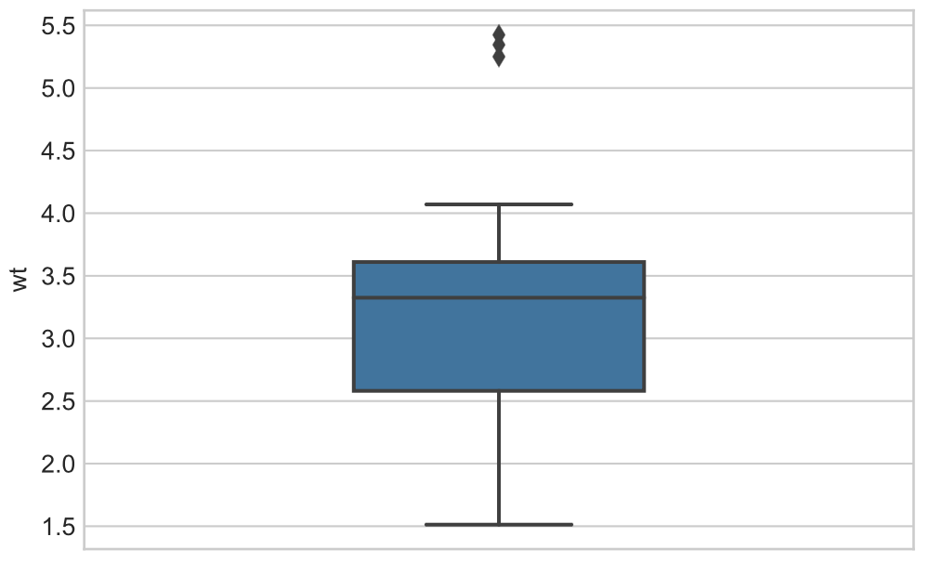

Python-Practice 1.10.1: Histograms.

The [Height](http://data-analytics.zybooks.com/height.csv) dataset gives the heights, in inches, of students in a particular class.

Histograms are plotted using the hist() function in the matplotlib.pyplot library. The function takes the dataset as the first parameter and the number of bins as the optional second parameter.

**import** pandas as pd

**import** matplotlib.pyplot as plt

heights = pd.read_csv('http://data-analytics.zybooks.com/height.csv')

fig, ax = plt.subplots()

plt.hist(heights['Height'], bins=6)

ax.set_xlabel('Height')

ax.set_ylabel('Frequency')

plt.savefig('histogram6.png')

plt.show()

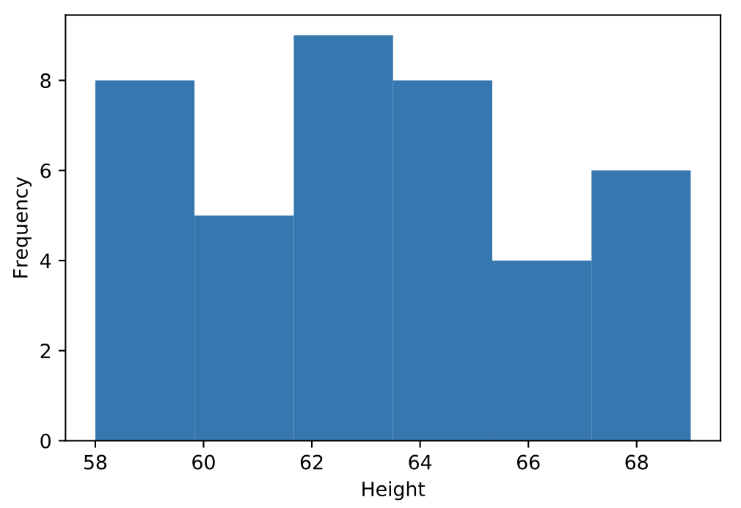

The same data can be represented as a histogram with more bins by modifying the bins argument.

**import** pandas as pd

**import** matplotlib.pyplot as plt

heights = pd.read_csv('http://data-analytics.zybooks.com/height.csv')

fig, ax = plt.subplots()

plt.hist(heights['Height'], bins=10)

ax.set_xlabel('Height')

ax.set_ylabel('Frequency')

plt.savefig('histogram10.png')

plt.show()

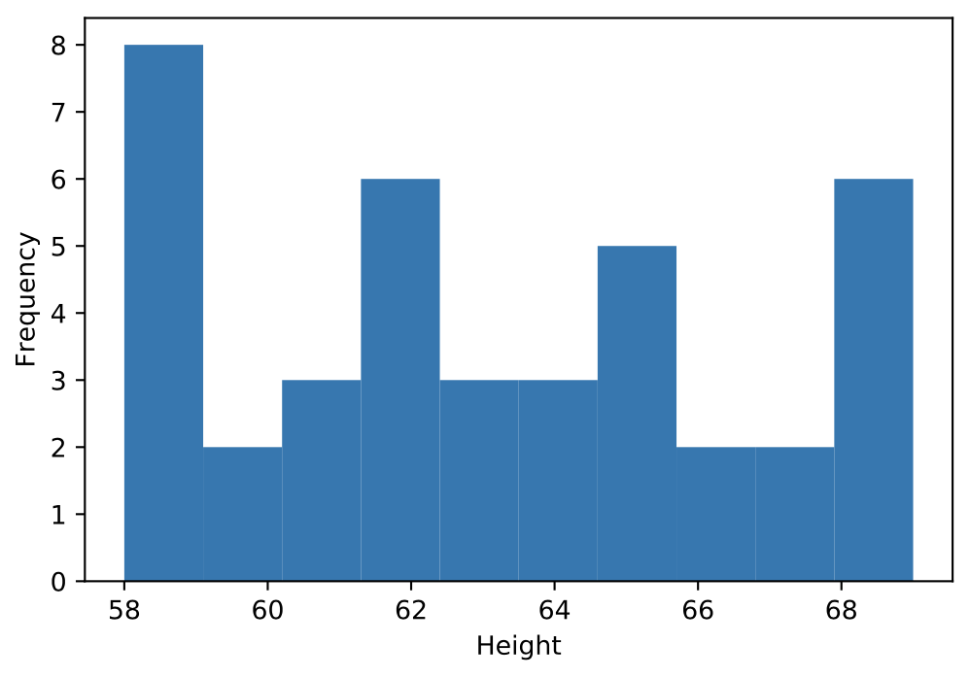

### Intersection of A and B

The intersection of events **A** and **B**, written as **P(A ∩ B)** or **P(A AND B)** is the joint probability of at least two events, shown below in a Venn diagram. In the case where **A** and **B** are mutually exclusive events, **P(A ∩ B) = 0**. Consider the probability of rolling a 4 and 6 on a single roll of a die; it is not possible. These events would therefore be considered mutually exclusive. Computing **P(A ∩ B)** is simple if the events are independent. In this case, the probabilities of events **A** and **B** are multiplied. To find the probability that two separate rolls of a die result in 6 each time:

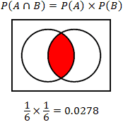

The calculator provided considers the case where the probabilities are independent. Calculating the probability is slightly more involved when the events are dependent, and involves an understanding of conditional probability, or the probability of event **A** given that event **B** has occurred, **P(A|B)**. Take the example of a bag of 10 marbles, 7 of which are black, and 3 of which are blue. Calculate the probability of drawing a black marble if a blue marble has been withdrawn without replacement (the blue marble is removed from the bag, reducing the total number of marbles in the bag):

Probability of drawing a blue marble:

P(A) = 3/10

Probability of drawing a black marble:

P(B) = 7/10

Probability of drawing a black marble given that a blue marble was drawn:

P(B|A) = 7/9

As can be seen, the probability that a black marble is drawn is affected by any previous event where a black or blue marble was drawn without replacement. Thus, if a person wanted to determine the probability of withdrawing a blue and then black marble from the bag:

Probability of drawing a blue and then black marble using the probabilities calculated above:

P(A ∩ B) = P(A) × P(B|A) = (3/10) × (7/9) = 0.2333

### Union of A and B

In probability, the union of events, **P(A U B)**, essentially involves the condition where any or all of the events being considered occur, shown in the Venn diagram below. Note that **P(A U B)** can also be written as **P(A OR B)**. In this case, the "inclusive OR" is being used. This means that while at least one of the conditions within the union must hold true, all conditions can be simultaneously true. There are two cases for the union of events; the events are either mutually exclusive, or the events are not mutually exclusive. In the case where the events are mutually exclusive, the calculation of the probability is simpler:

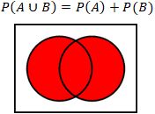

A basic example of mutually exclusive events would be the rolling of a dice, where event **A** is the probability that an even number is rolled, and event **B** is the probability that an odd number is rolled. It is clear in this case that the events are mutually exclusive since a number cannot be both even and odd, so **P(A U B)** would be **3/6 + 3/6 = 1**, since a standard dice only has odd and even numbers.

The calculator above computes the other case, where the events **A** and **B** are not mutually exclusive. In this case:

P(A U B) = P(A) + P(B) - P(A ∩ B)

Using the example of rolling dice again, find the probability that an even number or a number that is a multiple of 3 is rolled. Here the set is represented by the 6 values of the dice, written as:

|  |  |
| --- | --- |
|  | S = {1,2,3,4,5,6} |
| Probability of an even number: | P(A) = {2,4,6} = 3/6 |
| Probability of a multiple of 3: | P(B) = {3,6} = 2/6 |
| Intersection of A and B: | P(A ∩ B) = {6} = 1/6 |
|  | P(A U B) = 3/6 + 2/6 -1/6 = 2/3 |

### Descriptive and inferential statistics

Two types of statistical analysis exist to describe survey data: descriptive statistics and inferential statistics.

***Descriptive statistics*** focuses on summarizing survey data about a sample drawn from a population. Summary statistics include measures of central tendency such as mean, median, and mode; and dispersion such as range and standard deviation. Descriptive statistics cannot make conclusions based on the data. Rather, descriptive statistics is a way to present data in a meaningful way.

***Inferential statistics*** focuses on using information from the sample to make conclusions about the population from which the sample was drawn. The two primary methods of inferential statistics are confidence intervals, which specify the range within which a parameter falls with a given probability, and hypothesis testing, which allows differences between population parameters to be compared.

### Surveys

***Surveys*** are conducted to allow statisticians to make generalizations about a population.

A ***population*** is any collection of objects, people, or things about which statistical inference are made. A ***parameter*** of a population is a numerical characteristic of a population, such as mean, median, or standard deviation.

A ***sampling unit*** is an individual in the population on which a measurement can be taken.

The ***sampling frame*** is the subset of the population from which a sample is drawn.

The ***sample*** is composed of the sampling units that provide data to be collected.

A ***statistic*** is a numerical characteristic of a sample, rather than the population.

The following animation shows the relationship between the population, sampling unit, sampling frame, and sample.

### Bias

In statistics, a ***bias*** is a difference between the parameter predicted from a survey from the true value of the parameter in the population. Two broad categories of statistical bias include selection bias and response bias.

***Selection bias*** exists when the sampling units selected from a population are not representative of the entire population, and are instead biased toward certain subsets of the population. A population should be surveyed in such a way to minimize sampling bias. Several types of selection bias follow.

***Undercoverage*** occurs when certain members of a population are inadequately represented in a sample.

***Nonresponse bias*** occurs when a sample is biased toward members of a population that participate in a survey.

***Voluntary response bias*** occurs when a sample is biased toward members that self-select for participation in a survey.

***Response bias*** can result if the responses of survey participants are affected by how a question is asked or the behaviors or attitudes of the participant. Several types of response bias follow.

***Acquiescence bias*** occurs when respondents tend to agree with a statement in a survey.

***Extreme responding*** occurs when respondents tend to select the most extreme options available.

***Social desirability bias*** occurs when respondents tend to answer questions in a way that is socially accepted by others. In other words, a social desirability bias exists when respondents over-report "good" behaviors or under-report "bad" behaviors.

### Sampling methods

Different sampling methods can help mitigate certain types of statistical bias.

In ***simple random sampling***, a sample is constructed by random selection from the population. Mathematically, simple random sampling is a sampling method in which all possible samples consisting of n units selected from a population of N units are equally likely.

In ***systematic sampling***, every kth unit from a population of N units is selected to be in a sample.

In ***stratified sampling***, the population is first divided into groups, or strata, depending on some characteristic. Next, samples within each stratum are randomly selected in a proportional manner.

In ***cluster sampling***, the population is first divided into groups, or clusters, depending on some characteristic. Next, the sample is constructed by randomly selecting one or more clusters.

In ***convenience sampling***, units are drawn from a subset of the population that is readily available.

### The mean

Large amounts of data can be overwhelming. A single number can summarize information about a dataset, such as the central tendency or the dispersion of the dataset. A common data summary is the ***arithmetic mean*** or ***mean***, which is the sum of the data values in a dataset divided by the number of values in the dataset.

Mathematically, the mean of a set of n data values x1,x2,…,xn is denoted x¯ and is defined as follows.

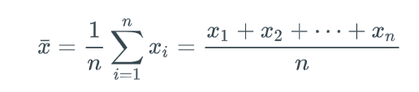

A similar quantity called the weighted mean is often calculated in addition to the mean. The ***weighted mean*** is a measure of center where some values are counted more than once. Weights are often expressed either as positive integers or percentages. Mathematically, the weighted mean of a set x1,x2,…,xn with corresponding weights a1,a2,…,an is defined as follows.

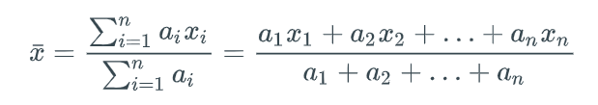

Python-Function 2.2.1: mean().

The DataFrame.mean() function is used to find the mean.

|  |  |
| --- | --- |
| **import** pandas as pd  scores = pd.read_csv('http://data-analytics.zybooks.com/ExamScores.csv')  # Prints the first few lines of data  **print**(scores.head())  # Prints the mean for each exam  **print**(scores.mean())  # Prints the mean for Exam1 only  **print**(scores[['Exam1']].mean())  # Prints the means for Exam1 and Exam2  **print**(scores[['Exam1', 'Exam2']].mean()) | Exam1 Exam2 Exam3 Exam4  0 100 66 74 68  1 76 84 100 75  2 89 80 100 95  3 83 76 91 74  4 86 99 78 78  Exam1 82.70  Exam2 79.40  Exam3 73.34  Exam4 76.50  dtype: float64  Exam1 82.7  dtype: float64  Exam1 82.7  Exam2 79.4  dtype: float64 |

### The median

The ***median*** is the middle value in a sorted dataset. To find the median of a dataset, the dataset must first be sorted in ascending or descending order. The method of finding the median depends on whether the number of data values n is even or odd.

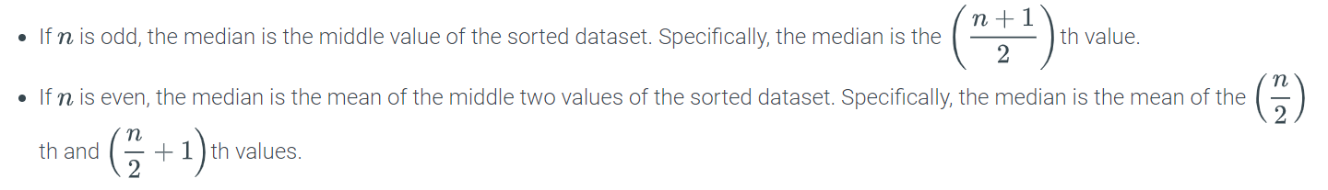

### Outliers

The dataset 100,3,6,9,2 in a previous example illustrates an advantage of the median over the mean. The data value 100 is much larger than the other data values. Such a value is an ***outlier***, or a data value that is either much greater than or much less than the rest of the data and not representative of the rest of the data being considered. Compared to the median of 6, the mean is (2+3+6+9+100)/5=1205=24, which is much larger than 6 due to influence by the outlier of 100.

As a practical example, the net worth (in USD) of 5 particular individuals in Medina, Washington in 2015 was $300,000, $400,000, $250,000, $80,000,000,000, and $600,000. The outlier of $80,000,000,000 is due to Bill Gates, a co-founder of Microsoft, living in Medina. The mean net worth of $16,000,000,000 is thus a poor data summary because the mean suggests that all 5 people are wealthy multimillionaires.

### The mode

The ***mode*** is the most frequently-occurring value in a dataset and is another measure of center. A dataset may have multiple modes if multiple values have the same maximum frequency. A dataset with only unique values does not have a mode.

### Variance and standard deviation

***Variability*** is the difference between values in a dataset and the center of the dataset. A measure of center alone does not indicate the extent of variability. Ex: the data set 1, 2, 8, and 9 and the data set 4, 5, 5, and 6 both have a mean of 5 and a median of 5. However, the values in the first dataset have a larger variability. Two common measures of variability are *variance* and *standard deviation*. ***Variance***, is the average of the square difference from the mean. ***Standard deviation*** is the square root of the variance. By definition, the variance is the square of the standard deviation.

The formula for variance and standard deviation depends on whether the dataset contains the whole population or or a subset of the population. The sample standard deviation is denoted by s, while the population standard deviation is denoted by σ. The formulas are given below.

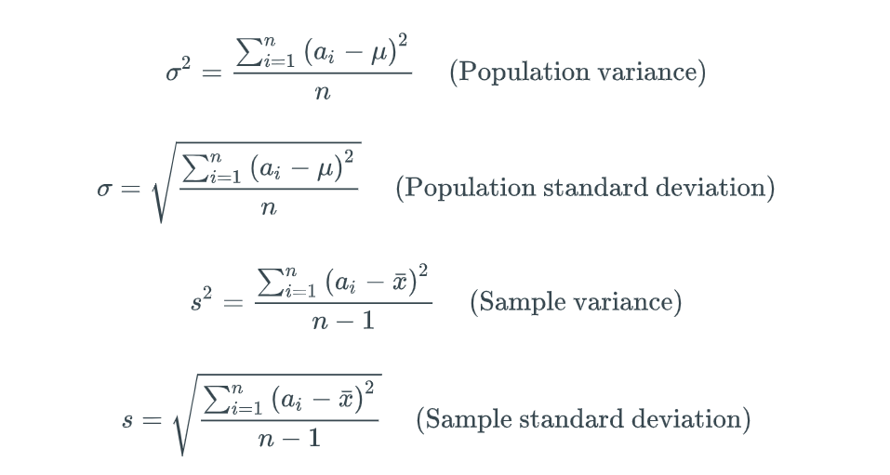



### Mean absolute deviation

***Mean absolute deviation (MAD)*** is the mean of the absolute difference between each value and the mean of the values. The MAD uses the absolute value instead of the square root of a sum of squares to avoid negative distances. The formula for the MAD is given below.

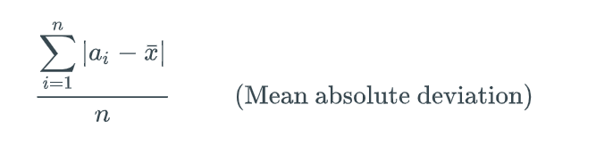

Python-Function 2.3.2: mad().

The DataFrame.mad() function is used to find the mean absolute deviation.

|  |
| --- |
| **import** pandas as pd  # Loads the ExamScores dataset  scores = pd.read_csv('http://data-analytics.zybooks.com/ExamScores.csv')  # Prints the mean absolute deviation of all scores  **print**(scores.mad())  # Prints the mean absolute deviation of Exam 1  **print**(scores['Exam1'].mad()) |

### Experiments, outcomes, and sample spaces

An ***experiment*** is a procedure that results in one out of a number of possible outcomes. An ***outcome*** is the result of an experiment. Ex: Rolling a six-sided die is an experiment, and the number of dots displayed is an outcome. The set of all possible outcomes is called the ***sample space*** of the experiment and is denoted S. Ex: The sample space of a six-sided die roll is S={1,2,3,4,5,6}.

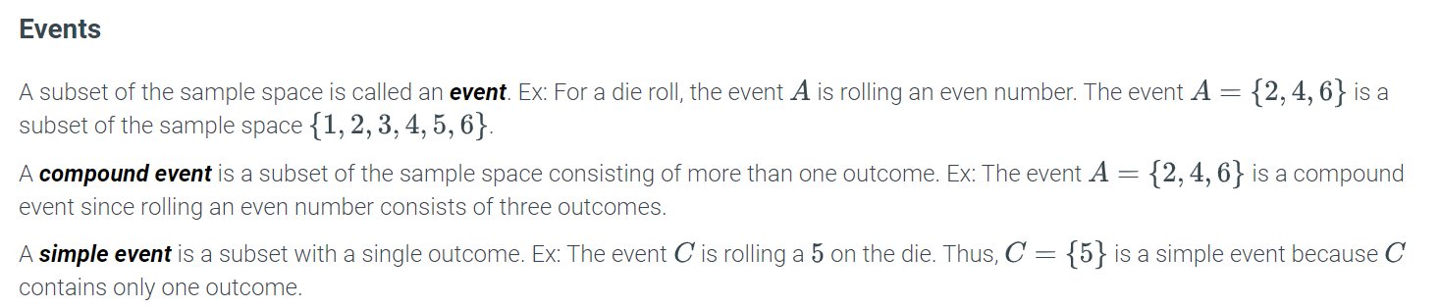

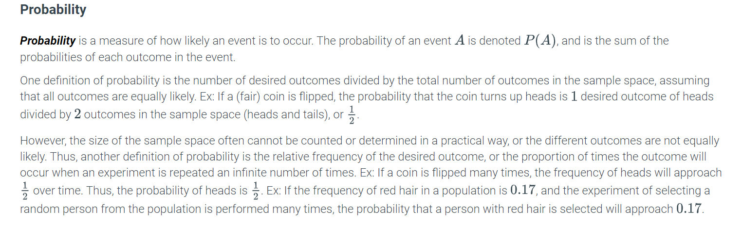

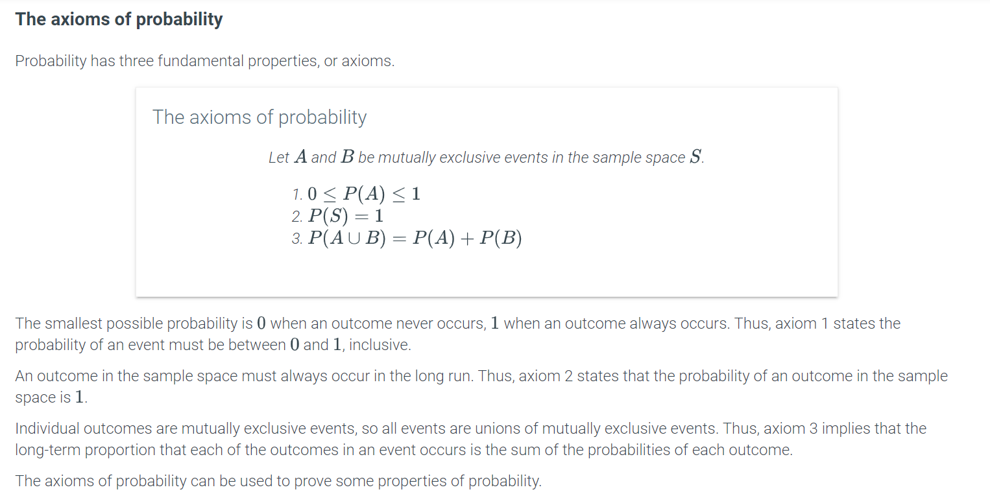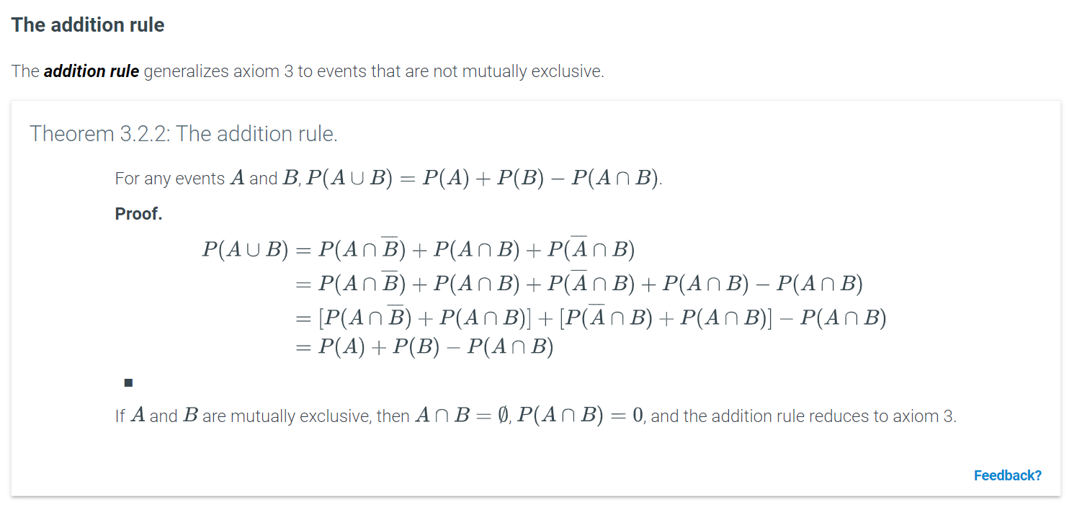

### Graphical user interface, application Description automatically generatedGraphical user interface, text, application Description automatically generatedGraphical user interface, application Description automatically generatedText Description automatically generated with low confidenceGraphical user interface Description automatically generatedRandom variables

A ***random variable*** is a rule that assigns a number to every outcome in the sample space of an experiment. Ex: In the experiment of a coin toss, a random variable may assign 1 to heads and 0 to tails. A random variable is typically defined using a capital letter, such as X=1 (if the coin toss yielded heads) or 0 (if the coin toss yielded tails).

Random variables can be used to model quantities that can change if an experiment is repeated.

### Discrete and continuous random variables

A random variable may be discrete or continuous. A ***discrete random variable*** can take on a countable number of distinct values like the integers between 0 and 100. Ex: The possible outcomes of a die roll are 1, 2, 3, 4, 5, or 6. A ***continuous random variable*** can take on any value within a range of values like the real numbers between 0 and 1. Ex: The time used by a student to complete a timed 60-minute test is a continuous random variable with possible outcomes in the range [0,60], such as 30.2 minutes, 33.657 minutes, 59 minutes, or 49.0000001 minutes. Continuous random variables are typically measured, while discrete random variables are typically counted.

Understanding discrete and continuous random variables is important in determining the best model for a situation. Ex: An analyst interested in modeling the average global temperature over time would use a continuous random variable. On the other hand, the number of days a particular city experiences temperatures above 90 degrees is best modeled using a discrete random variable.

### The probability mass function of a discrete probability distribution

Random variables have many powerful uses in modeling real world situations. A probability mass function captures useful information about a discrete random variable. A ***probability mass function (pmf)*** assigns the probability that a discrete random variable is exactly equal to some value (typically depicted as a table, plot, or equation). The notation p(X=x) or p(x) is typically used for the pmf of X. The probabilities assigned in a pmf are between 0 and 1, and the total probability must sum to 1.

Example 4.2.1: The probability mass function of a discrete random variable.

An adult can be classified as either underweight, normal weight, overweight, or obese. The discrete random variable W is used to model the weight classification of a randomly selected person from the U.S. population. W is assigned 0 if the person is underweight, 1 if normal weight, 2 if overweight, and 3 if obese.

In recent years, 2% of the adult population of the U.S. is classified as underweight, 27% as normal weight, 33% as overweight, and 38% as obese. Construct a table showing the probability mass function (pmf) of W.

#### Solution

The pmf of W is p(W=0)=0.02, p(W=1)=0.27, p(W=2)=0.33, and p(W=3)=0.38.

|  |  |  |  |  |
| --- | --- | --- | --- | --- |
| W | 0 | 1 | 2 | 3 |
| p(W) | 0.02 | 0.27 | 0.33 | 0.38 |

### The cumulative distribution function of a probability distribution

Another function used to describe the probabilities for all possible outcomes of a random variable is a cumulative distribution function. The ***cumulative distribution function (cdf)*** of a discrete random variable is the probability that for any number x, the observed value of the random variable will be at most x or p(X≤x). Ex: When a fair die is rolled and the value facing up recorded, the cdf describes the probability of getting less than or equal to any value x such that the probability X is less than or equal to 3, that is, p(X≤3)=p(1)+p(2)+p(3). The notation F(x) is typically used for the cdf of X. Ex: F(3)=p(X≤3)=12 is read "the probability X is less than or equal to 3 is one half". The cdf always starts at 0 and ends at 1 and never decreases as the value of X increases.

### Mean or expected value of a discrete random variable

The ***mean*** or ***expected value*** μμ of a discrete random variable XX is the sum of the possible values of XX multiplied by the probability of the value. The mean is calculated as follows.

μ=E(X)=∑(x⋅p(x))

The mean is a weighted average of the possible values of XX with the probabilities as the weights. The mean represents the average value for the population modeled by the random variable XX. Computing the mean does not always make sense for a discrete random variable. Ex: XX models the race of a randomly selected voter with 11 denoting white, 22 black and 33 other. The mean of XX is 1.631.63, but reporting the mean race is not useful.

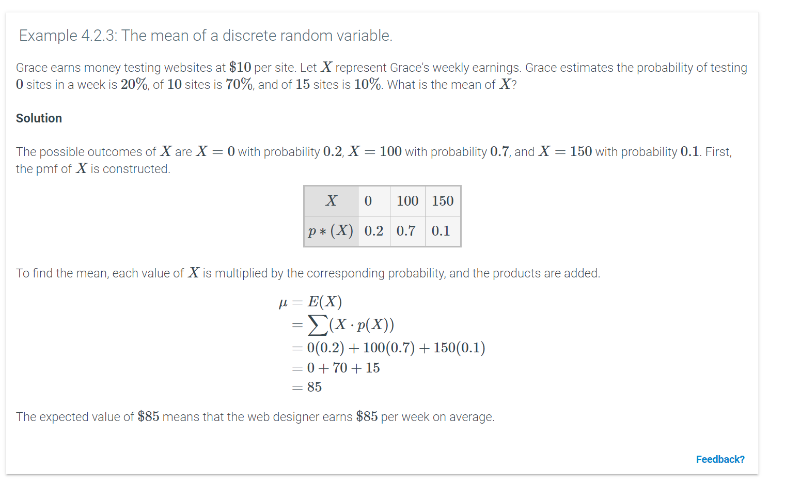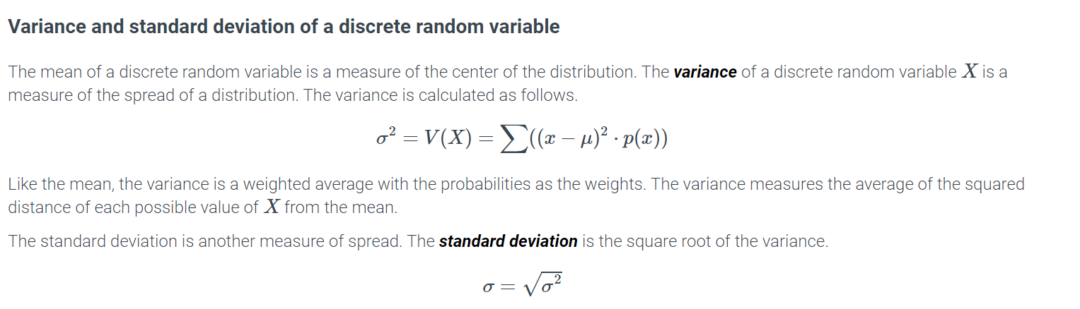

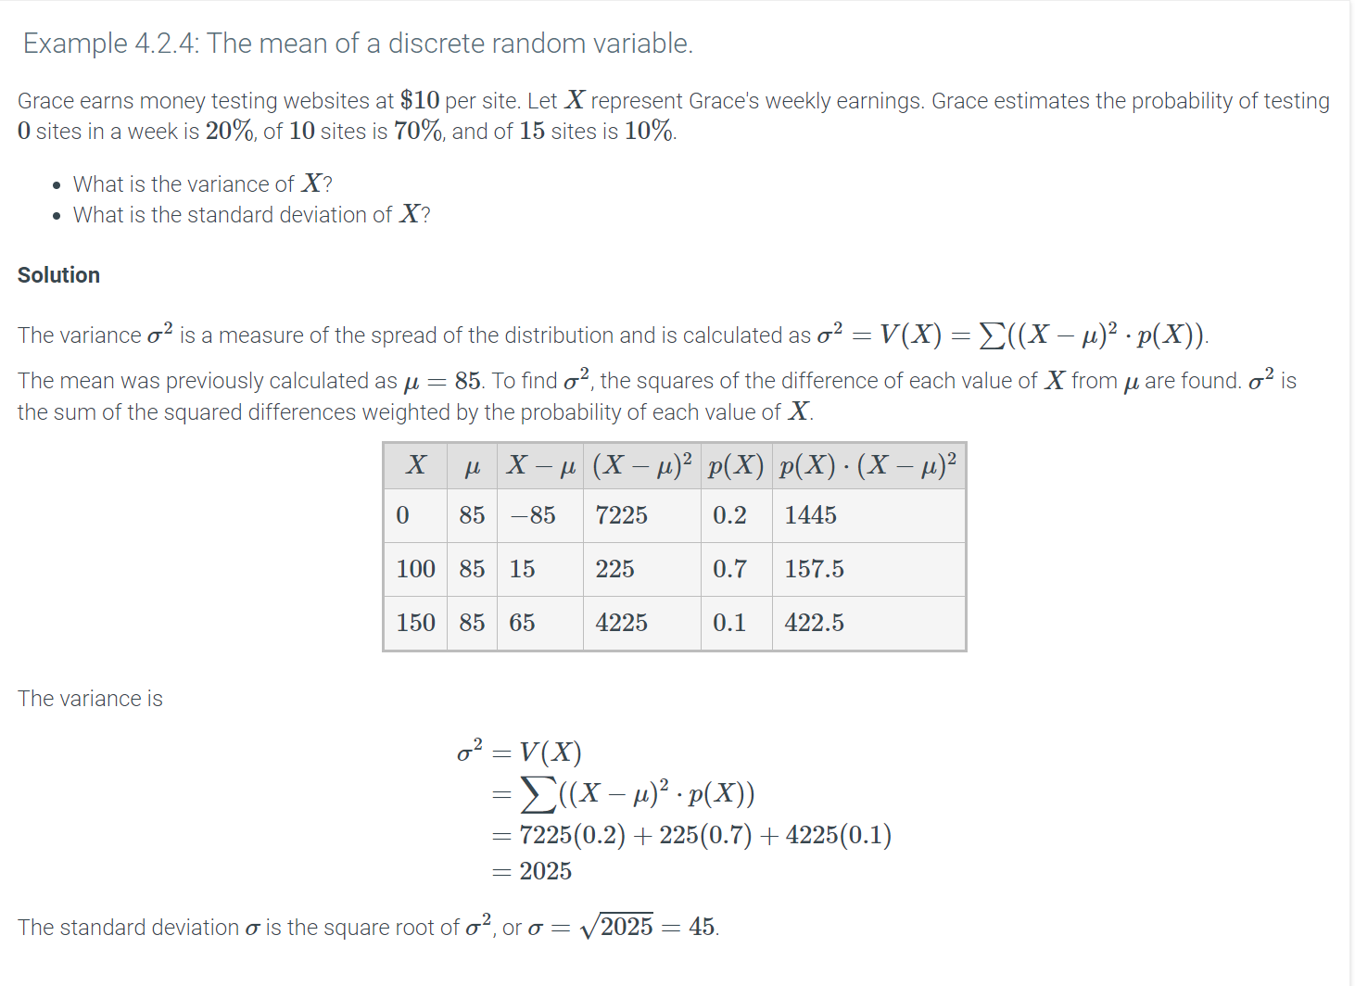

Python-Practice 4.2.1: Mean, variance, and standard deviation of a discrete random variable.

To find the mean, variance, and standard deviation of a discrete random variable, the rv_discrete class must be imported from the scipy.stats library. Next, a list containing the outcomes in a sample space and a list containing the probabilities of each outcome are defined. The outcome and probability lists are then linked.

|  |
| --- |
| **from** scipy.stats **import** rv_discrete  # Defines a list containing the outcomes in the sample space  x = [0,1,2,3,4,5,6]  # Defines a list containing the probabilities for each outcome  p = [0.1,0.2,0.3,0.1,0.1,0.0,0.2]  # Links the values in x to the probabilities in p  discvar = rv_discrete(values=(x,p)) |

To find the mean, the .mean() method is used.

|  |  |
| --- | --- |
| # Returns the mean of the discrete random variable  **print**(discvar.mean()) | 2.7 |

To find the variance, the .var() method is used.

|  |  |
| --- | --- |
| # Returns the variance of the discrete random variable  **print**(discvar.var()) | 3.81 |

To find the standard deviation, the .std() method is used.

|  |  |
| --- | --- |
| # Returns the standard deviation of the discrete random variable  **print**(discvar.std()) | 1.95192212959 |

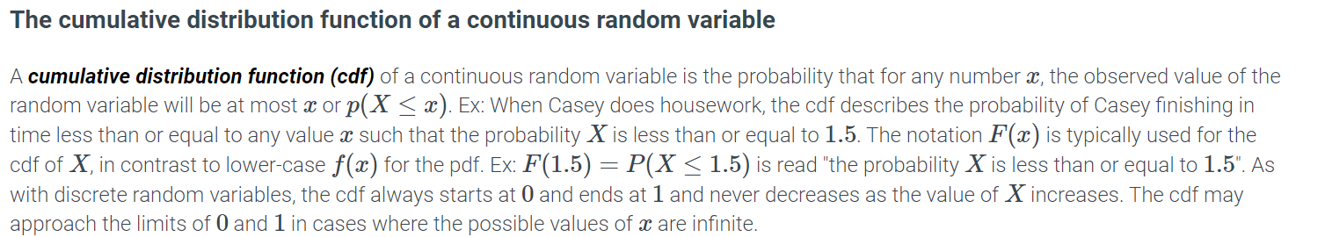

### Mean, variance, and standard deviation of a continuous random variable

In a previous section, the mean, variance, and standard deviation for a discrete random variable were defined. The interpretation of the three measures is similar for continuous random variables.

* The ***mean*** μμ or expected value E(X)E(X) of a continuous random variable XX is a measure of the center of the distribution. The mean is a weighted average of the possible values of the random variable, with the pdf providing the weights. Graphically, the mean is where a pivot is placed so that the pdf balances.
* The ***variance*** σ2σ2 of a continuous random variable XX is a measure of the spread of a distribution. The variance, like the mean, is a weighted average. The variance averages the squared distance of each possible value of XX from the mean, with weights provided by the pdf.
* The ***standard deviation*** σσ is another measure of the spread of the distribution. The standard deviation is the square root of the variance, σ=√σ2σ=σ2.

Integral calculus is required to compute the three quantities in the case of continuous random variables. The details are not discussed in this material.

### Normal distribution

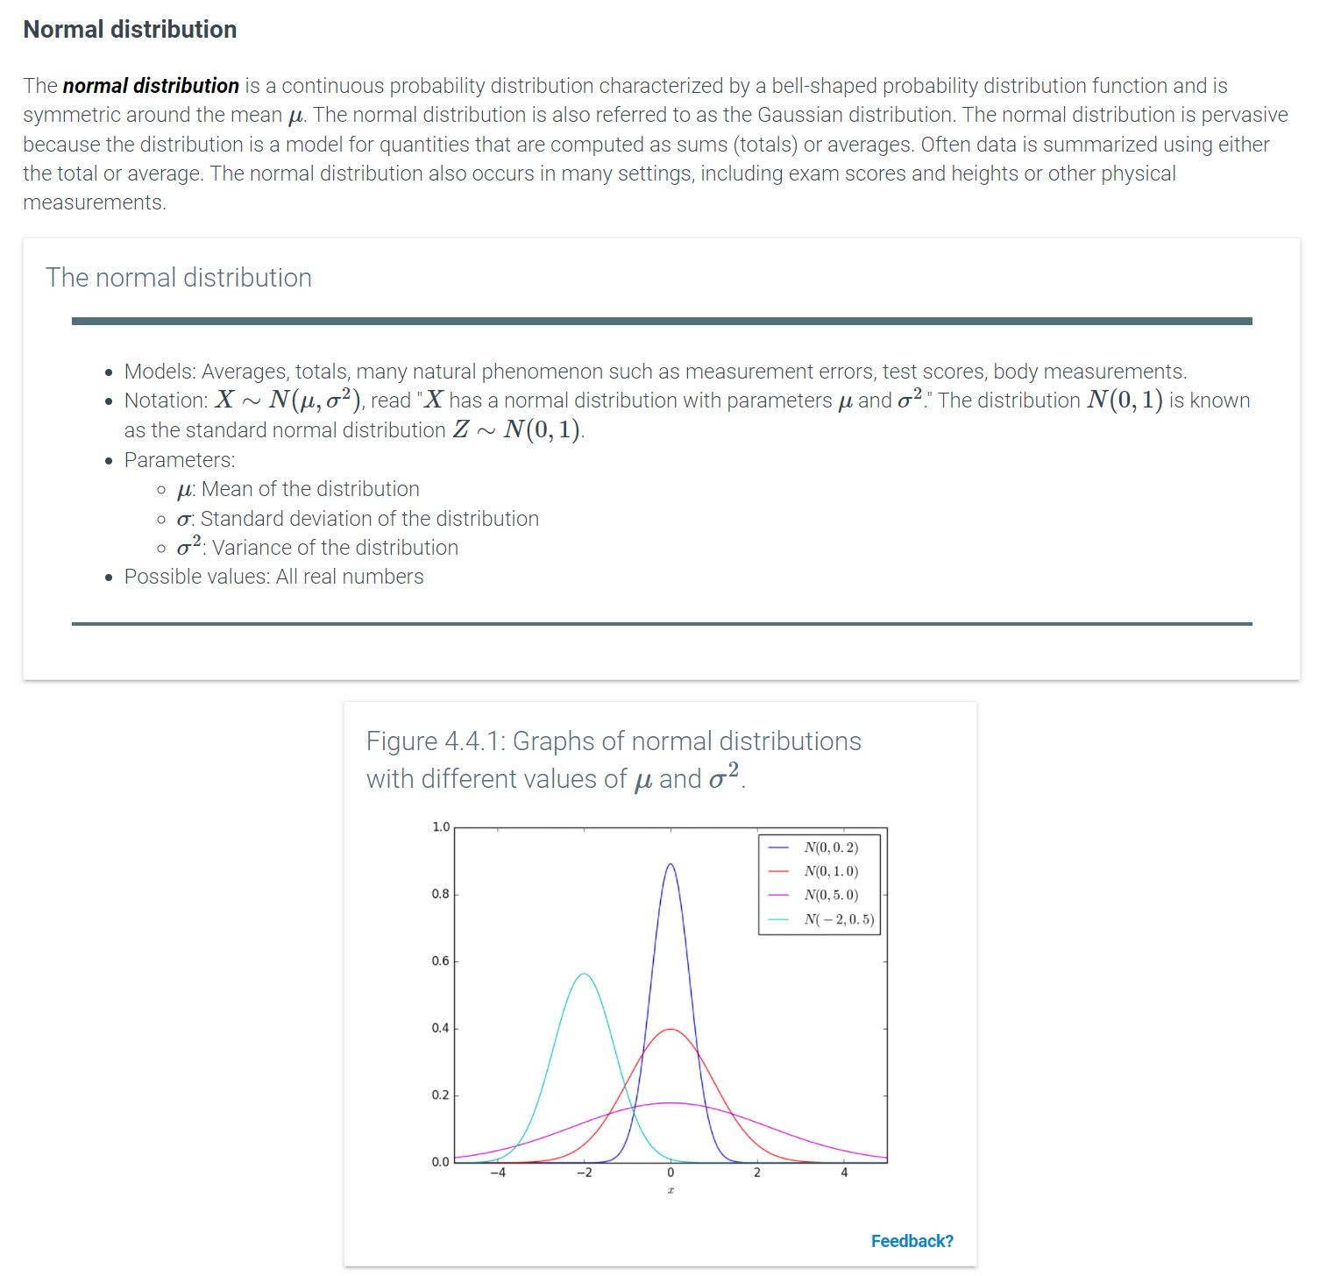

Feedback?

### Empirical rule

#### A picture containing text Description automatically generatedGraphical user interface, text, application, email Description automatically generatedTable Description automatically generatedAnalysis

To determine whether the eps of Walmart compared to the other companies is unusual, the sample mean and sample standard deviation should be computed. Using Python, these quantities can be calculated as follows.

|  |  |
| --- | --- |
| **import** pandas as pd  # Create a DataFrame containing the eps data  earnings_surprise = pd.DataFrame([11.36, 7.89, 1.96, 0, -3.12, -9.52])  **print**(earnings_surprise.mean())  **print**(earnings_surprise.std()) | 0 1.428333  dtype: float64  0 7.526849  dtype: float64 |

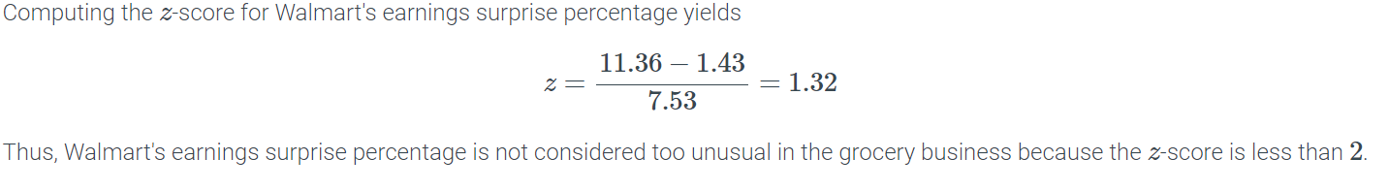

Python-Function 4.4.1: norm.cdf() and norm.sf().

The norm.cdf() and norm.sf() functions are used to find probabilities related to the normal distribution. The scipy.stats library must be imported to use these functions.

norm.cdf(z, mean, sd) returns the probability of zz being less or equal to than the critical value zz for a normal distribution with the specified mean and standard deviation.

|  |  |
| --- | --- |
| **import** scipy.stats as st  # For a normal distribution, if the mean is 0 and  # the standard deviation is 1, what is P(z <= -0.25)?  **print**(st.norm.cdf(-0.25, 0, 1))  # For a normal distribution, if the mean is 0 and  # the standard deviation is 1, what is P(z <= 1.5)?  **print**(st.norm.cdf(1.5, 0, 1)) | 0.401293674317  0.933192798731 |

norm.sf(z, mean, sd) returns the probability of zz being greater than or equal to the critical value zz for a normal distribution with the specified mean and standard deviation.

|  |  |
| --- | --- |
| # For a normal distribution, if the mean is 0 and  # the standard deviation is 1, what is P(z >= -0.25)?  **print**(st.norm.sf(-0.25, 0, 1))  # For a normal distribution, if the mean is 0 and  # the standard deviation is 1, what is P(z >= 1.5)?  **print**(st.norm.sf(1.5, 0, 1)) | 0.598706325683  0.0668072012689 |

To find the probability between two critical values, the difference between the two probabilities is calculated.

|  |  |
| --- | --- |
| # For a normal distribution, if the mean is 0 and  # the standard deviation is 1, what is P(-0.25 <= z <= 1.5)?  **print**(st.norm.cdf(1.5, 0, 1) - st.norm.cdf(-0.25, 0, 1))  # For a normal distribution, if the mean is 0 and  # the standard deviation is 1, what is P(1.5 <= z <= 2.85)?  **print**(st.norm.cdf(2.85, 0, 1) - st.norm.cdf(1.5, 0, 1)) | 0.531899124414  0.0646212398139 |

Both norm.cdf() and norm.sf() can also be used for non-standard normal distributions, that is, when the mean is not 00 or the standard deviation is not 11.

|  |  |
| --- | --- |
| # For a normal distribution, if the mean is 55 and  # the standard deviation is 7.5, what is P(x <= 62)?  **print**(st.norm.cdf(62, 55, 7.5))  # For a normal distribution, if the mean is 55 and  # the standard deviation is 7.5, what is P(x >= 51)?  **print**(st.norm.sf(51, 55, 7.5))  # For a normal distribution, if the mean is 55 and  # the standard deviation is 7.5, what is P(49 <= x <= 60)?  **print**(st.norm.cdf(60, 55, 7.5) - st.norm.cdf(49, 55, 7.5)) | 0.824676055148  0.703098571396  0.53565206387 |

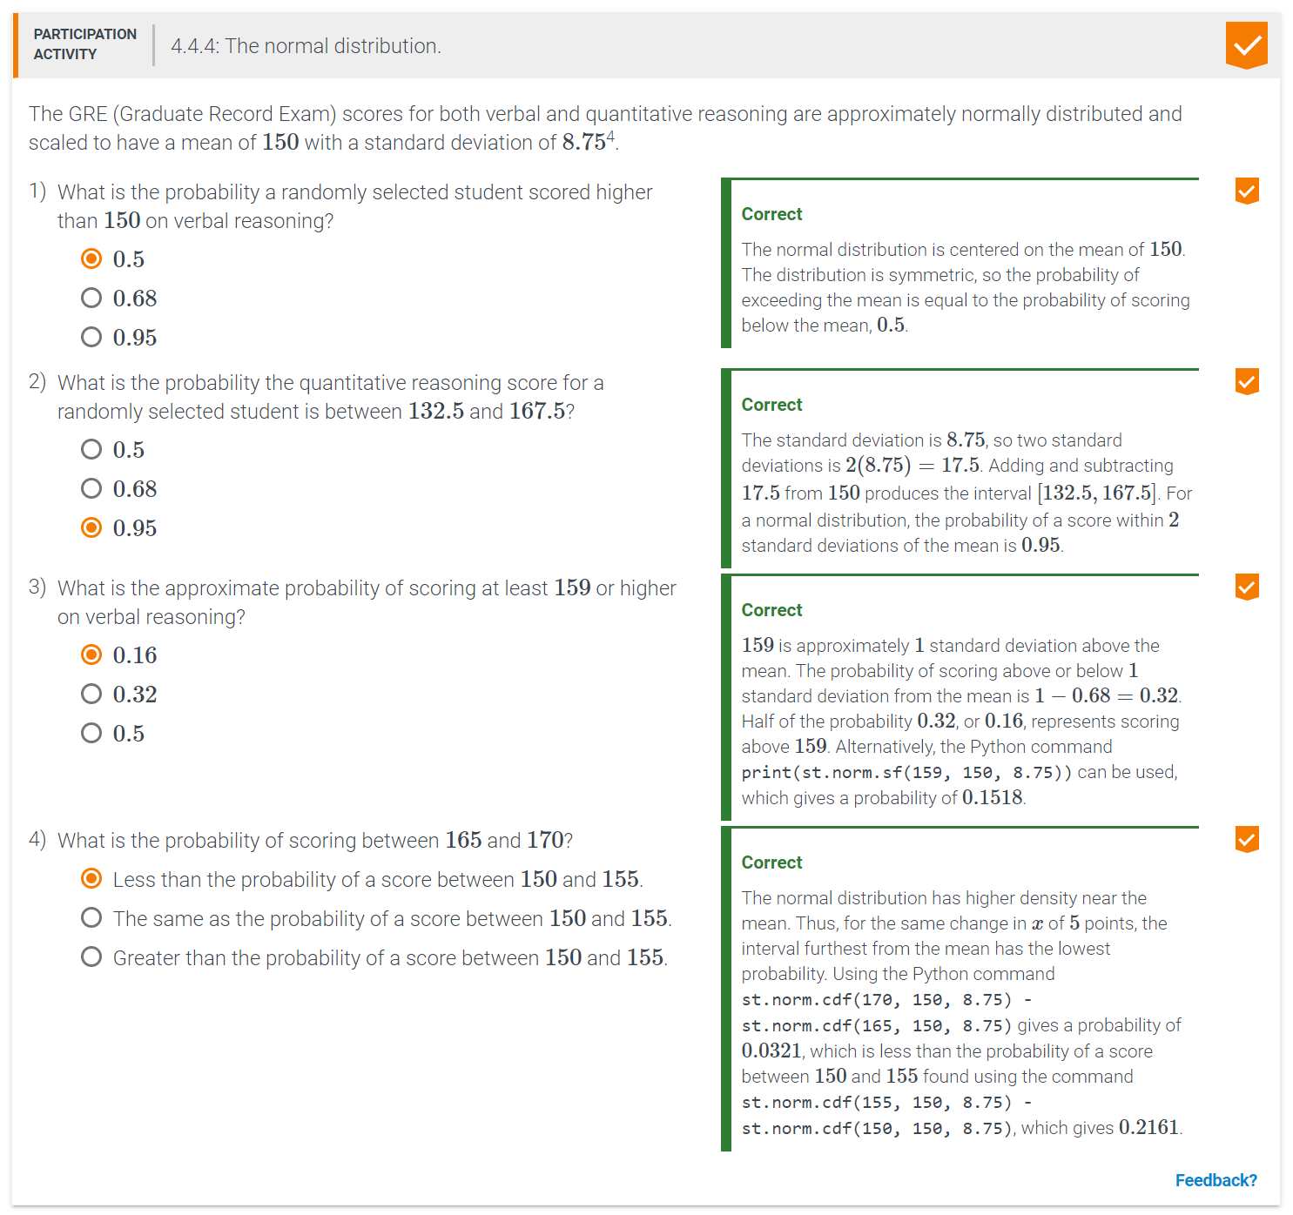

Python-Function 4.4.2: norm.ppf() and norm.isf().

The norm.ppf() and norm.isf() functions are used to convert percentiles to zz-scores. The scipy.stats library must be imported to use these functions.

norm.ppf(p, mean, sd) returns the critical zz-score for which the probability of zz being below that zz-score is p, for a normal distribution with the specified mean and standard deviation.

|  |  |
| --- | --- |
| **import** scipy.stats as st  # For a normal distribution, if the mean is 0 and  # the standard deviation is 1, what is z* if P(z < z*) = 0.135?  **print**(st.norm.ppf(0.135, 0, 1)) | -1.1030625562 |

norm.isf(p, mean, sd) returns the critical zz-score for which the probability of zz being above that zz-score is p, for a normal distribution with the specified mean and standard deviation.

|  |  |
| --- | --- |
| # For a normal distribution, if the mean is 0 and  # the standard deviation is 1, what is z* if P(z > z*) = 0.405?  **print**(st.norm.isf(0.405, 0, 1)) | 0.240426031142 |

Both norm.ppf() and norm.isf() can also be used with non-standard normal distributions.

|  |  |
| --- | --- |
| # For a normal distribution, if the mean is 55 and  # the standard deviation is 7.5, what is x* if P(x < x*) = 0.8247?  **print**(st.norm.ppf(0.8247, 55, 7.5))  # For a normal distribution, if the mean is 55 and  # the standard deviation is 7.5, what is x* if P(x > x*) = 0.95?  **print**(st.norm.isf(0.95, 55, 7.5)) | 62.0006958915  42.6635977979 |

[Run example](https://trinket.io/python3/d68eb97bac)

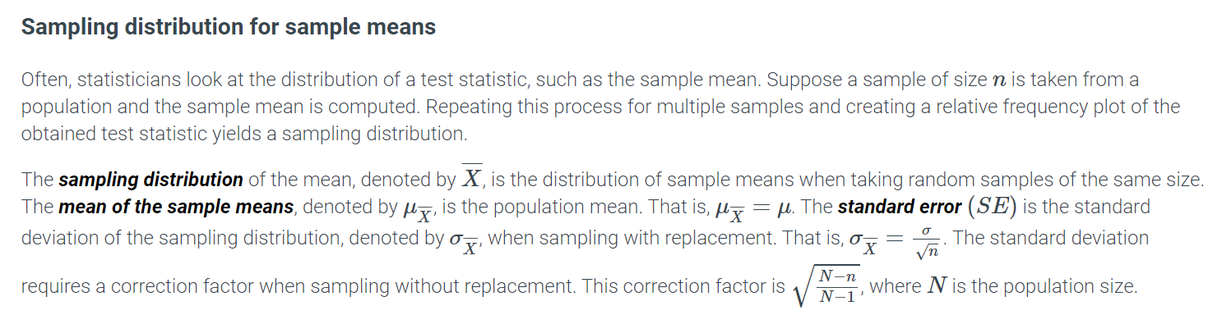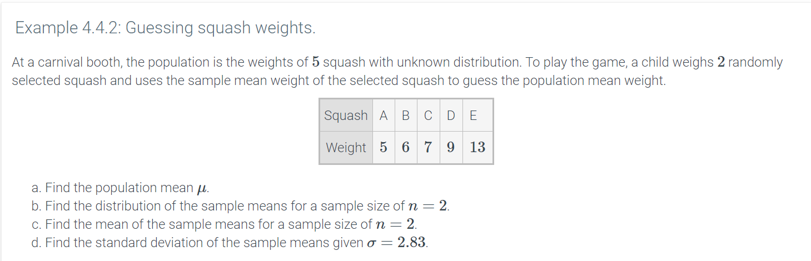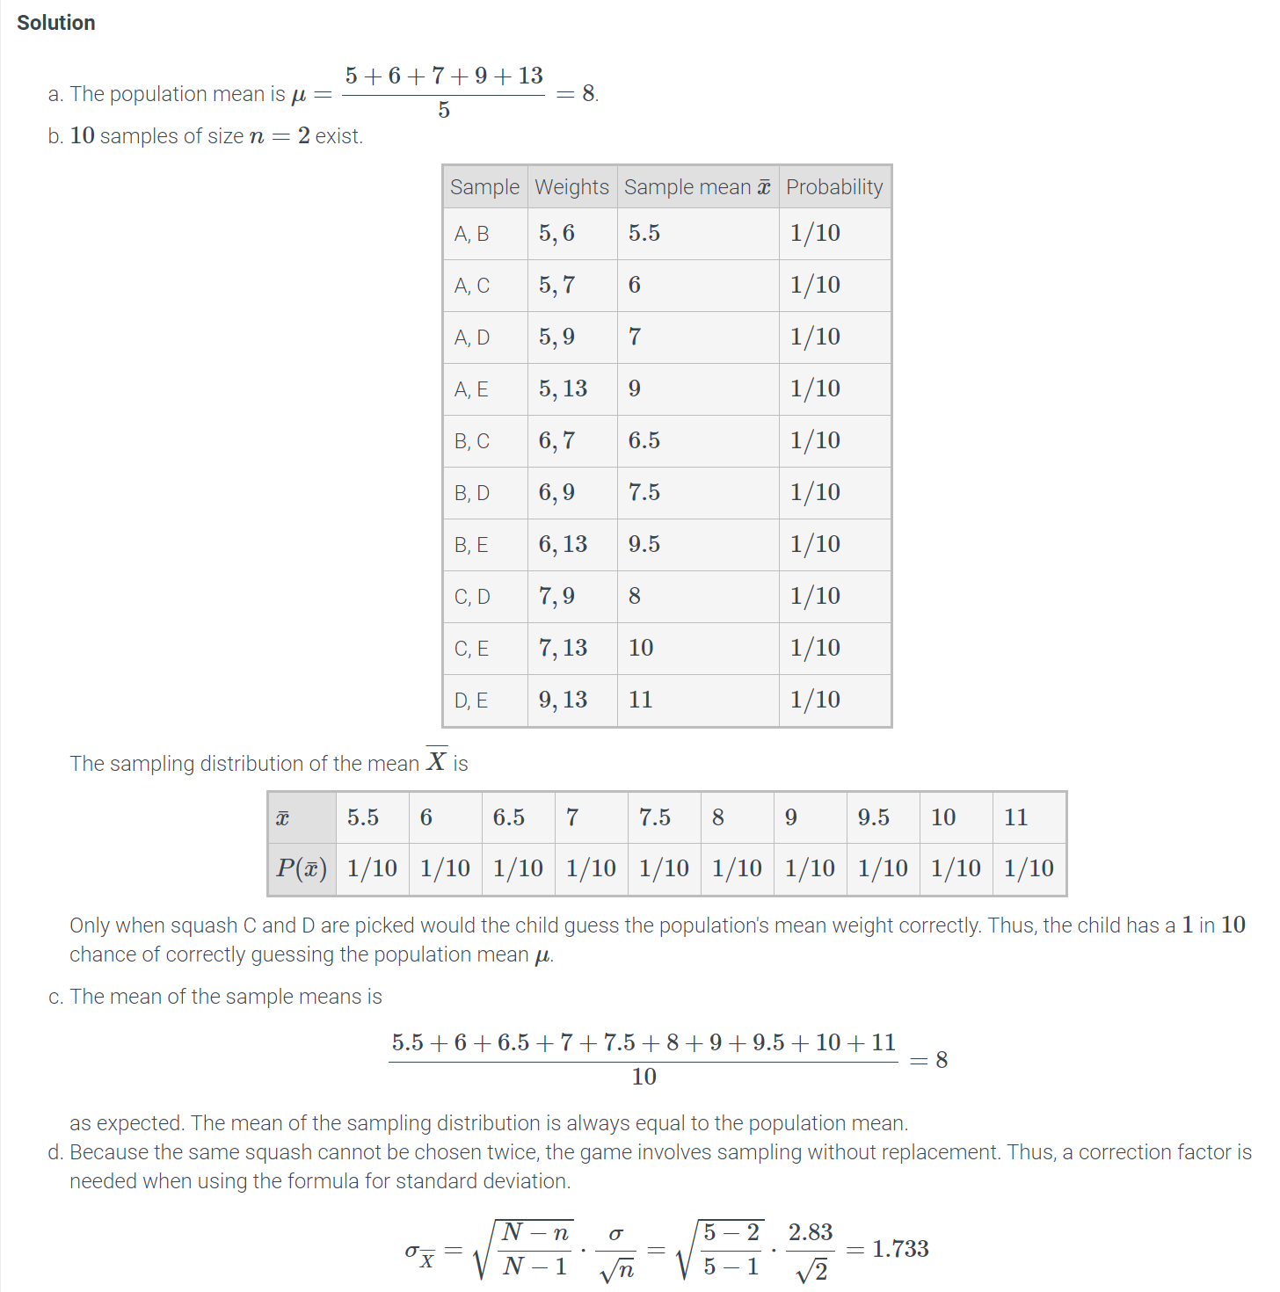

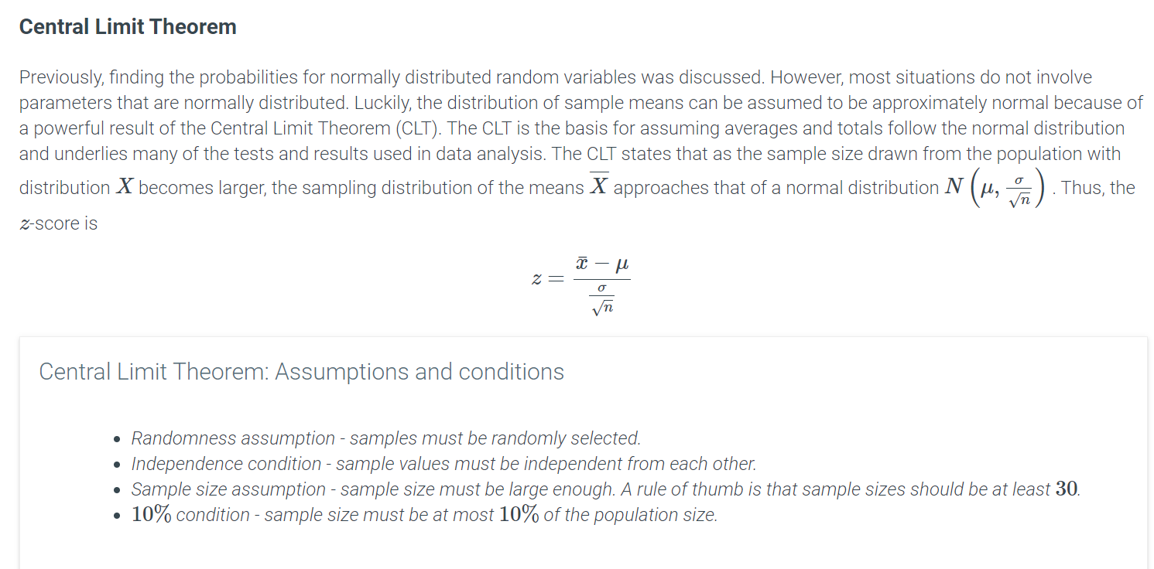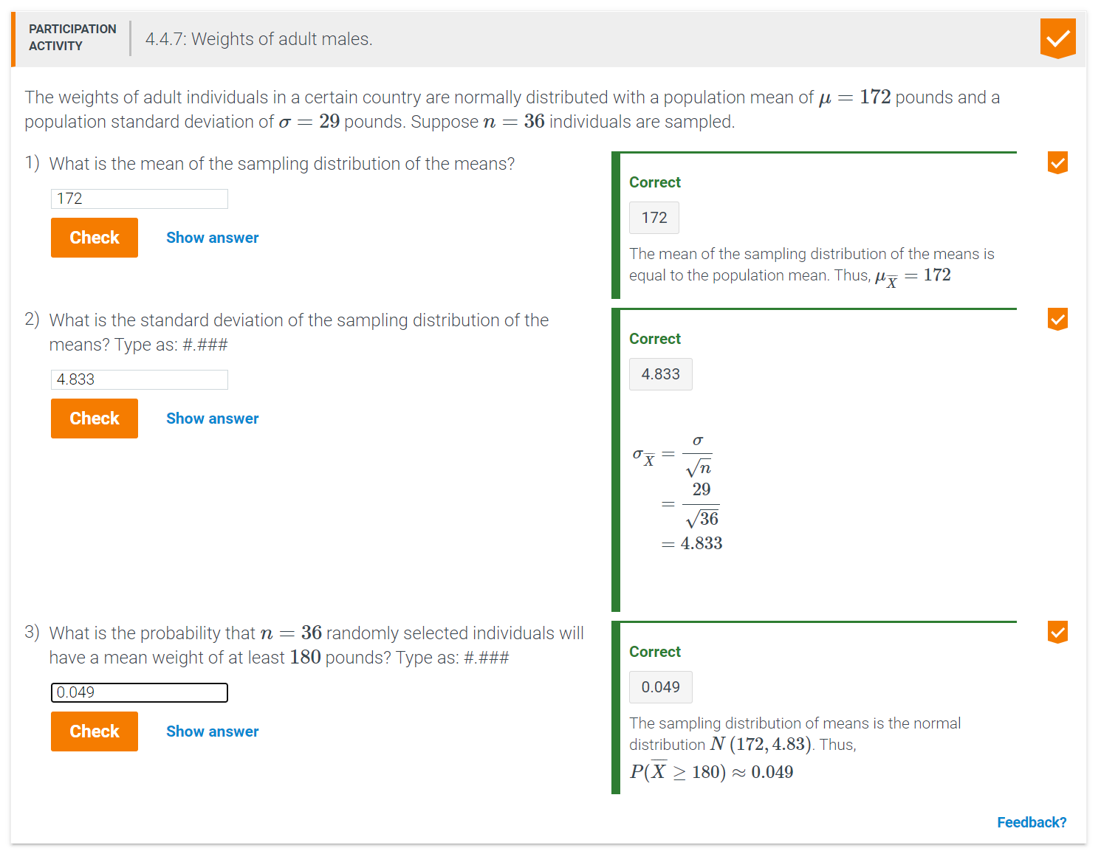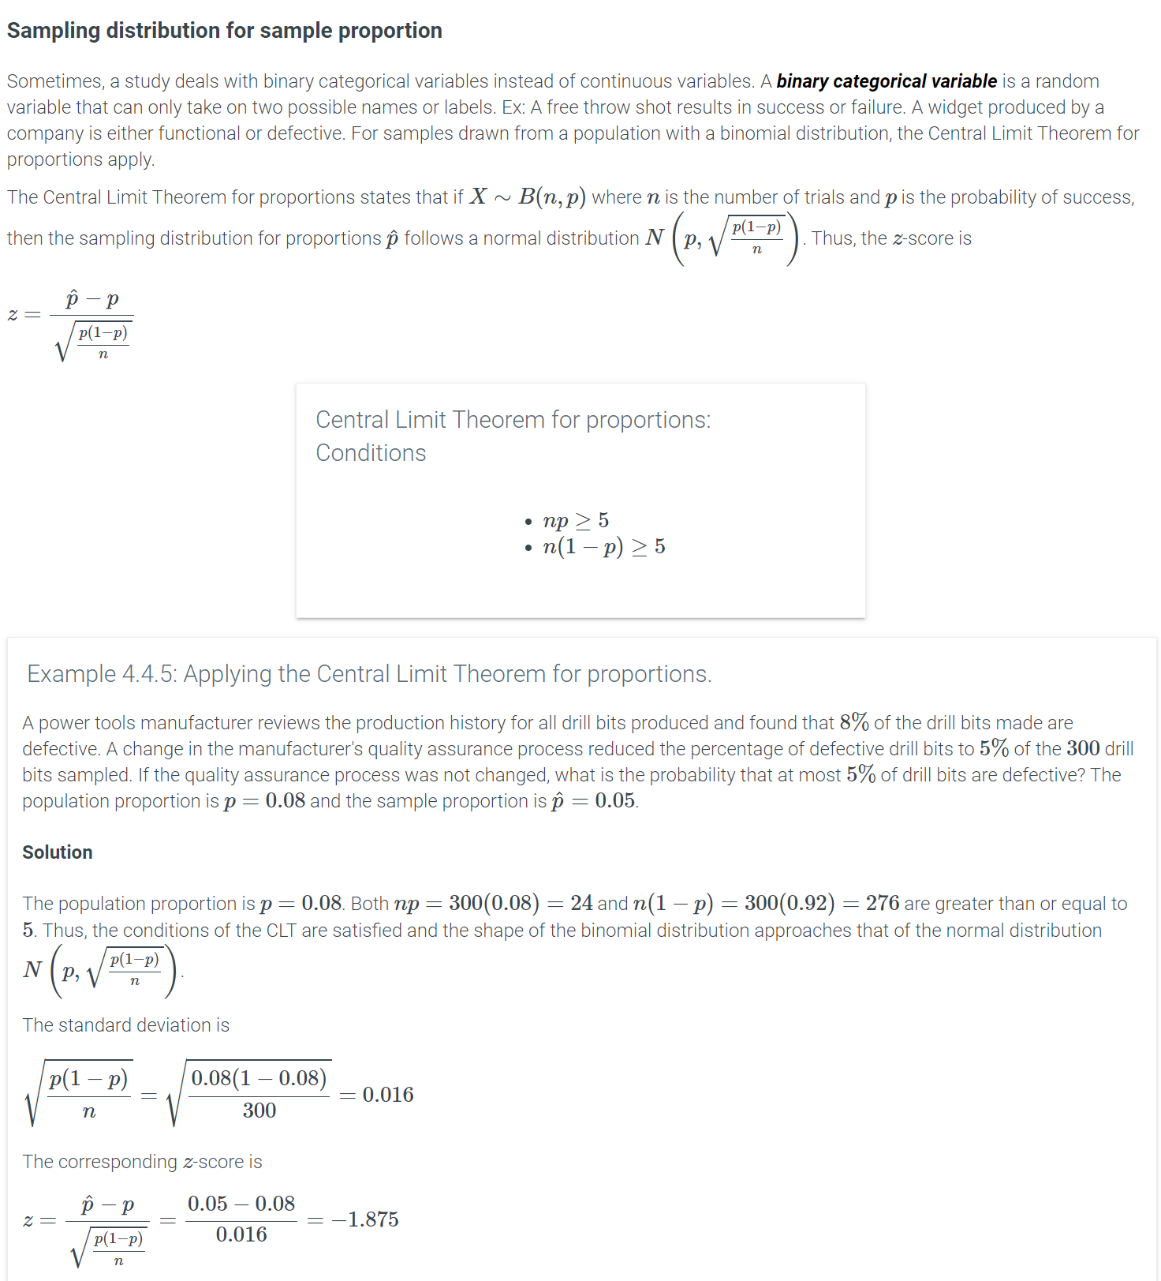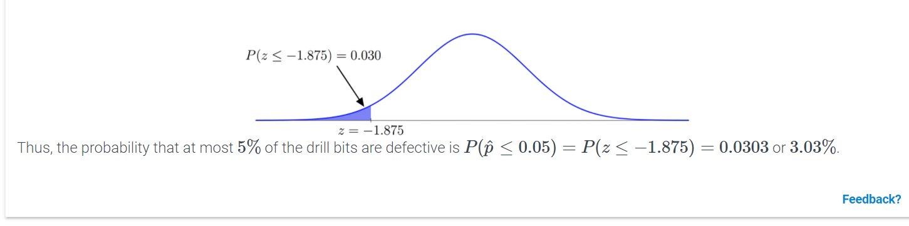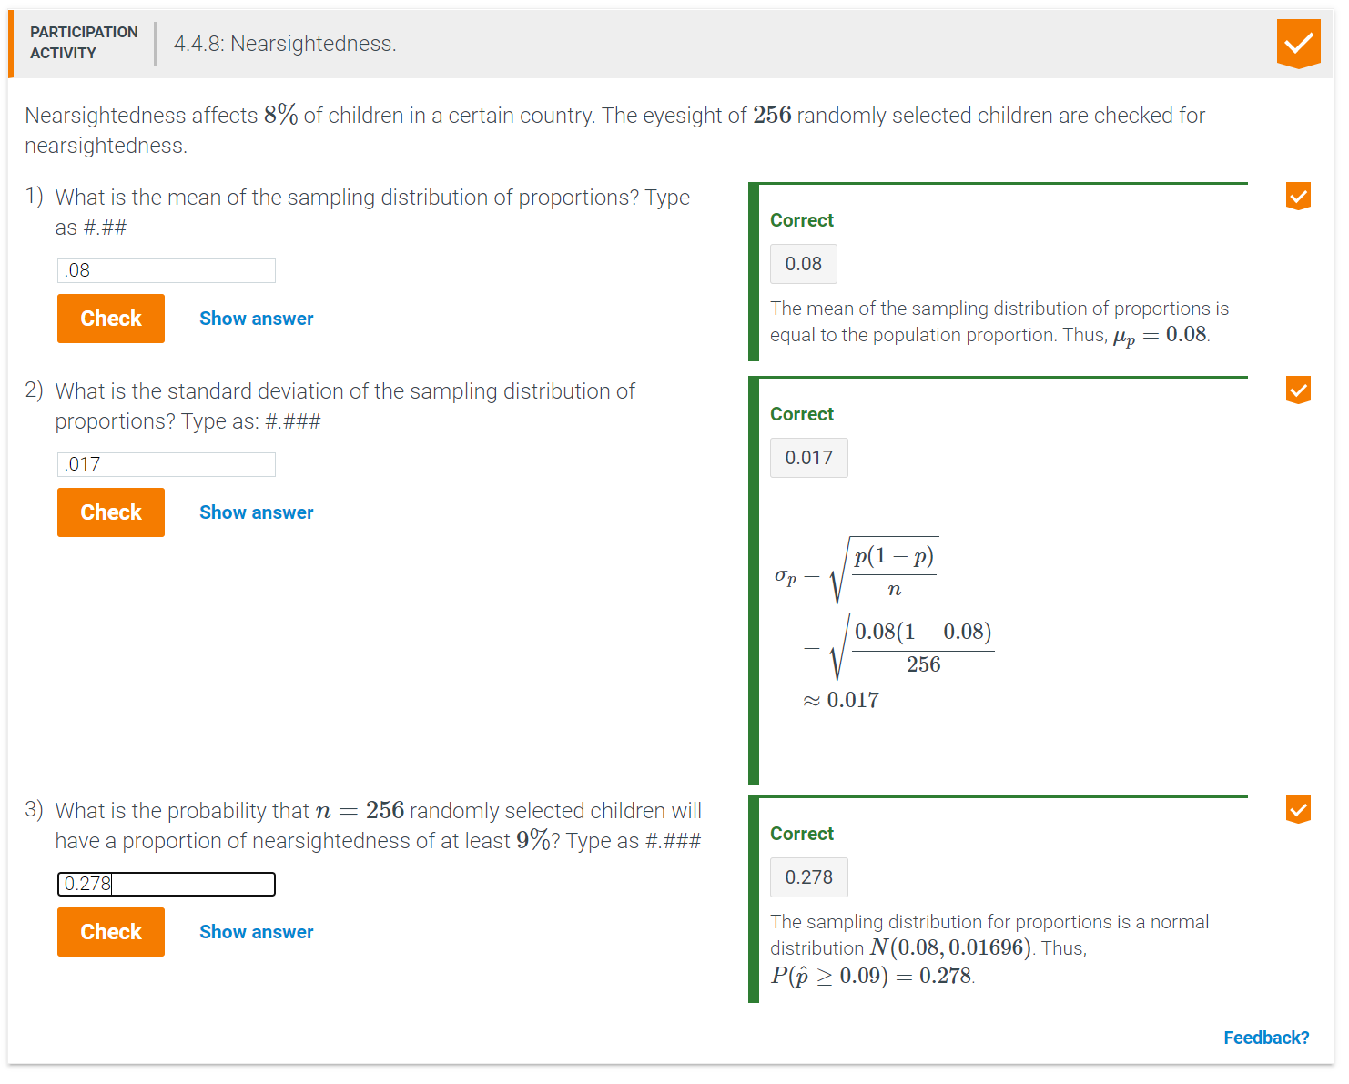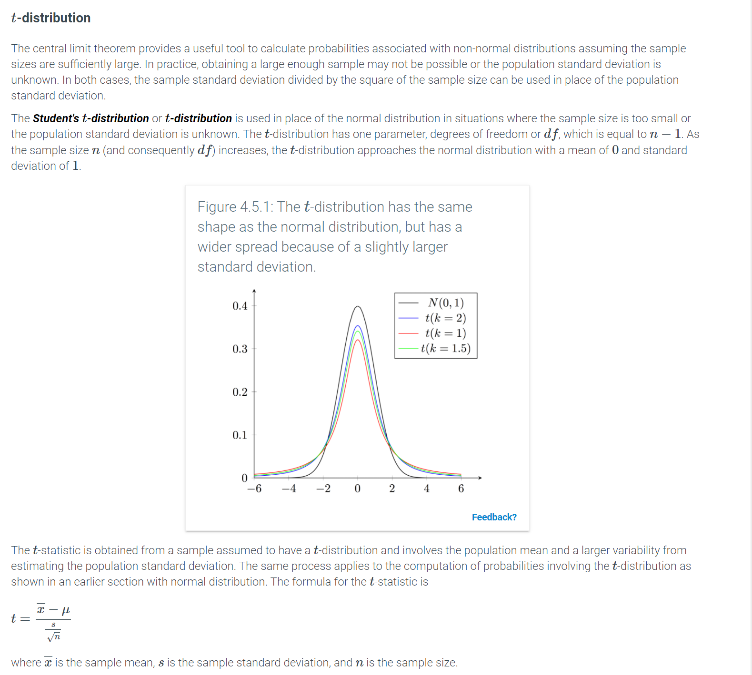Python-Function 4.5.1: t.cdf() and t.sf().

The t.cdf() and t.sf() functions are used to find probabilities related to the tt-distribution. The scipy.stats library must be imported to use these functions.

t.cdf(t, df, mean, sd) returns the probability of tt being less than the critical value tt for a tt-distribution with the specified degrees of freedom, mean, and standard deviation.

|  |  |
| --- | --- |
| **import** scipy.stats as st  # For a t-distribution, if the degrees of freedom is 30, the mean is 0,  # and the standard deviation is 1, what is P(t < -0.25)?  **print**(st.t.cdf(-0.25, 30, 0, 1))  # For a t-distribution, if the degrees of freedom is 30, the mean is 0,  # and the standard deviation is 1, what is P(t < 1.5)?  **print**(st.t.cdf(1.5, 30, 0, 1)) | 0.40214570454  0.927967035436 |

t.sf(t, df, mean, sd) returns the probability of tt being greater than the critical value tt for a tt-distribution with the specified degrees of freedom, mean, and standard deviation.

|  |  |
| --- | --- |
| **import** scipy.stats as st  # For a t-distribution, if the degrees of freedom is 30, the mean is 0,  # and the standard deviation is 1, what is P(t > -0.25)?  **print**(st.t.sf(-0.25, 30, 0, 1))  # For a t-distribution, if the degrees of freedom is 30, the mean is 0,  # and the standard deviation is 1, what is P(t > 1.5)?  **print**(st.t.sf(1.5, 30, 0, 1)) | 0.59785429546  0.0720329645643 |

To find the probability between two critical values, the difference between the two probabilities is calculated.

|  |  |
| --- | --- |
| **import** scipy.stats as st  # For a t-distribution, if the degrees of freedom is 30, the mean is 0,  # and the standard deviation is 1, what is P(-0.25 < t < 1.5)?  **print**(st.t.cdf(1.5, 30, 0, 1) - st.t.cdf(-0.25, 30, 0, 1))  # For a t-distribution, if the degrees of freedom is 30, the mean is 0,  # and the standard deviation is 1, what is P(1.5 < t < 2.85)?  **print**(st.t.cdf(2.85, 30, 0, 1) - st.t.cdf(1.5, 30, 0, 1)) | 0.525821330895  0.0681176765133 |

Both t.cdf() and t.sf() can also be used for tt-distributions with different degrees of freedom and when the mean is not 00 or the standard deviation is not 11.

|  |  |
| --- | --- |
| **import** scipy.stats as st  # For a t-distribution, if the degrees of freedom is 59, the mean is 55,  # and the standard deviation is 7.5, what is P(t < 62)?  **print**(st.t.cdf(62, 59, 55, 7.5))  # For a t-distribution, if the degrees of freedom is 34, the mean is 55,  # and the standard deviation is 7.5, what is P(t > 51)?  **print**(st.t.sf(51, 34, 55, 7.5))  # For a t-distribution, if the degrees of freedom is 59, the mean is 55,  # and the standard deviation is 7.5, what is P(49 < t < 60)?  **print**(st.t.cdf(60, 59, 55, 7.5) - st.t.cdf(49, 59, 55, 7.5)) | 0.82277404211  0.701363849613  0.532747974268 |

[Run example](https://trinket.io/python3/c10aeb5ca4)

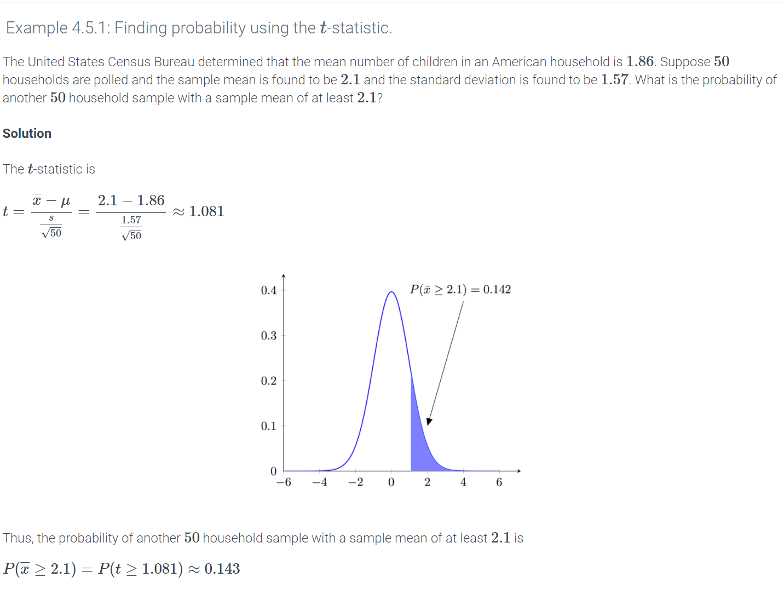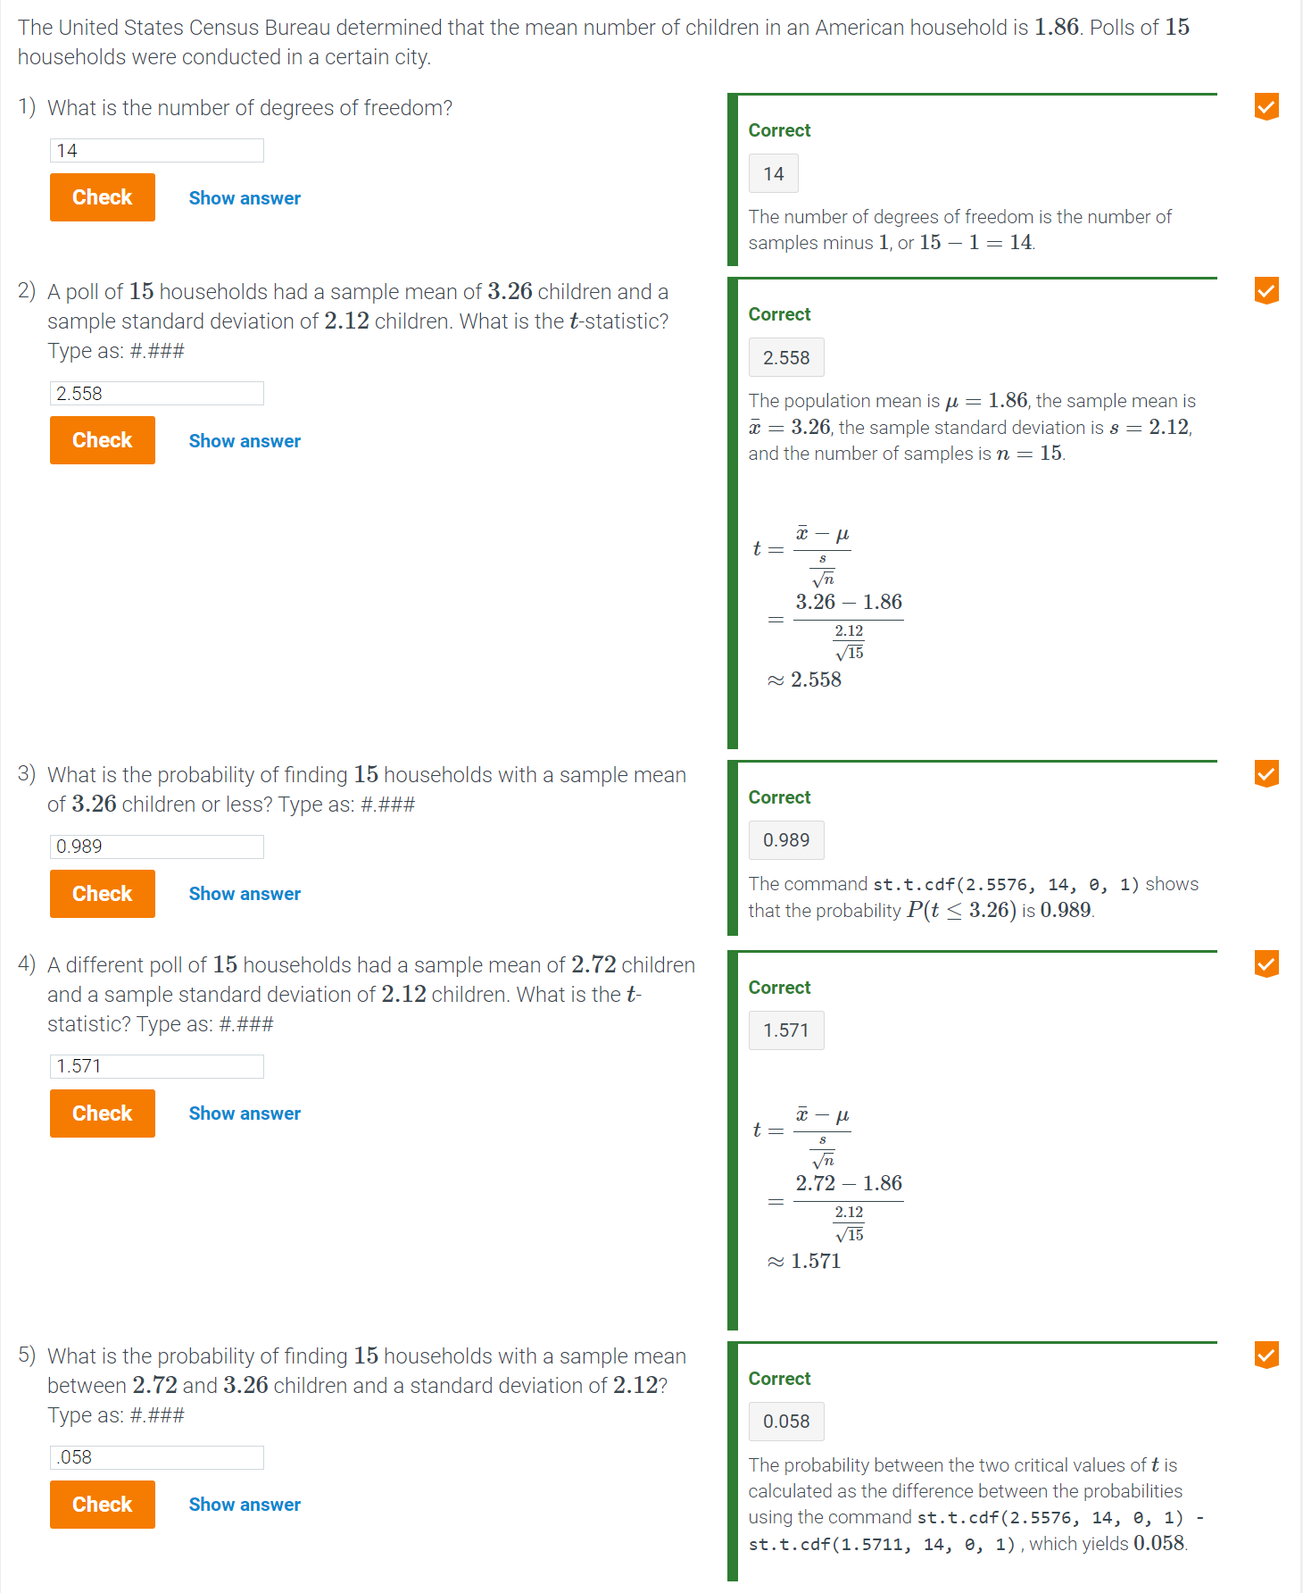

### Estimation and confidence intervals

***Estimation*** is the process of obtaining information about a parameter by using a statistic. An ***estimator*** is a statistical method used to calculate an estimate based on observable data. A good estimator gives estimates that are both accurate and precise. Accuracy is measured in terms of bias. Numerically, bias is the distance between the mean of the sampling distribution and the population mean. Precision is measured in terms of standard error.

1. Accuracy is a measure of closeness to the true value of a parameter. Precision is a measure of closeness to the average value of the measurements.
2. Measurements that are neither accurate nor precise are neither close to the true value nor tightly clustered.
3. Measurements that are accurate but not precise are loosely spread out around the true value.
4. Measurements that are precise but not accurate are tightly clustered around an incorrect value.
5. Measurements that are both accurate and precise are tightly clustered around the true value.

Two types of estimates exist: point estimates and interval estimates. A ***point estimate*** is a single value estimate for a parameter. An ***interval estimate*** is a range of values that is likely to contain the parameter being estimated. Combined with a probability statement, an interval estimate is called a ***confidence interval***. The percentage in which the confidence interval contains the parameter is called the ***confidence level***, which is denoted by c.

A confidence interval is ***accurate*** if the confidence interval contains the true population parameter. A confidence interval's ***precision*** refers to the width of the confidence interval.

A confidence interval is constructed by looking at the sample statistic and margin of error. A ***margin of error***, denoted by m, is the range of values above and below the point estimate. Numerically,

m=(critical value)(standard error)

where the critical value, which depends on c and the underlying distribution of the statistic, is the number of standard errors to be added to the point estimate. Thus,

estimate±m=estimate±(critical value)(standard error)

The resulting interval is referred to as the c(100)% confidence interval. That is, c(100)% of the time, the true value of the population parameter will be in the c(100)% confidence interval when the same estimator is used, as shown in the animation below.

Example 5.1.1: How millennials acquire news.

A survey by the Media Insight Project asked a random sample of 1,045 American adults between the ages of 18 and 34 questions about technology use when acquiring news and frequency1. The results of the survey have a margin of error of ±3.8 percentage points.

|  |  |
| --- | --- |
| Percent of millennials who ... | |
| Say keeping up with the news is at least somewhat important | 85% |
| Get news daily | 69% |
| Regularly follow five or more 'hard' news topics | 45% |
| Usually see diverse opinions through social media | 86% |
| Pay for at least one news-specific service, app, or digital subscription | 40% |

1. What is the point estimate for the percent of millennials who get their news daily?
2. What is the 95% confidence interval for the percent of millennials who get their news daily?
3. What is the interpretation of this interval?

**Solution**

1. 69%
2. 69%±3.8%
3. A 95% confidence exists that the true population percentage of millennials who get news daily is between 65.2% and 72.8%. The 95% represents the probability that the true population percentage is contained in a confidence interval if the estimator is used repeatedly.

### Z confidence intervals

Choosing an appropriate estimator for the population mean μ depends on what is known about the population. Although the population mean is usually unknown, the confidence interval that quantifies the range within which the true population mean lies can be calculated by sampling the population. Ex: A 95% confidence interval means that the interval calculated has a 95% probability of containing the population mean. If such a population is sampled 20 times, 19 of the 20 calculated intervals are expected to contain the population mean.

The critical values z∗ for common confidence levels are shown in the following table.

Table 5.2.1: Critical values for common confidence levels.

|  |  |
| --- | --- |
| Confidence level | Critical value |
| c=0.90 | z∗=1.645 |
| c=0.95 | z∗=1.960 |
| c=0.99 | z∗=2.576 |

Feedback?

Example 5.2.1: Confidence interval for the mean final grade.

Suppose the mean final grade is estimated for all introductory statistics classes taught at a particular college. The population standard deviation is 4. The final grades for a randomly selected statistics class with 9 people are: 76, 80, 82, 83, 83, 85, 85, 87, and 88. Find the 95% confidence interval for the mean final grade.

#### Solution

The sample mean is

x¯=76+80+82+83+83+85+85+87+889=83.222

At the 95% confidence level, the margin of error is

z∗=1.960z∗σn=1.96049≈2.613

Thus, the 95% confidence interval is [83.222−2.613,83.222+2.613]=[80.609,85.835].

#### Analysis

The population mean final grade is generally unknown. The obtained interval means that a 95% confidence exists that [80.609,85.835] contains the true population mean final grade.

### Python-Function 5.2.1: norm.interval().

The norm.interval() function is used to find a confidence interval for a normally distributed variable. The function takes the desired confidence level, the sample mean, and the standard error as parameters.

|  |  |
| --- | --- |
| **import** scipy.stats as st  **print**(st.norm.interval(0.95, 0, 1)) | (-1.959963984540054, 1.959963984540054) |

A confidence interval can also be calculated from raw data. The following example imports data from ExamScores.csv into a DataFrame, calculates the sample mean, calculates the standard error based on a given population standard deviation, and calculates the 99% confidence interval.

|  |  |
| --- | --- |
| scores = pd.read_csv('http://data-analytics.zybooks.com/ExamScores.csv')  sigma = 2.5  mean = scores['Exam1'].mean()  stderr = sigma/math.sqrt(len(scores['Exam1']))  **print**(st.norm.interval(0.99, mean, stderr)) | (81.78930681614078, 83.610693183859226) |

### Margin of error and sample size for means when **σ** is known

The width of the confidence interval is twice the margin of error. Recall that the margin of error depends on the confidence level and the standard error. Thus, given a confidence level, the width of the confidence interval changes by changing the standard error. Increasing the sample size decreases the standard error. Similarly, decreasing the sample size increases the standard error. The size of the sample needed to guarantee a confidence interval with a specified margin of error is given by the formula

n=(z∗σm)2

Example 5.2.2: Microbeads in a water reservoir.

Scientists study the amount of microbeads (in μg/liter) in a water reservoir. The scientists need to know how many water samples should be taken to be 95% sure that their estimate x¯ differs from the actual value μ by at most 0.8 μg/liter given a population standard deviation of σ=2.5 μg/liter. How many water samples should the scientists take?

#### Solution

The margin of error is m=0.8 and the population standard deviation is σ=2.5. Since the confidence level is 95%, the critical value is z∗=1.960. Using the formula above,

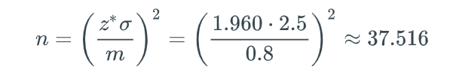Thus, the scientists should take at least 38 water samples.

### confidence intervals

The confidence interval for a population mean is defined as

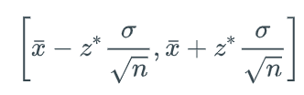

In practice, however, the population standard deviation is rarely known. Thus, confidence intervals using the t-distribution are more useful because the sample standard deviation can always be computed.

The t-confidence interval is given by

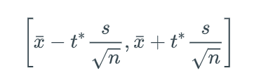

where t∗ is the critical value that depends on the degrees of freedom and significance level. The values for common significance levels given selected degrees of freedom are shown in the table below.

Table 5.2.2: Critical values t∗ for selected degrees of freedom df and significance level α.

|  |  |  |  |
| --- | --- | --- | --- |
|  | α=0.1 | α=0.05 | α=0.01 |
| df=5 | 2.015 | 2.571 | 4.032 |
| df=10 | 1.812 | 2.228 | 3.169 |
| df=15 | 1.753 | 2.131 | 2.947 |
| df=24 | 1.711 | 2.064 | 2.797 |

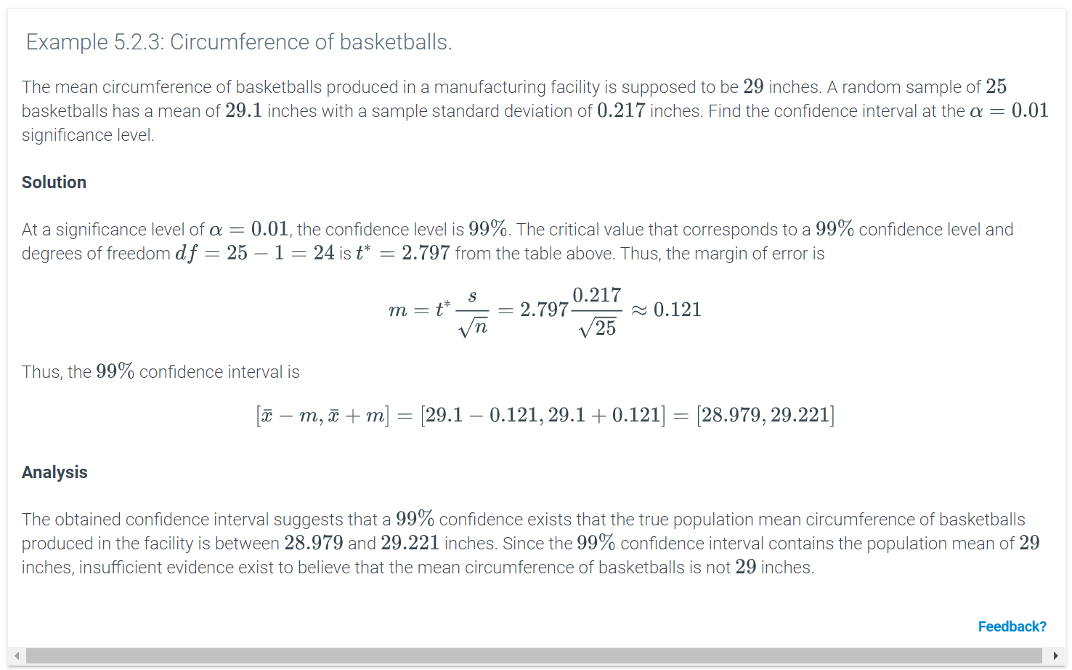

Python-Function 5.2.2: t.interval().

The t.interval() function is used to find a confidence interval for a variable with a t-distribution. The function takes the desired confidence level, the degrees of freedom, the mean, and the standard error as parameters.

In the following example, the degrees of freedom and standard error are calculated from the number of samples and the standard deviation given in a data summary.

|  |  |
| --- | --- |
| **import** scipy.stats as st  n = 100  # Degrees of freedom is number of samples minus 1  df = n - 1  mean = 219  # The standard error is standard deviation/sqrt(number of samples)  stderr = 35.0/(n ** 0.5)  **print**(st.t.interval(0.95, df, mean, stderr)) | (212.05524066971961, 225.94475933028039) |

A confidence interval can also be calculated from raw data. The following example imports data from ExamScores.csv into a DataFrame and finds the confidence interval.

|  |  |
| --- | --- |
| **import** pandas as pd  **import** scipy.stats as st  scores = pd.read_csv('http://data-analytics.zybooks.com/ExamScores.csv')  # Let n be the number of students who took Exam 1.  n = scores[['Exam1']].count()  # Degrees of freedom is number of samples minus 1  df = n - 1  # The mean of Exam1 scores are obtained  mean = scores[['Exam1']].mean()  # The standard error is standard deviation/sqrt(number of samples)  stdev = scores[['Exam1']].std()  stderr = stdev/(n ** 0.5)  **print**(st.t.interval(0.95, df, mean, stderr)) | (array([ 80.05931209]), array([ 85.34068791])) |

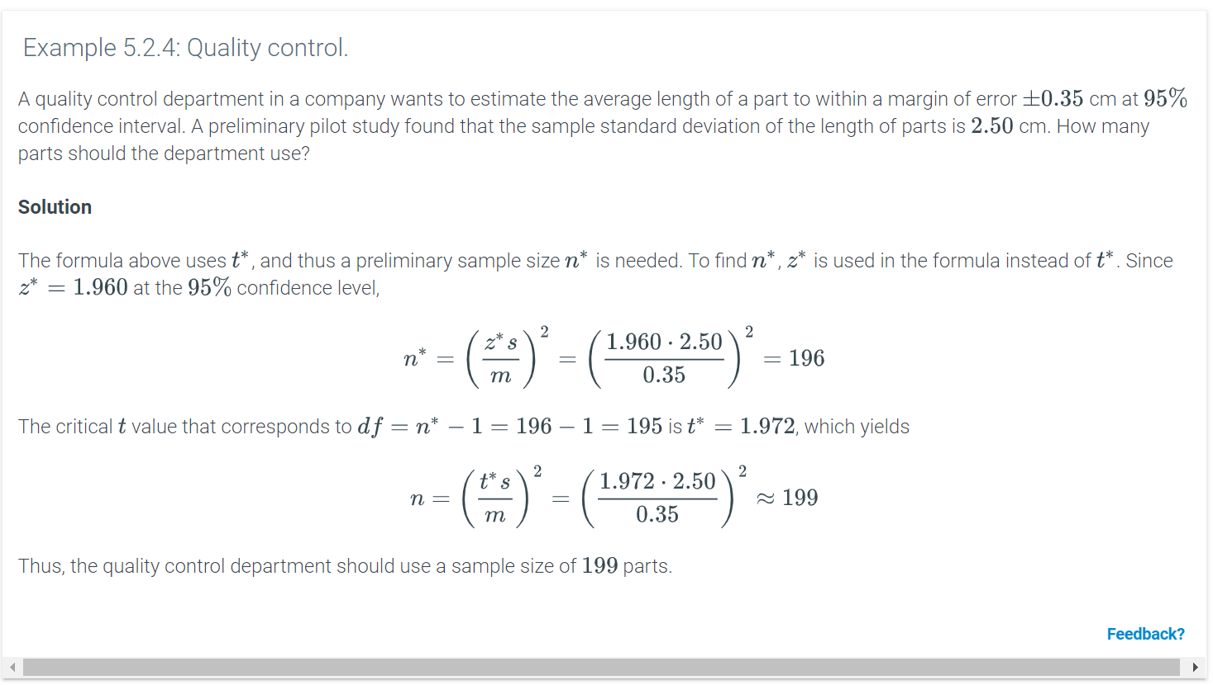

### Confidence interval for population proportions

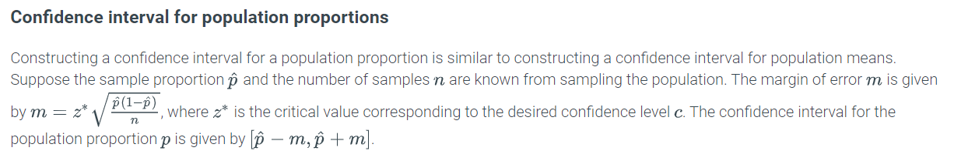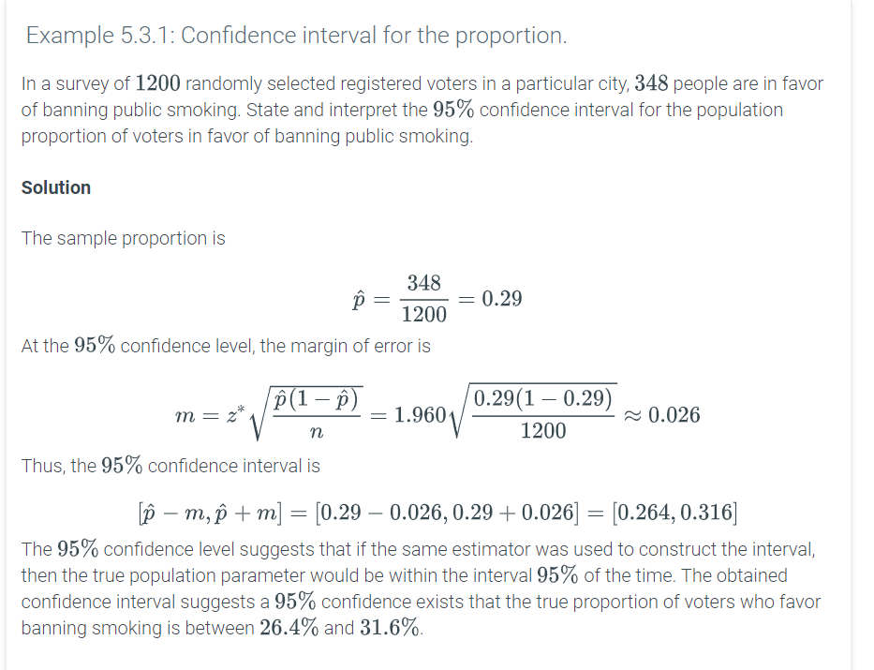

Python-Function 5.3.1: norm.interval().

The norm.interval() function can also be used to find the confidence interval for population proportion. In the following example, the standard error is calculated from the number of samples and the proportion given in a data summary and the result is used as input in the norm.interval() function.

|  |  |
| --- | --- |
| # In a survey of 1200 randomly selected registered voters,  # 348 were in favor of banning public smoking. Find the 95%  # conﬁdence interval for the proportion of voters in favor  # of banning public smoking.  **import** scipy.stats as st  # Let n be the number of voters surveyed.  n = 1200  # Let p be the proportion of voters that voted in favor  p = 348.0/1200.0  # The standard error is sqrt(p * (1-p)/n)  stderr = (p * (1 - p)/n) ** 0.5  **print**(st.norm.interval(0.95, p, stderr)) | (0.26432646675431226, 0.3156735332456877) |

A confidence interval can also be calculated from raw data. The following example imports data from ExamScores.csv into a DataFrame, filters based on a minimum score, and finds the confidence interval.

|  |  |
| --- | --- |
| # In the Exam Scores data set, find a 99% confidence interval  # for the proportion of students who scores more than 90 in Exam 1.  **import** pandas as pd  **import** scipy.stats as st  scores = pd.read_csv('http://data-analytics.zybooks.com/ExamScores.csv')  # Let n be the number of students who took Exam 1.  n = scores[['Exam1']].count()  # Let x be the total of all Exam 1 scores greater than 90  x = (scores[['Exam1']] > 90).values.sum()  # Let p be x/n, the proportion of all students that scored over 90 on Exam 1  # Multiplying by 1.0 is needed for correct floating point arithmetic  p = x/n*1.0  # The standard error is sqrt(p * (1-p)/n)  stderr = (p * (1 - p)/n) ** 0.5  **print**(st.norm.interval(0.99, p, stderr)) | (array([ 0.02645375]), array([ 0.29354625])) |

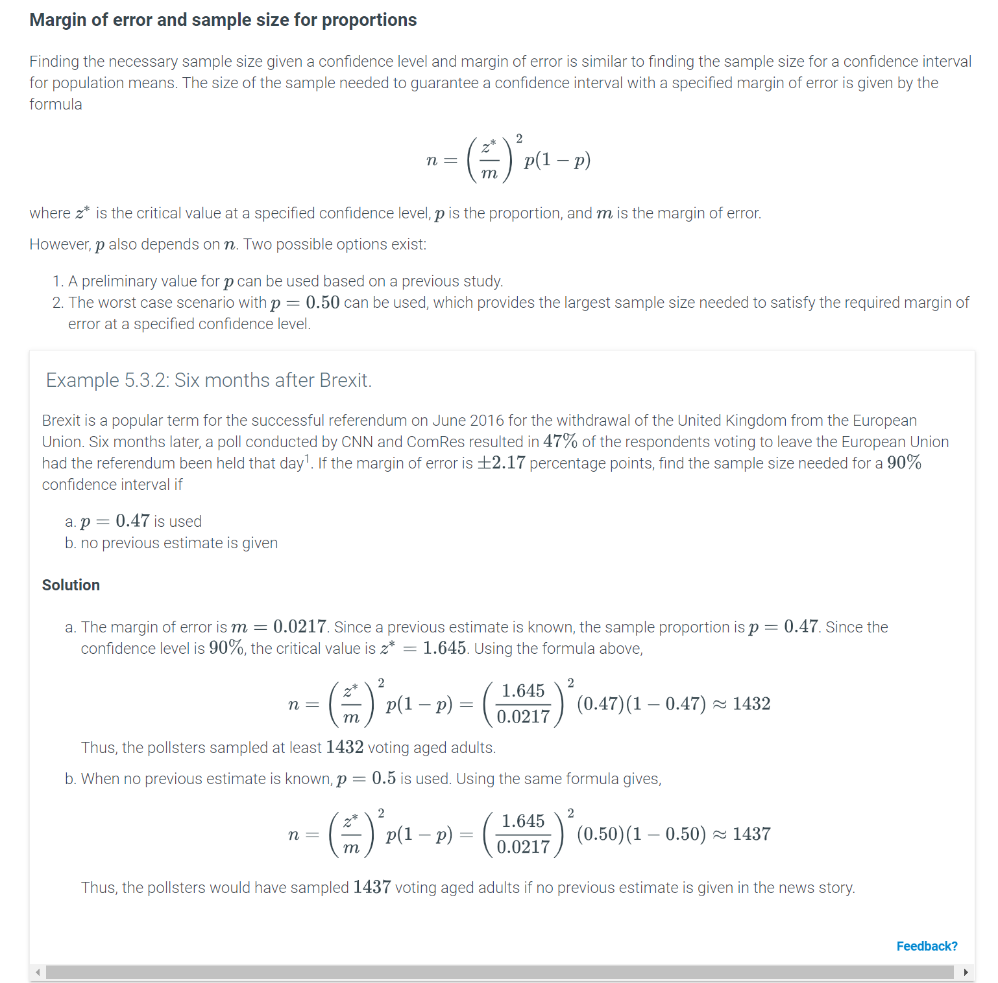

### Hypothesis

A ***hypothesis*** is a proposed explanation of a phenomenon, usually as a starting point for further analysis. Ex: If a lamp doesn't illuminate when turned on, one hypothesis is: "Lamp is not plugged in". Subsequent analysis may result in rejecting the hypothesis. Ex: Observing the lamp is indeed plugged into an electric outlet causes one to reject the "Lamp is not plugged in" hypothesis.

### Null and alternative hypotheses

In statistics, a ***hypothesis*** is a statement that makes a claim about the parameters of one or more populations. ***Hypothesis testing*** is the formal process by which a hypothesis is retained or rejected. Hypothesis testing compares two competing hypotheses about a population, the null hypothesis and the alternative hypothesis.

A ***null hypothesis***, denoted H0, is a statement assumed to be true unless sufficient data indicates otherwise. Typically, a null hypothesis is a statement of equality between the true value of the population parameter and the hypothesized value or a statement of no difference between the parameters of two populations. Ex: The statement "The average salary of the residents of San Francisco is not different than the average salary of the residents of Austin" or "The average salary of the residents of San Francisco is the same as the average salary of the residents of Austin" is a null hypothesis.

In contrast, an ***alternative hypothesis***, denoted Ha, is a statement that contradicts H0. Typically, an alternative hypothesis asserts that the true value of the population parameter is not the same as the hypothesized value or that the parameters for two populations are different. Ex: The alternative hypothesis corresponding to the null hypothesis above is "The average salary of the residents of San Francisco is different from the average salary of the residents of Austin, Texas."

An alternative hypothesis may be left-tailed, right-tailed, or two-tailed depending on the nature of the difference from the null hypothesis.

* A left-tailed alternative hypothesis asserts that the value of a parameter is less than the value asserted in the null hypothesis.
* A right-tailed alternative hypothesis asserts that the value of a parameter is greater than the value asserted in the null hypothesis.
* A two-tailed alternative hypothesis asserts that the value of a parameter is not equal to, that is, either less than or greater than the value asserted in the null hypothesis.

Example 5.4.1: Null hypothesis and alternative hypothesis.

Identify the type of each alternative hypothesis and state the corresponding null hypothesis.

1. The average time spent sitting at a particular company's office is not 5.7 hours.
2. Patients given a drug recover from a disease in less time than patients not given the drug.

#### Solution

1. The alternative hypothesis asserts that a parameter is not equal to a value and is thus a two-tailed alternative hypothesis. The corresponding null hypothesis is "The average time spent sitting at a particular company's office is 5.7 hours".
2. The alternative hypothesis asserts that a parameter is less than a value and is thus a left-tailed hypothesis. The corresponding null hypothesis is "Patients given a drug recover from the disease in the same amount of time as or more time than patients not given the drug".

Feedback?

Example 5.4.2: Do non-smokers earn more than smokers?

Among Northern California's unemployed, 60 non-smokers and 29 smokers were surveyed after getting jobs, and those two samples' mean salaries were $32,000 and $24,000, respectively. Researchers posed two hypotheses:

* (Null hypothesis) H0 : Non-smokers do NOT earn more than smokers.
* (Alternative hypothesis) Ha: Non-smokers earn more than smokers.

Through analysis of data, the researchers rejected the null hypothesis (do not earn more); the large salary difference among the two samples is unlikely explainable by chance. The researchers favored the alternative hypothesis, that non-smokers do earn more.1 Note that the study makes no claim that smoking *causes* lower salary; for example, smokers might have another trait that causes both lower salary and smoking.



### Comparative experiments

Sometimes a person creates hypotheses and analyzes existing data, such as examining U.S. Census Bureau data to compare employment statistics between 1970 and 2010. However, other times a person poses a hypothesis and then conducts a study to generate data to be analyzed. In one kind of study, the sample is divided into a ***treatment group*** who was given a treatment being studied (like doing daily exercise), and a ***control group*** who was not (like not doing daily exercise), with individuals randomly assigned to a group.

### Test statistic

Sufficient data from samples of populations are needed to test a hypothesis. Ex: If the average salary of a sample of 50 people from San Francisco is $105,200 and the average salary of a sample of 40 people from Austin is $98,700, no decision can be immediately made about the null hypothesis. Factors such as the sampling method, the sample size, and the magnitude of the difference in the average salary affect whether the hypothesis should be rejected. In addition, the observed difference in average salary may be due to chance.

The central goal of hypothesis testing is to determine whether H0 can be rejected in favor of Ha or whether H0 fails to be rejected based on evidence in the form of sample data. A ***test statistic*** is a value calculated from sample data during hypothesis testing that measures the degree of agreement between the sample data and the null hypothesis. Mathematically, the test statistic is the difference between the estimate and the value asserted in the null hypothesis divided by the standard error.

Common hypothesis tests and associated test statistics are shown in the following table. The specific methods and formulas used to find these test statistics are introduced elsewhere.

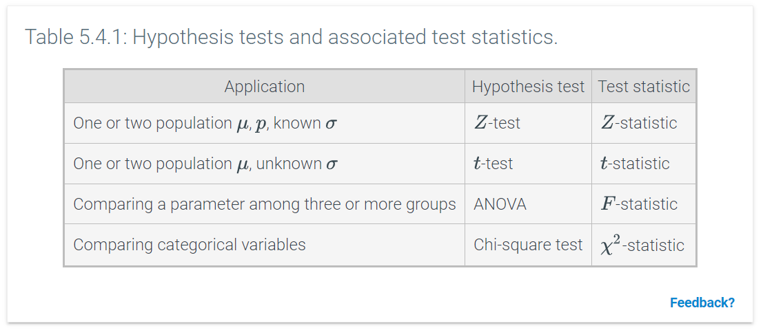

### p-value and statistical significance

Intuitively, inferences cannot be made from a trivially small difference between populations or a difference between populations in which the sample sizes are very small, as differences can be observed by chance in such cases. The concept of statistical significance formalizes the intuition of making inferences about populations from observed sample statistics. A ***statistically significant*** result differs enough from a null hypothesis that a conclusion can be inferred about the population.

In hypothesis testing, the probability of obtaining a result that is as extreme or more extreme than the data if the null hypothesis were true is known as the p***-value***. The p-value of a result is determined from the test statistic. If the p-value is less than a specified significance level, denoted by α, then two possibilities exist.

* The null hypothesis is true and the observed data is relatively unusual with a sample statistic that is extreme simply due to chance.
* The null hypothesis is false and the alternative hypothesis provides a more reasonable explanation for the population parameter.

In most fields, α=0.05 is used most often as the significance level for hypothesis testing. Thus, the probability that a result with an extreme deviation from the null hypothesis is due to chance must be 5% or less for the result to be considered statistically significant.

A ***practically significant*** result implies that the magnitude of the difference between the hypothesized value of a parameter and the sample statistic is large enough to be meaningful in real life. Statistical significance does not necessarily imply practical significance of a result. Ex: A statistically significant difference in the number of employees at a company arriving to work at 8:00 am and the number of employees arriving at 7:59 am is likely of little practical significance.

### Type I and type II errors

In hypothesis testing, a researcher can decide to reject the null hypothesis or fail to reject the null hypothesis. In reality, the null hypothesis is either true or false. Thus, the researcher can make an error by rejecting a true null hypothesis or failing to reject a false null hypothesis. A ***type I error*** is the incorrect rejection of a true null hypothesis, and a ***type II error*** is the failure to reject a false null hypothesis. In other words, a type I error is a false positive and a type II error is a false negative.

The significance level of a hypothesis test, denoted α, is the probability of making a type I error. The probability of making a type II error is denoted β, and the probability 1−β of avoiding type II errors is the power of the hypothesis test.

The following animation illustrates the relationship between the truth of H0, the decision made, and type I and type II errors.

**PARTICIPATION**

Summary of hypothesis testing

*The following are the basic steps of performing a hypothesis test.*

1. *Specify the null hypothesis*H0*and the alternative hypothesis*Ha*.*
2. *Specify the significance level*α*.*
3. *Collect the data.*
4. *Calculate the test statistic and the corresponding*p*-value.*
5. *Compare the*p*-value with the significance level.*
6. *Determine whether to reject or fail to reject*H0*.*

### z-test for population means

A z-test is a hypothesis test in which the z-statistic follows a normal distribution. The z-test for a population mean can be used to determine whether the population mean is the same as the hypothesized mean μ0, assuming that the population standard deviation σ is known. When performing a hypothesis test involving the mean of a single population with a known population standard deviation, the distribution of the z-test statistic is assumed to be 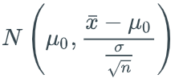. In practice, the population standard deviation is rarely known, so a more useful test involves the t-distribution because the standard deviation of a sample can always be computed.

Conditions for performing the z-test for a population mean

* *Randomness. Data should be collected randomly by means of simple random sampling, stratified random sampling, or cluster sampling. For the examples presented in this material, this condition can be assumed.*
* *Independence. Each observation should not affect other observations. In most surveys, sampling is performed without replacement, which means that a person or an observation is not used twice. For sampling without replacement, the sample size should be less than*10%*of the population size to guarantee independence.*
* *Normality. The sampling distribution should be approximately normal, which is guaranteed either when the sample size is at least*30*by the CLT or when the data's parent distribution is also normal.*

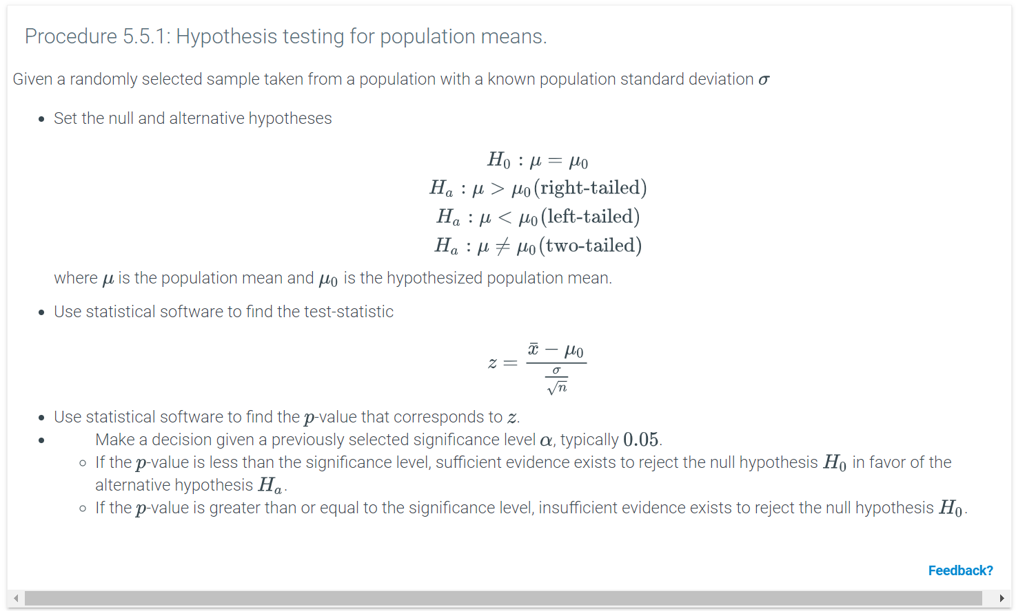

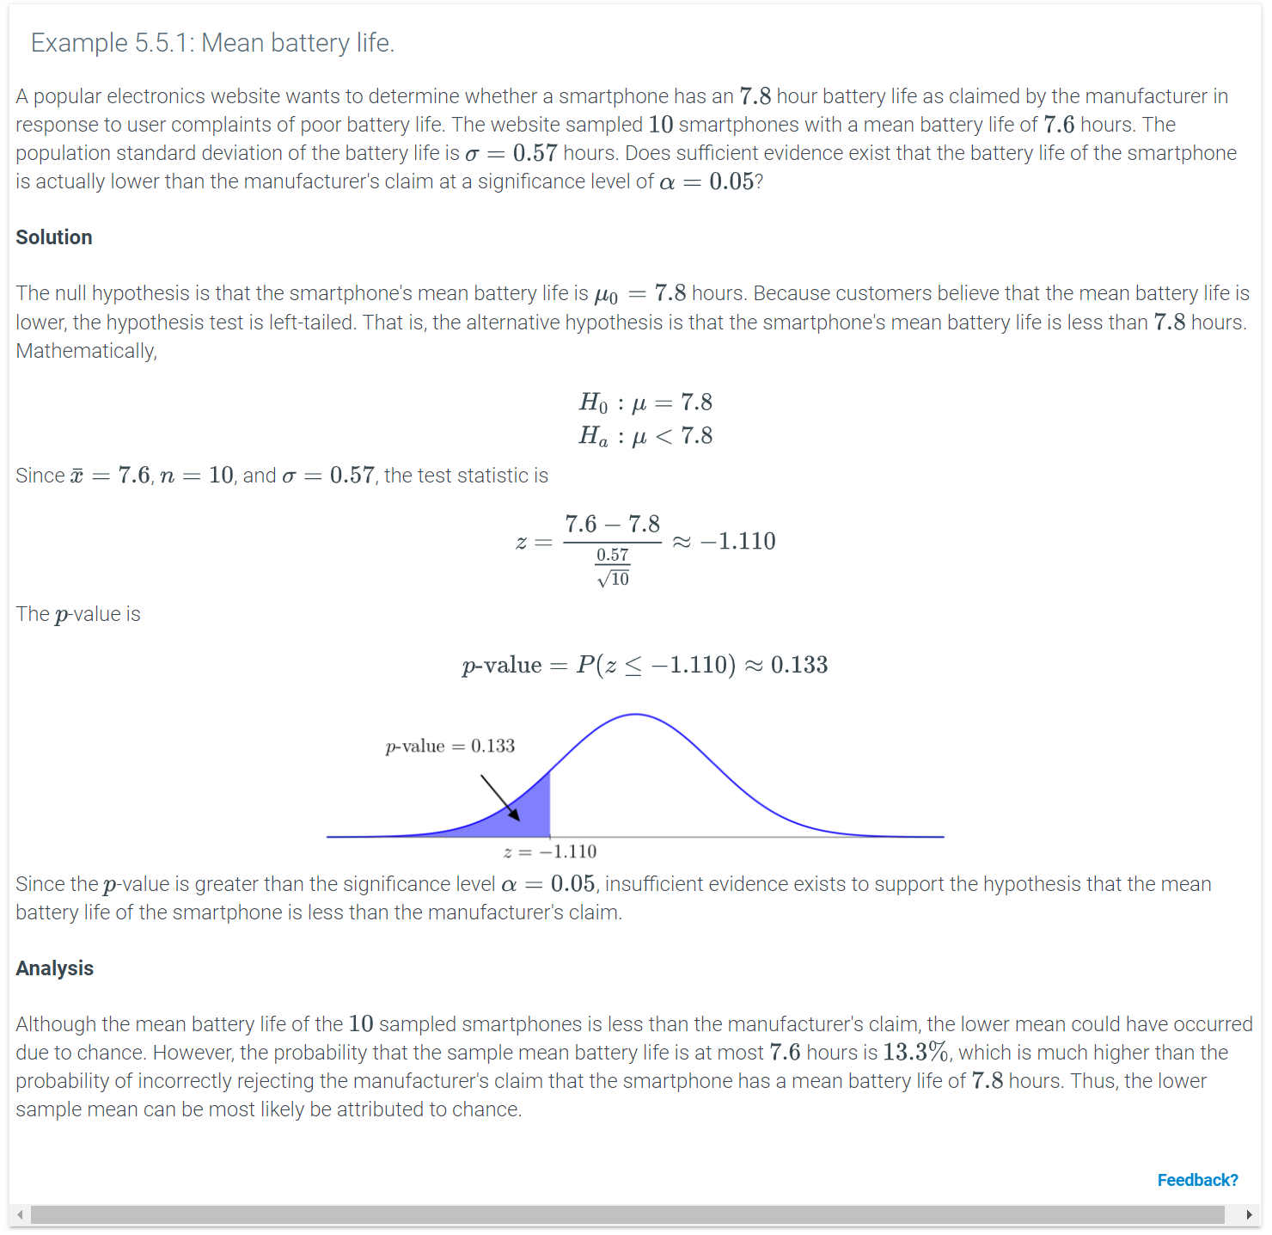 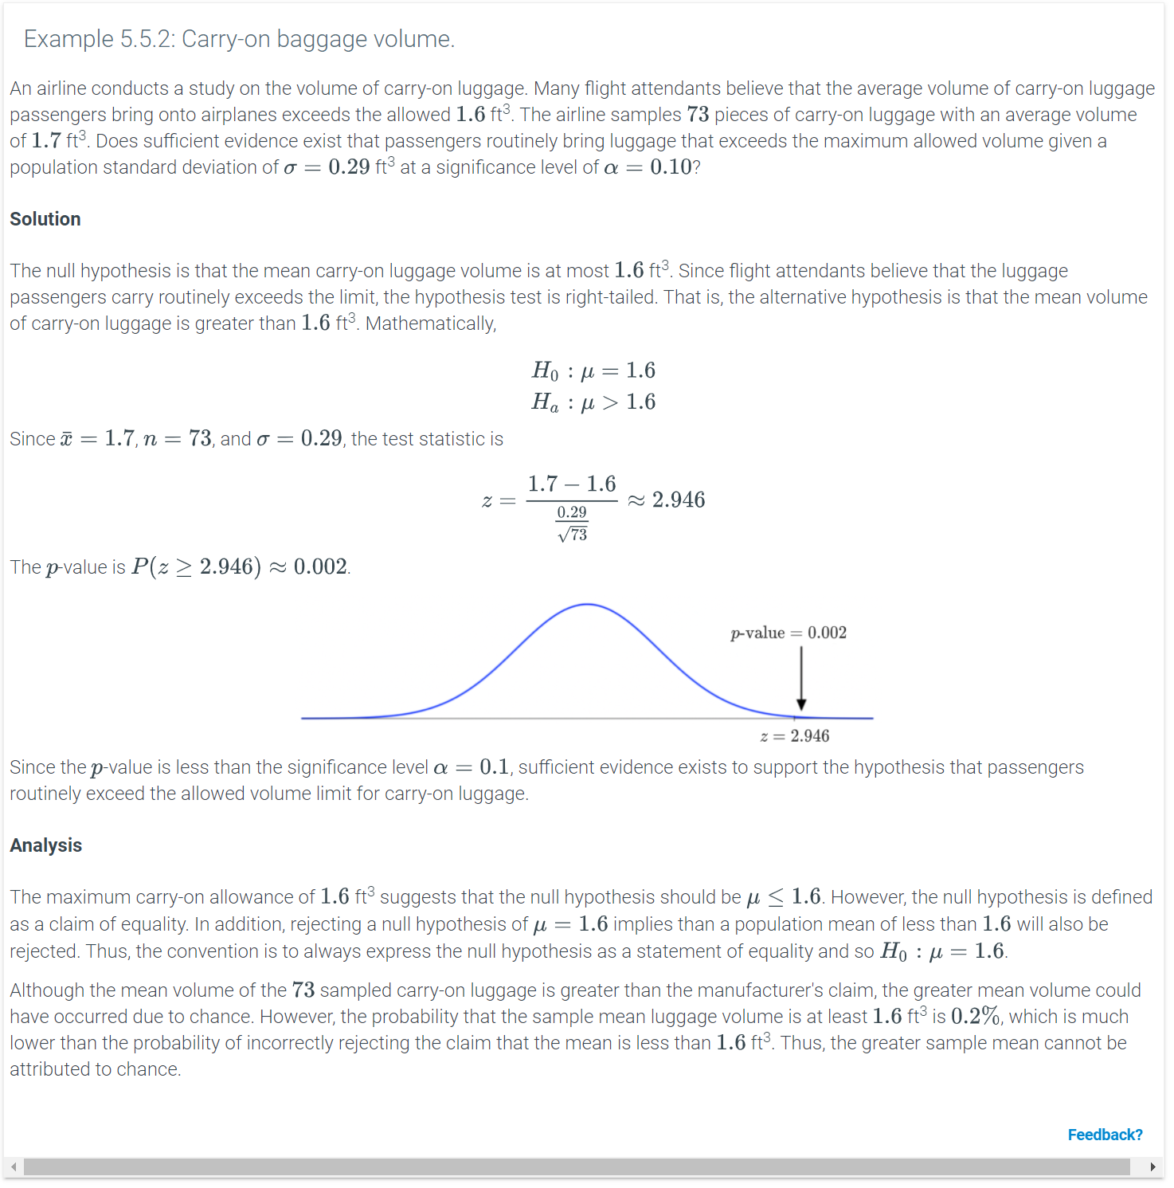

Python-Function 5.5.1: ztest(x1, value).

The ztest(x1, value) function is used to perform a one-sample z-test for means. The function requires the statsmodels.stats.weightstats library to be imported, and takes two inputs. The first input x1 is an array and the second input value is the hypothesized value of the population mean.

The function returns the z-score and the two-tailed p-value.

|  |
| --- |
| **from** statsmodels.stats.weightstats **import** ztest  **import** pandas as pd  scores = pd.read_csv('http://data-analytics.zybooks.com/ExamScores.csv')  **print**(ztest(x1 = scores['Exam1'], value = 86)) |
| (-2.5113146627890988, 0.012028242796839027) |

The graph for the two-tailed z-test corresponding to the output above is shown below.

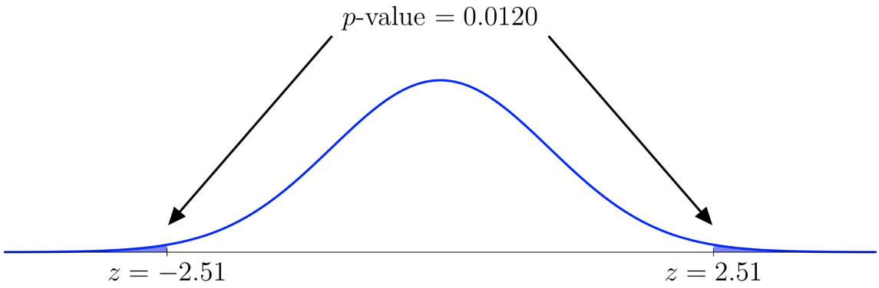

The one-sided p-value is the two-sided p-value divided by 2. The graph for the corresponding left-tailed z-test is shown below.

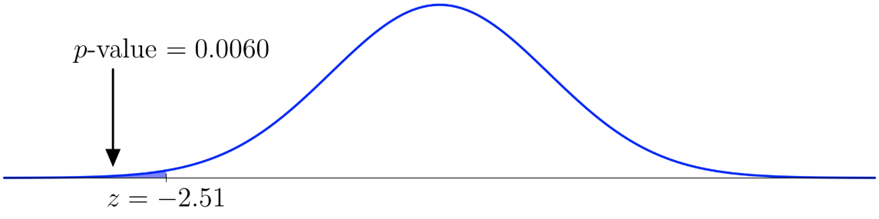

The graph for the corresponding right-tailed z-test is shown below.

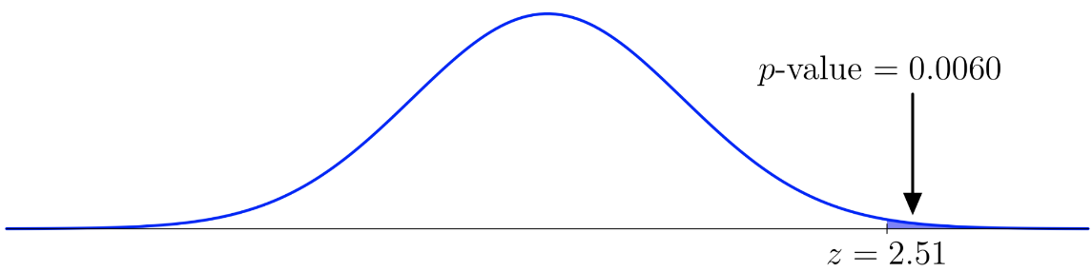

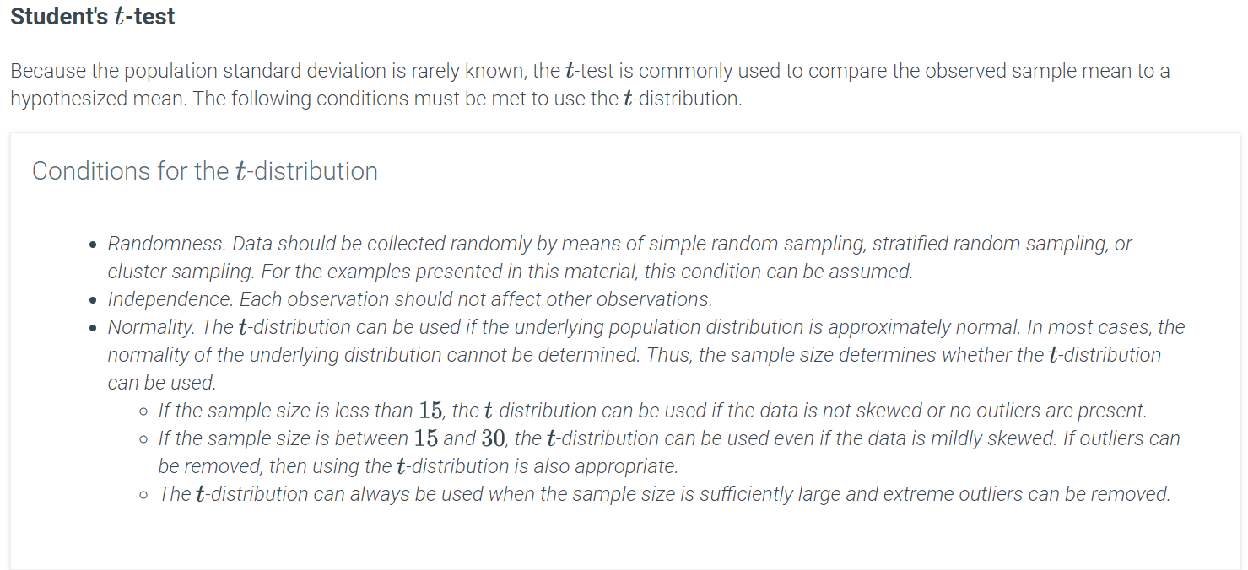

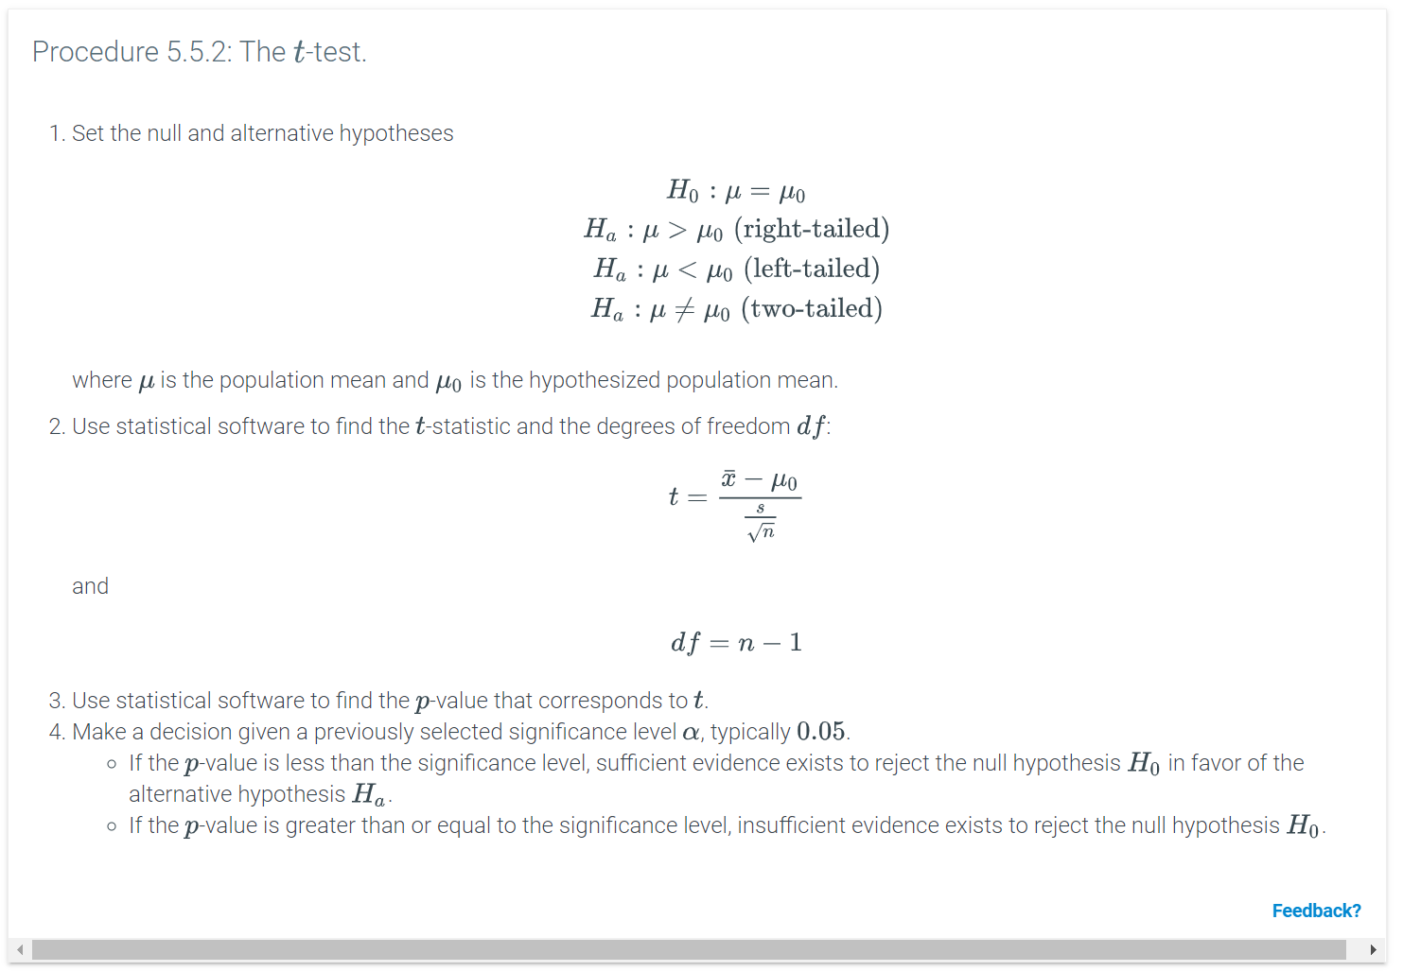

Python-Function 5.5.2: scipy.stats.ttest_1samp(a, popmean).

The scipy.stats.ttest_1samp(a, popmean) function takes in an array or a column of a DataFrame and the hypothesized population mean as inputs and gives the t-statistic and two-tailed p-value as outputs.

|  |
| --- |
| **import** pandas as pd  **import** scipy.stats as st  scores = pd.read_csv('http://data-analytics.zybooks.com/ExamScores.csv')  **print**(st.stats.ttest_1samp(scores['Exam1'], 82)) |
| Ttest_1sampResult(statistic=0.53270311028859929, pvalue=0.59664679344599247) |

The graph for the two-tailed t-test corresponding to the output above is shown below.

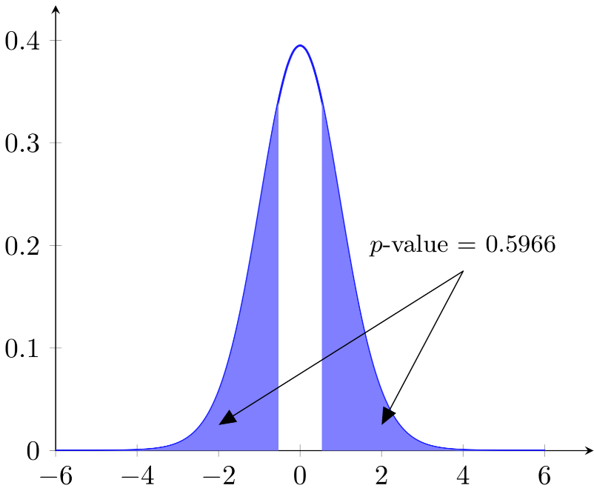

The one-sided p-value is the two-sided p-value divided by 2. The graph for the corresponding left-tailed t-test is shown below.

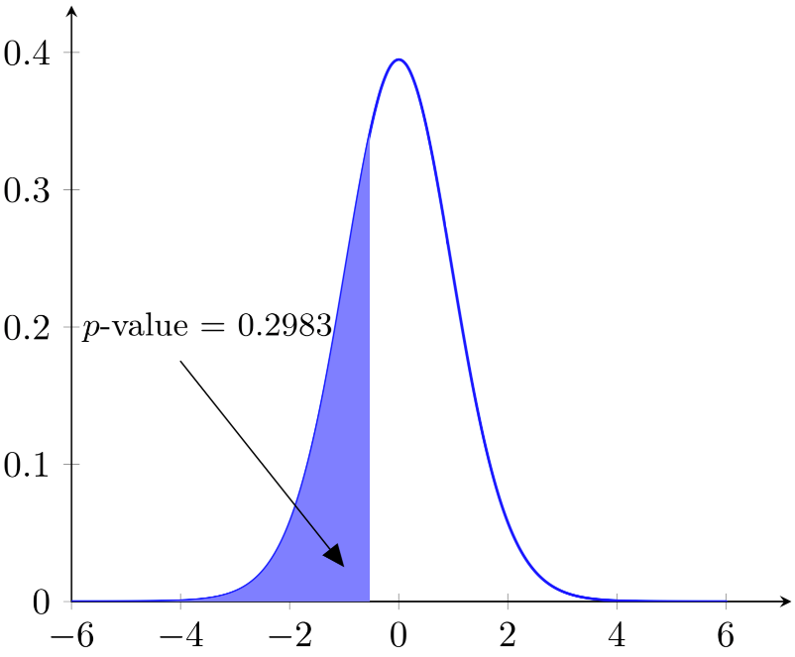

The graph for the corresponding right-tailed t-test is shown below.

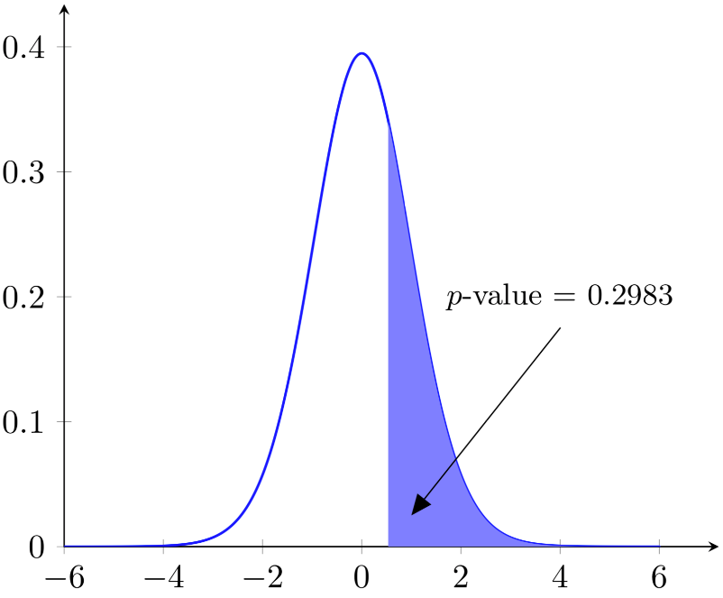

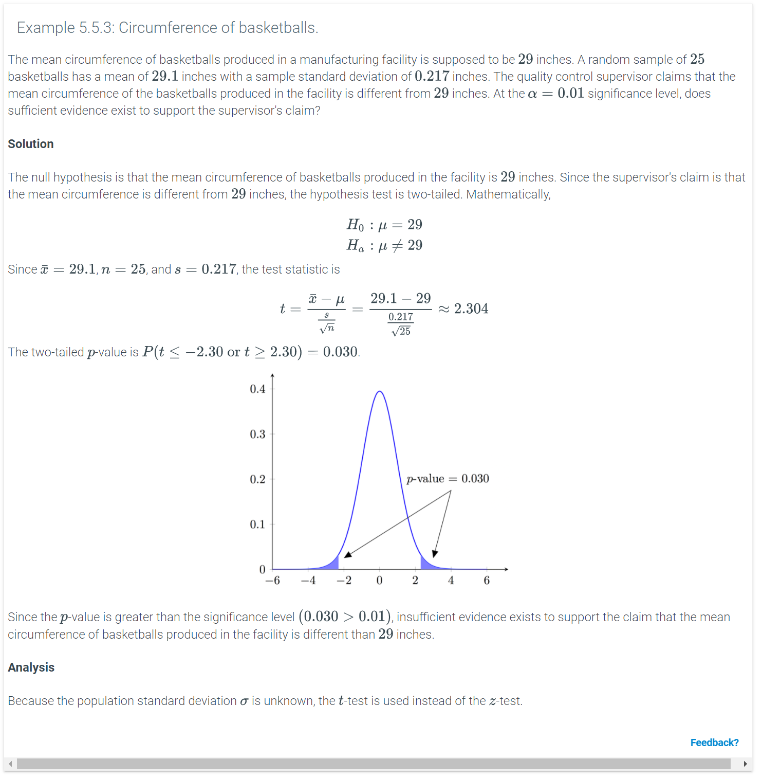

# **Hypothesis test for the difference between two population means**

### Comparing two populations

Hypothesis testing involving a one-sample test determines whether an observed value differs statistically from a hypothesized population value. Sometimes, differences between two populations are studied instead. Ex: Pollsters often look at issues in which the opinions of two different groups may vary wildly, such as political preferences of men compared to those of women.

Hypothesis tests involving two samples follow the same steps. A survey is conducted and statistics are calculated. The standard error for the difference between populations is the square root of the sum of the squares of the standard errors of each population. The test statistic is the difference between the observed and hypothesized value divided by the standard error. Mathematically,



### Two-sample **z**-test for population means

The z-test can also be used to determine whether the means of two independent populations are the same when the population standard deviations are known. When performing a hypothesis test involving the means of two independent populations, the distribution of the z-test statistic is assumed to be 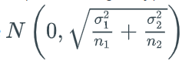. In practice, the standard deviation for populations are generally unknown, so either the paired or unpaired t-test is needed.

The conditions that must be satisfied are similar to those of a z-test for a population mean.

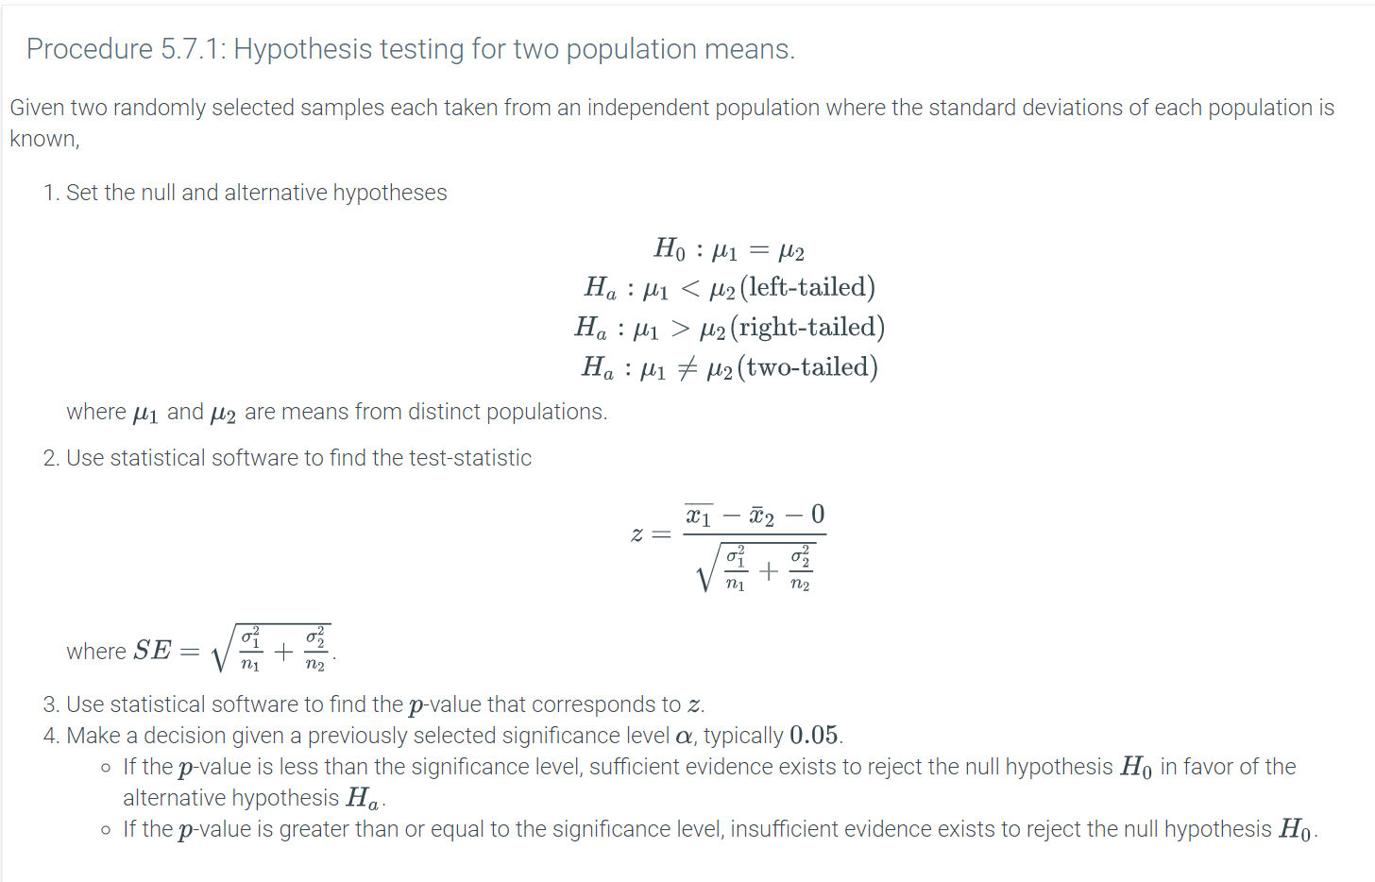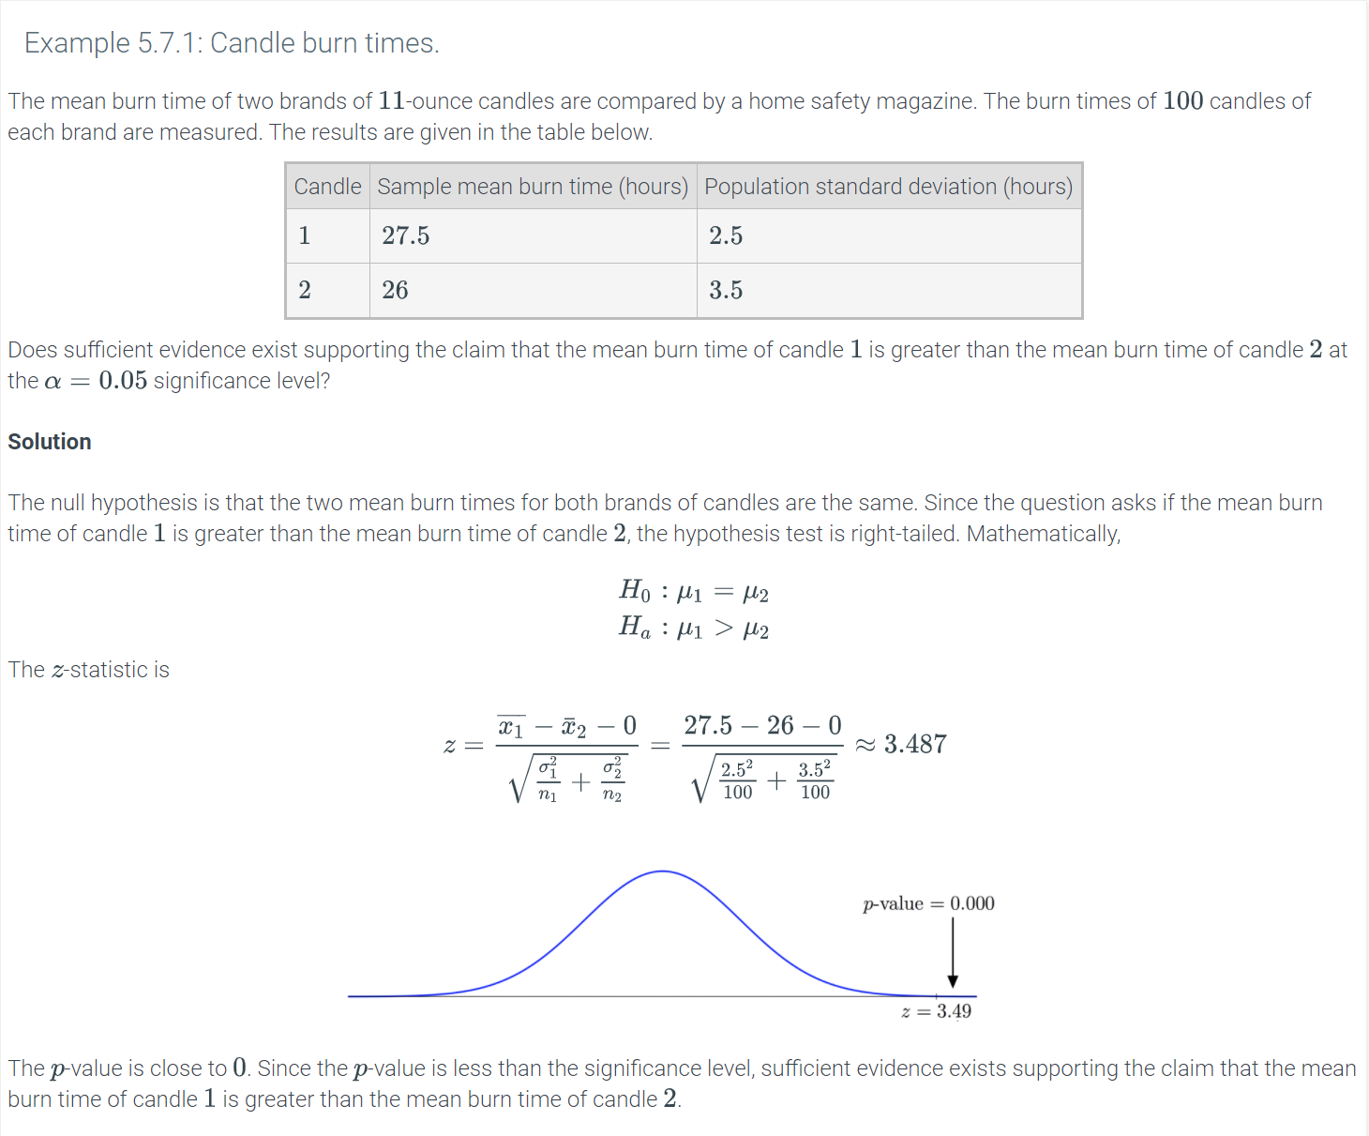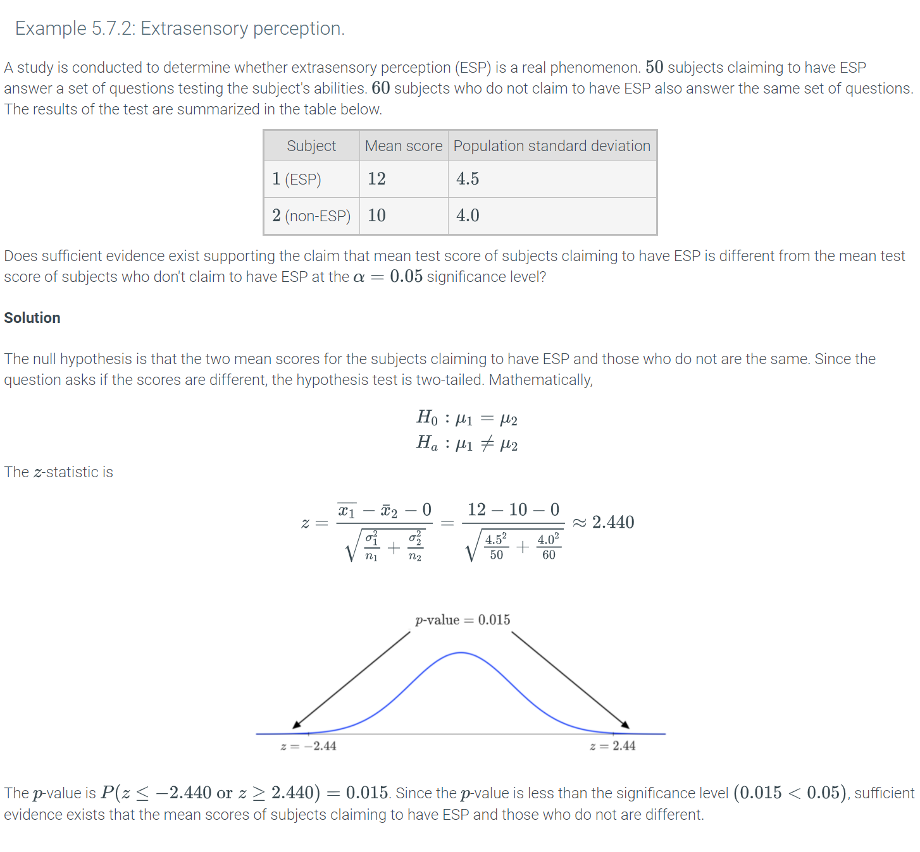

Python-Function 5.7.1: ztest(x1, x2).

The ztest(x1, x2, value = 0) function can also be used to perform a two-sample z-test for means. However, the value parameter should be set to 0. The function requires the statsmodels.stats.weightstats library to be imported and takes two inputs. The first input x1 is an array containing sample observations from one population and the second input is also an array containing sample observations from another population.

The function returns the z-score and the two-tailed p-value.

|  |
| --- |
| **from** statsmodels.stats.weightstats **import** ztest  sample1 = [21, 28, 40, 55, 58, 60]  sample2 = [13, 29, 50, 55, 71, 90]  **print**(ztest(x1 = sample1, x2 = sample2)) |
| (-0.58017208108908169, 0.56179857900464247) |

### Two-sample **t**-test

The t-test discussed analyzes the difference between the sample mean and the hypothesized value of the population mean. A similar method exists to compare the means of two different populations. The ***two-sample***t***-test*** is used to determine if a statistically significant difference exists between two population means. Two types of two-sample t-tests exist: paired and unpaired.

In a ***paired***t***-test*** or ***dependent***t***-test***, a sample taken from one population is exposed to two different treatments. The main idea is that measurements are recorded from the same group, usually before and after a treatment is applied or when each of two treatments is applied. Ex: A group of professional cycling athletes is selected for a study on the effects of caffeine dosage on exhaustion times. The populations are the cyclists for each of two dosages. The samples are the measured exhaustion times for each dosage, which implies dependence because the measurements were taken from the same group.

In an ***unpaired***t***-test*** or ***independent***t***-test***, a sample taken from one population is not related to a different sample taken from another population. In contrast to the paired t-test, measurements from an unpaired t-test are recorded from different groups when exposed to the same treatment. Ex: The effect of caffeine intake on exhaustion times is studied by measuring the exhaustion times of a randomly selected group of 9 professional cyclists taking caffeine pills and another group of 9 cyclists not taking caffeine pills. The two populations are all cyclists taking caffeine pills and those who are not taking the pills. The samples are the measured exhaustion times from the two groups, each with 9 cyclists, which implies independence because the times are for two different groups of cyclists.

### Paired **t**-test

To obtain probabilities for a paired t-test, the paired t-statistic is needed. The formula involves finding the mean and standard deviation of the differences between corresponding measurements :

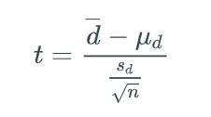

where sd is the sample standard deviation of the differences, d¯ is the mean difference between the samples, and n is the sample size. The most common scenario is that the hypothesized mean difference is 0. However, this scenario is not necessary. Ex: To continue the development of a new drug, a measurable improvement in the condition of the subjects must be seen. In this situation, the null hypothesis would be that the mean difference is the minimum amount of improvement set by the manufacturer in order to continue developing the drug. The differences are assumed to come from a normal distribution. Thus, the differences can be seen as a single sample following a t-distribution, which means that a paired t-test is equivalent to a one-sample t-test.

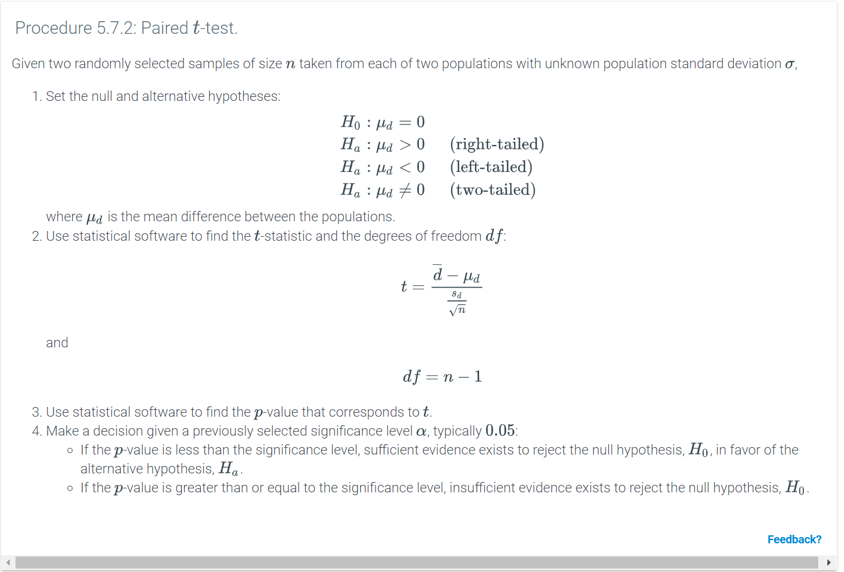

Python-Function 5.7.2: Paired t-test.

The st.ttest_rel(x, y) function takes two arrays or DataFrame columns x and y with the same length as inputs and returns the t-statistic and the corresponding two-tailed p-value as outputs.

|  |
| --- |
| **import** scipy.stats as st  **import** pandas as pd  df = pd.read_csv('http://data-analytics.zybooks.com/ExamScores.csv')  st.ttest_rel(df['Exam1'],df['Exam2']) |
| Ttest_relResult(statistic=1.4179252582484649, pvalue=0.16254101610053867) |

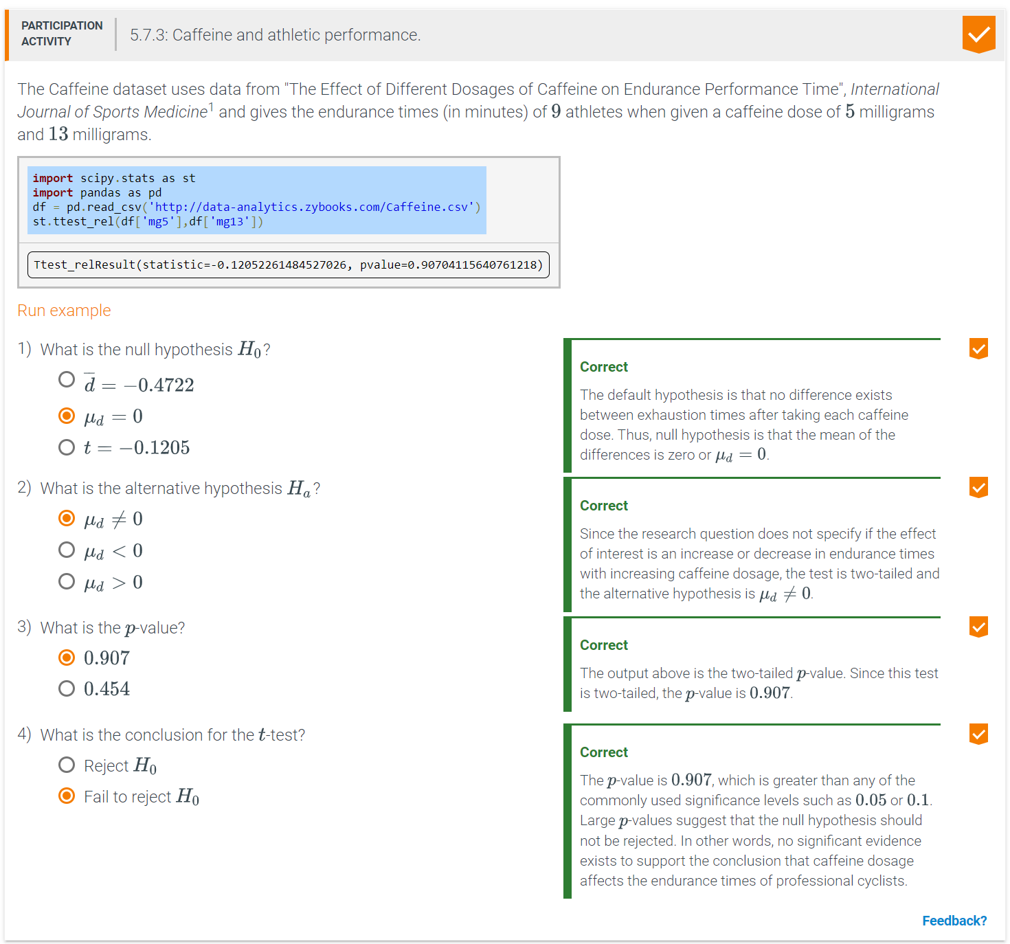

### Unpaired **t**-test

The t-test statistic for unpaired data is different from that of paired data. The formula involves subtracting the means of the two samples:

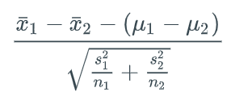where x1¯, s1, and n1 are the mean, standard deviation, and sample size of the sample drawn from the first population respectively; and x2¯, s2, and n2 are the mean, standard deviation, and sample size of the sample drawn from the second population. Since only sample means are subtracted and not individual observations, sample sizes do not need to be equal. The degrees of freedom are df=n1+n2−2. Although μ1−μ2 can be any number based on the hypothesized means for the two populations, most of the time, the accepted difference between the means of the populations is 0. Finally, the formula for the t-statistic above assumes that the variances are unequal. In most practical instances, the equality of variances should be verified using the Fisher's F-test before performing the unpaired t-test. However, this is beyond the scope of the material.

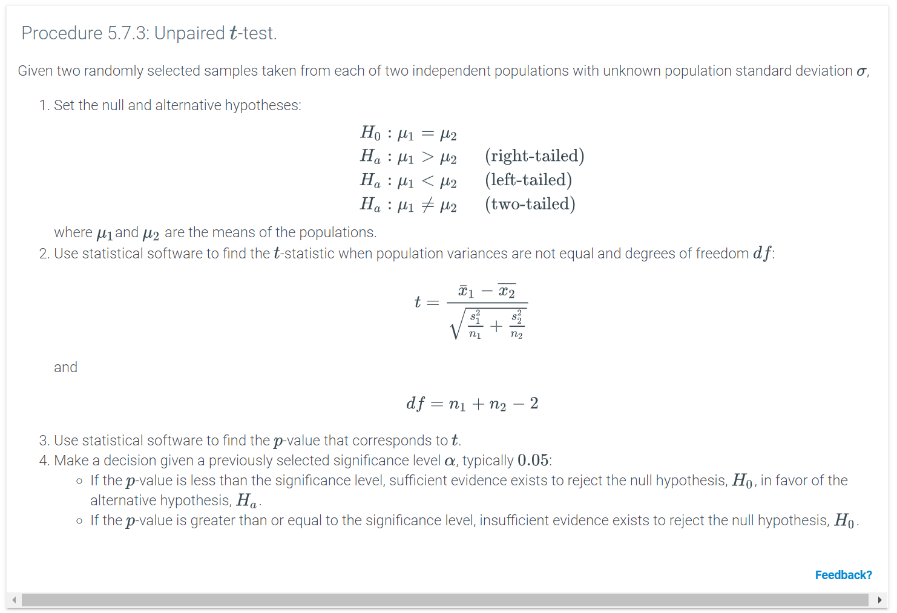

Python-Function 5.7.3: Unpaired t-test.

The st.ttest_ind(x, y) command takes two arrays or DataFrame columns x and y with the same length as inputs and returns the t-statistic and the corresponding two-tailed p-value as outputs.

|  |
| --- |
| **import** scipy.stats as st  **import** pandas as pd  df = pd.read_csv('http://data-analytics.zybooks.com/Machine.csv')  st.ttest_ind(df['Old'],df['New']) |
| Ttest_indResult(statistic=3.397230706117603, pvalue=0.0032422494663179747) |

# **Hypothesis test for the difference between two population proportions**

The z-test can also be used to determine whether the proportions of two distinct populations are the same. When performing a hypothesis test involving the proportion of two distinct populations, the distribution of the z-test statistic is assumed to be

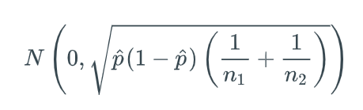

The conditions that must be satisfied are similar to those of the z-test for proportions involving two distinct populations. However, to satisfy the normality condition, all counts should be at least 5:

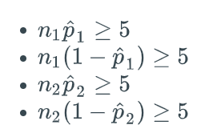

where p^1 is the probability of success in the first sample, p^2 is the probability of success in the second sample, p^ is the overall probability of success when two samples are combined, n1 is the size of the first sample, and n2 is the size of the second sample. 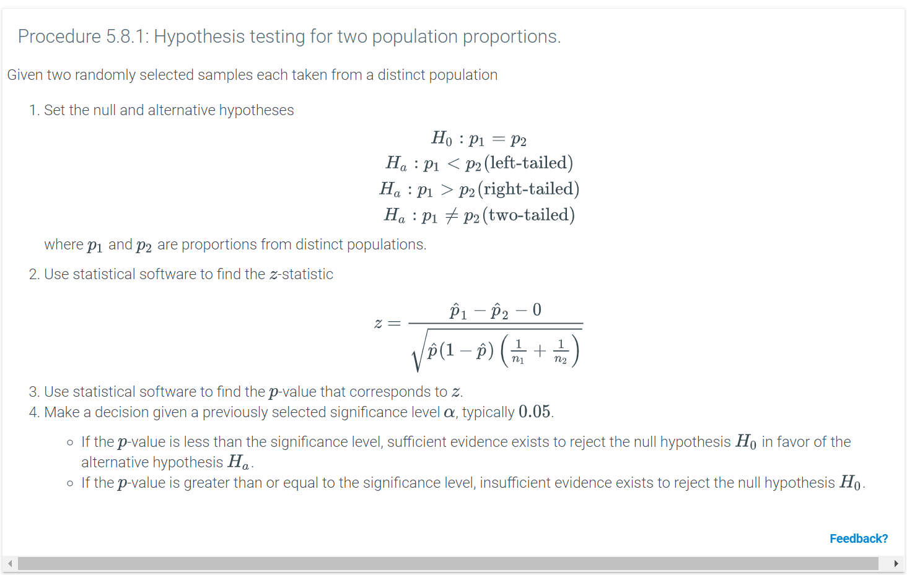

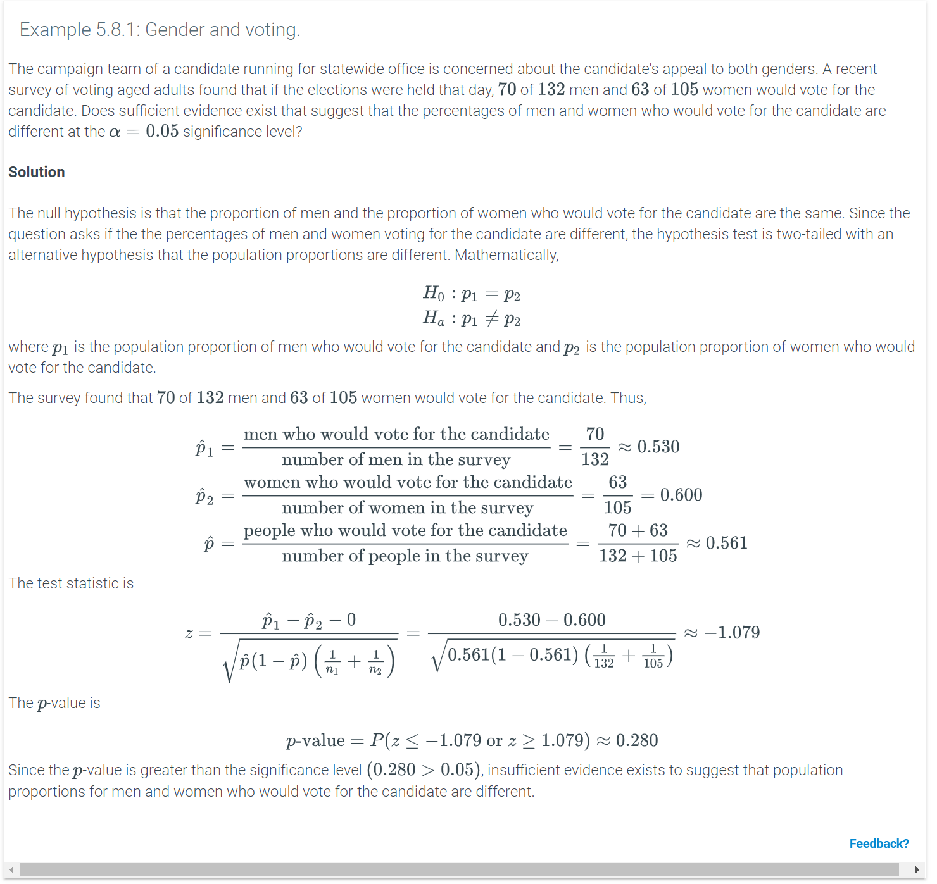

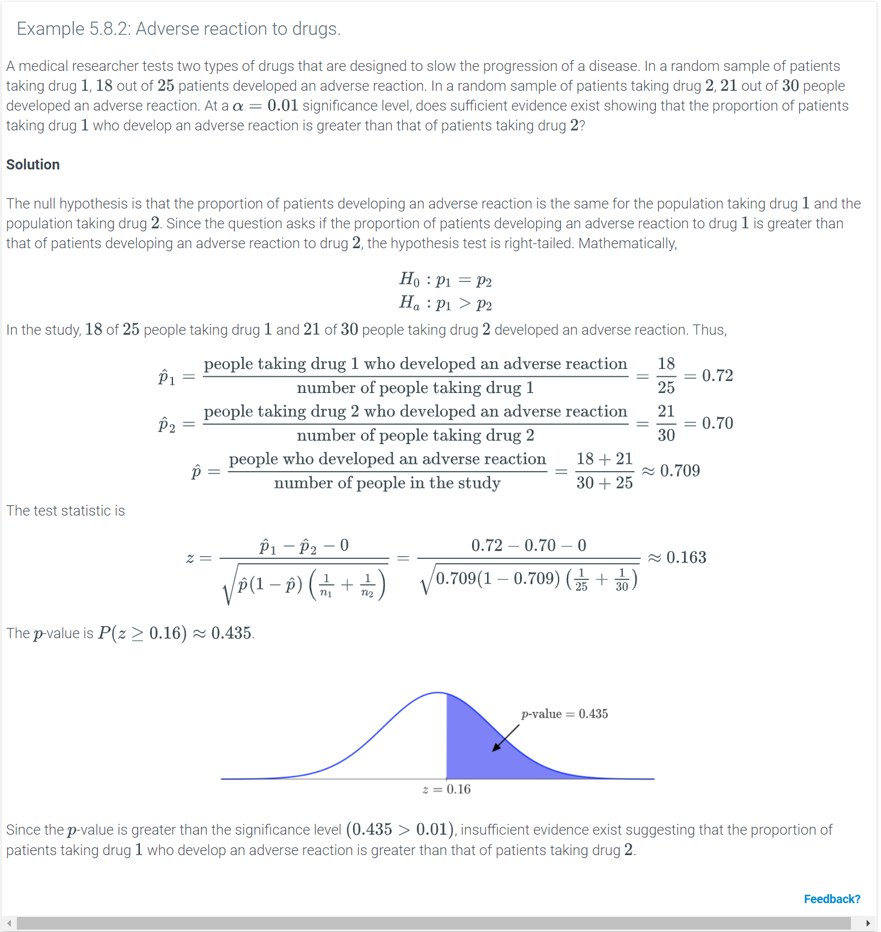

# **6.1 Introduction to simple linear regression (SLR)**

### Regression lines

A ***simple linear regression*** is a way to model the linear relationship between two quantitative variables, using a line drawn through those variables' data points, known as a ***regression line***. Ex: The animation below shows a scatterplot with several data points that represent house price and house size for 5 houses in Eugene, Oregon (Source: Victoria Whitman's 2005 house sales), with a regression line drawn through the points. A common use of a regression line is to make predictions.

### Response and predictor variables

Price is linearly related to size in the house example above. In the scatterplot with price on the vertical Y axis and size on the horizontal X axis, the regression line slopes upwards. This upward slope means larger houses tend to cost more than smaller houses. Without additional information, a person would predict that a larger house would cost more than a small house. Here, house price is known as the response variable, while house size is the predictor variable:

In a linear regression involving two variables, the ***response variable*** is the variable being modeled or predicted, while the ***predictor variable*** is the variable used to predict the response.

The response variable often responds in some way to a change in the predictor. Knowing the value of a predictor often allows one to predict the response. In a linear regression, the response variable is sometimes called the ***dependent variable*** or ***output*** or ***outcome***. Also, in a linear regression, a predictor variable is sometimes called an ***independent variable*** or ***input*** or ***covariate***.

### Creating a simple linear regression line

A scatterplot can display all the information of a simple linear regression model. The response variable goes on the vertical Y axis, while the predictor variable goes on the horizontal X axis. The plotted points show the data. The simple linear regression line shows the overall linear relationship among the plotted points Regress. Each position along the line represents where one would expect Y to be given a particular X, based on the linear relationship. Assuming the data represents a population, the line can be created as follows:

The ******, where β0 and β1 are regression parameters.

In the linear regression function, the E stands for ***expected value***, so E(Y) is read as "the expected value of Y".

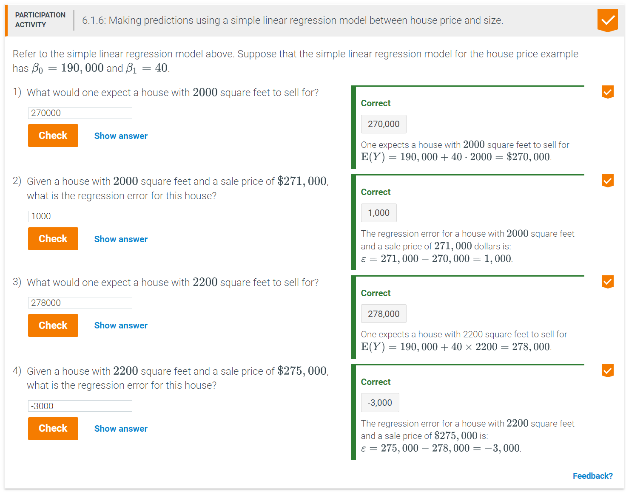

### Minimizing absolute error

The regression parameters are typically unknown because the entire population dataset is not often observable. Instead, a random sample of data points is obtained. Statistical inference is used to draw inferences about the population based on what can be observed in the sample. To apply statistical inference to make a prediction using regression requires estimating the population regression parameters β0 and β1 from sample data. Thus, given sample data points, finding the "best fitting" regression line for those data points provides estimates of β0 and β1.

One method for estimating β0 and β1 minimizes the sum of the absolute errors for the sample points.

### Least squares method

Summing the *absolute* errors is one method to measure how far the line is from the points. Another method to measure error is by computing the sum of squared errors. The sum of squared errors is the sum of the differences between the Y values of the data points and the values obtained from the regression line.

Example 6.1.1: Computing the sum of squared errors.

Given the data points below, compute the sum of squared errors for the regression equation Y=7+2X.

|  |  |  |  |  |
| --- | --- | --- | --- | --- |
| X | 0 | 3 | 7 | 10 |
| Y | 5 | 5 | 27 | 31 |

#### Solution

For each value of X, the regression values from the equation Y=7+2X are obtained. The errors are the difference between the Y values of the data points and the regression values.

|  |  |  |  |  |
| --- | --- | --- | --- | --- |
| X | 0 | 3 | 7 | 10 |
| Y | 5 | 5 | 27 | 31 |
| Y=7+2X | 7 | 13 | 21 | 27 |
| Errors | −2 | −8 | 6 | 4 |
| Square errors | 4 | 64 | 36 | 16 |

Thus, the sum of the square errors is 4+64+36+16=120.

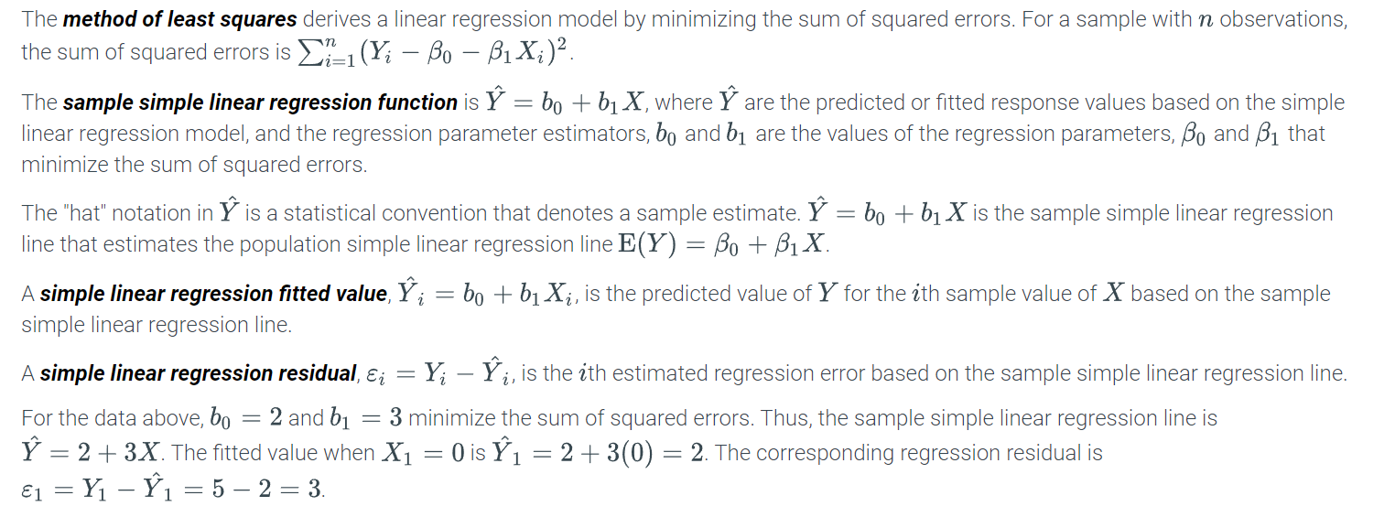

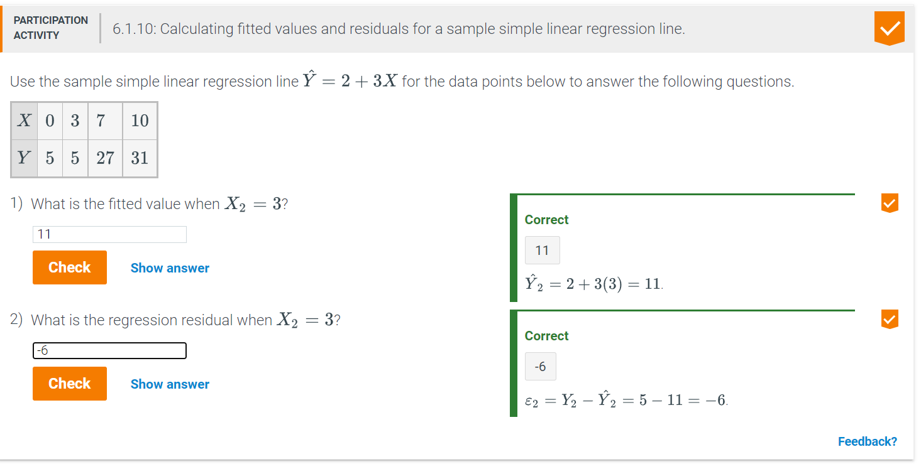

Python-Function 6.1.1: linregress(x,y).

The intercept parameter estimator b0 and the slope parameter estimator b1 can be obtained by using the linregress(x,y) function, which takes in two arrays of equal length as input and returns b0, b1, the correlation coefficient r, the p-value for the correlation coefficient t-test, and the corresponding standard error. The linregress(x,y) function uses the scipy.stats library.

|  |
| --- |
| # The numpy library is imported to build two arrays  **import** numpy as np  **import** scipy.stats as st  x = np.array([0, 3, 7, 10])  y = np.array([5, 5, 27, 31])  **print**(st.linregress(x,y)) |
| LinregressResult(slope=3.0, intercept=2.0, rvalue=0.94542880030087728, pvalue=0.054571199699122705, stderr=0.73108327748669655) |

# **6.2 SLR assumptions**

### Simple linear regression assumptions

The simple linear regression model assumes that at each value of the predictor, X, the probability distribution of the regression error,

* has a mean of zero,
* has constant variance, and
* is normal.

At each value of X in the figure below, the density curve shows the probability distribution of the regression error to be:

* centered on the regression line (where the error is zero),
* equally wide (equally variance), and
* bell-shaped and symmetric (normal).

Figure 6.2.1: Scatterplot illustrating regression error assumptions.

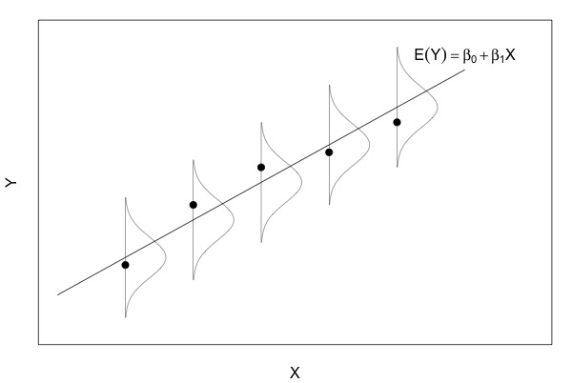

In addition, the value of ε for one observation is assumed to be independent of the value of ε for any other observation.

### Checking simple linear regression assumptions

* An earlier section stated that the simple linear regression model assumes that at each value of the predictor, X, the probability distribution of the regression error 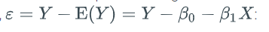has a mean of zero,
* has constant variance, and
* is normal.

In addition, the value of ε for one observation is assumed to be independent of the value of ε for any other observation.

A simple linear regression model should generally only be used for prediction if a reasonable chance exists that these assumptions hold in the population. Population regression errors are not observable, so to assess the assumptions, the sample residuals, 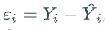, are used. Statistical tests for the residuals are available (not discussed here). Alternatively, graphical methods can be used.

*Assessing the "mean of zero" assumption:* Create a scatterplot with the residuals on the vertical axis and X on the horizontal axis. Scan the plot from left to right and visually estimate whether the mean of the residuals for each fixed value of X is approximately zero. If the mean is approximately zero all the way across the plot then conclude that the "mean of zero" assumption holds. Ex: The following plot on the left has a residual mean that is approximately zero all the way across the plot, so the "mean of zero" assumption holds. The residuals in the left-hand plot look random. By contrast, the residuals in the plot on the right have a non-random "falling-rising" pattern. The residual mean is positive on the left of the plot when X is low, negative in the middle of the plot, and positive on the right of the plot when X is high. The "mean of zero" assumption does not hold for the data in the right-hand plot. Other patterns that would indicate the "mean of zero" assumption does not hold include a "rising-falling" pattern or any strong linear trend. Figure 6.2.2: Residual plots for assessing the mean of zero assumption.

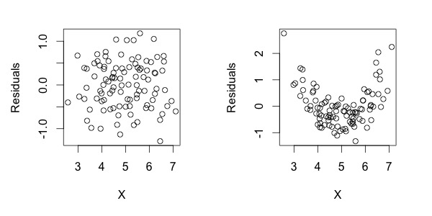

Feedback?

*Assessing the "constant variance" assumption:* Create a scatterplot with the residuals on the vertical axis and X on the horizontal axis. Scan the plot from left to right and visually estimate whether the variance of the residuals for each fixed value of X is approximately constant. If the variance is approximately constant all the way across the plot then conclude that the "constant variance" assumption holds. Ex: The following plot on the left has a residual variance that is approximately constant all the way across the plot, so the "constant variance" assumption holds. The residuals in the left-hand plot look random. By contrast, the residuals in the plot on the right have a non-random "megaphone" pattern. The residual variance is low on the left of the plot when X is low, medium in the middle of the plot, and high on the right of the plot when X is high. The "constant variance" assumption does not hold for the data in the right-hand plot. Another pattern that would indicate the "constant variance" assumption does not hold is a "funnel" pattern where the residual variance is high on the left of the plot and low on the right of the plot.

Figure 6.2.3: Residual plots for assessing the constant variance assumption.

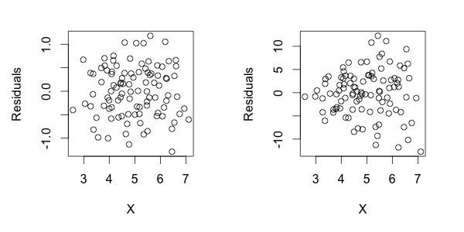

Feedback?

*Assessing the "normality" assumption:* Create a normal probability plot of the residuals, which has the ordered residuals plotted on the vertical axis and theoretical normal quantiles plotted on the horizontal axis. If the plotted points lie reasonably close to the diagonal line on the plot then conclude that the "normality" assumption holds. Ex: The following plot on the left has plotted points that lie reasonably close to the diagonal line, so the "normality" assumption holds. By contrast, the plotted points in the plot on the right do not lie close to the diagonal line. The "normality" assumption does not hold for the data in the right-hand plot. Another pattern that would indicate the "normality" assumption does not hold is a nonlinear pattern curving down instead of up.

Figure 6.2.4: Residual normal probability plots for assessing the normality assumption.

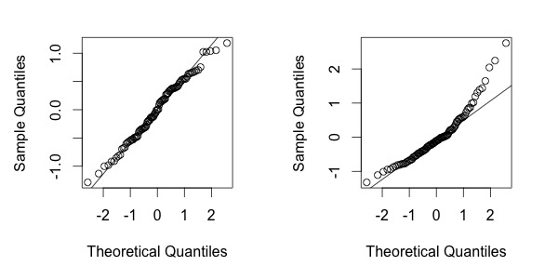

Feedback?

*Assessing the "independence" assumption:* One form of dependence that can affect regression models arises through poor study design. Ex: failing to adjust for the same family members in a study of cholesterol. Another common form of dependence is time dependence. Such time dependence can be assessed if the data were collected in time order and that information is available. Otherwise, the independence assumption is difficult to assess. However, if a variable that tracks time is available, create a scatterplot with the residuals on the vertical axis and time order on the horizontal axis. Scan the plot from left to right and visually estimate whether the residuals tend to track one another no more closely than would be expected by chance. If the residuals seem random then conclude that the "independence" assumption holds. Ex: The following plot on the left has residuals with no discernible pattern all the way across the plot, so the "independence" assumption holds. In contrast, the residuals in the plot on the right tend to track one another more closely than would be expected by chance. The "independence" assumption does not hold for the data in the right-hand plot.

Figure 6.2.5: Time order residual plots for assessing the independence assumption.

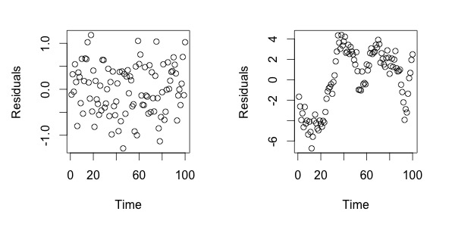

Feedback?

# **Correlation and coefficient of determination**

### Correlation

***Correlation*** describes the association or dependence between two variables. A ***positive correlation*** between two variables means that as one variable increases, the other variable increases as well. A ***negative correlation*** between two variables means that as one variable increases, the other variable decreases. The strength of correlation between a predictor variable and a response variable can be measured by the correlation coefficient. The population correlation coefficient is denoted by ρ and the sample correlation coefficient is denoted by R.

The strength of correlation can be described by the absolute value of R. The table below gives a rough guideline.

Table 6.3.1: Strength of correlation.

|  |  |
| --- | --- |
| Value of |R| | Strength of correlation |
| 0<|R|≤0.40 | Weak |
| 0.40<|R|≤0.80 | Moderate |
| 0.80<|R|≤1.00 | Strong |

Feedback?

Figure 6.3.1: (a) Perfect positive correlation, (b) strong positive correlation, (c) weak positive correlation, (d) perfect negative correlation, (e) strong negative correlation, (f) weak negative correlation.

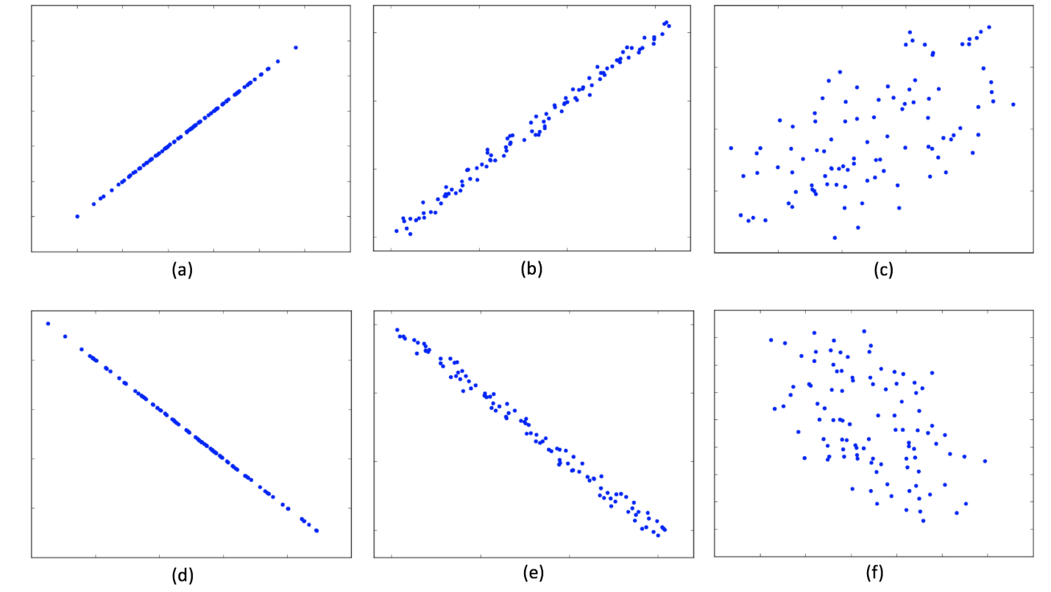

Feedback?

Several methods to find the correlation coefficient exist. The formula to calculate the Pearson correlation coefficient R is given below

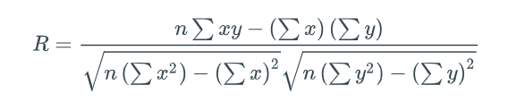Calculating the correlation coefficient using the formula is almost never done by hand, especially when dealing with large datasets. Commonly, a programming language like R or Python is used. The example below illustrates the use of the formula. However, built-in functions will be used in further examples.

Example 6.3.1: Calculating the correlation coefficient using the formula.

Consider the paired datasets X={1,2,4,5} and Y={1,3,5,7}.

1. Find the correlation coefficient between X and Y.
2. Determine the strength and direction of the correlation between X and Y.

**Solution**

1. The table below is useful in obtaining ∑xy, ∑x, ∑y, ∑x2, and ∑y2.

|  |  |  |  |  |
| --- | --- | --- | --- | --- |
| x | y | xy | x2 | y2 |
| 1 | 1 | 1 | 1 | 1 |
| 2 | 3 | 6 | 4 | 9 |
| 4 | 5 | 20 | 16 | 25 |
| 5 | 7 | 35 | 25 | 49 |
| ∑x=12 | ∑y=16 | ∑xy=62 | ∑x2=46 | ∑y2=84 |

1. Note that n=4 because each dataset has 4 elements. Thus,
2. R=n∑xy−(∑x)(∑y)n(∑x2)−(∑x)2n(∑y2)−(∑y)2=4(62)−(12)(16)4(46)−(12)24(84)−(16)2=0.990
3. Since the value of R=0.990>0.8, X and Y are positively and strongly correlated.

Often, applications deal with more than one variable. A ***correlation matrix*** is a table that shows the correlation coefficients between each pair of variables. A correlation matrix for a collection of n variables X1,…,Xn is an n×n matrix where the ijth entry is the correlation coefficient of Xi and Xj. Note that the diagonal entries are always 1 because the correlation between a variable and itself is 1. Further, the correlation matrix is symmetric. That is, the ijth entry is the same as the jith entry.

Python-Function 6.3.1: corr().

The correlation function DataFrame.corr() calculates the pairwise correlation of the columns in the dataframe and outputs a correlation matrix.

The code below uses the Exam1 and Exam2 columns of the ExamScore dataset and produces a 2×2 correlation matrix.

|  |
| --- |
| **import** pandas as pd  scores = pd.read_csv("http://data-analytics.zybooks.com/ExamScores.csv")  **print**(scores[['Exam1','Exam2']].corr()) |
| Exam1 Exam2  Exam1 1.000000 0.078613  Exam2 0.078613 1.000000 |

The code below uses the Exam1, Exam2, Exam3, and Exam4 columns of the ExamScore dataset and produces a 4×4 correlation matrix.

|  |
| --- |
| **print**(scores[['Exam1','Exam2','Exam3','Exam4']].corr()) |
| Exam1 Exam2 Exam3 Exam4  Exam1 1.000000 0.078613 0.256859 0.261306  Exam2 0.078613 1.000000 0.271642 0.318124  Exam3 0.256859 0.271642 1.000000 0.277656  Exam4 0.261306 0.318124 0.277656 1.000000 |

### T-test for the population correlation coefficient

The distribution of the Pearson correlation coefficients for samples of size n follows a t-distribution with n−2 degrees of freedom. When determining whether a linear relationship or association exist, the t-test for population correlation coefficient is useful.

The t-test for the population correlation coefficient is performed as follows.

Procedure 6.3.1: The t-test.

1. Set the null and alternative hypotheses

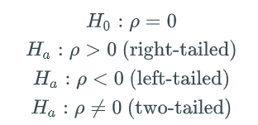

where ρ is the population correlation coefficient.

1. Use statistical software to find the test-statistic

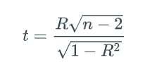 where the degrees of freedom is n−2.

1. Use statistical software to find the p-value that corresponds to t.
2. Make a decision given a previously selected significance level α, typically 0.05.
   * If the p-value is less than the significance level, sufficient evidence exists to reject the null hypothesis H0 in favor of the alternative hypothesis Ha. That is, statistically significant evidence exists to support a correlation or association between the variables.
   * If the p-value is greater than or equal to the significance level, insufficient evidence exists to reject the null hypothesis H0. That is, no statistically significant evidence exists to support a correlation or association between the variables.

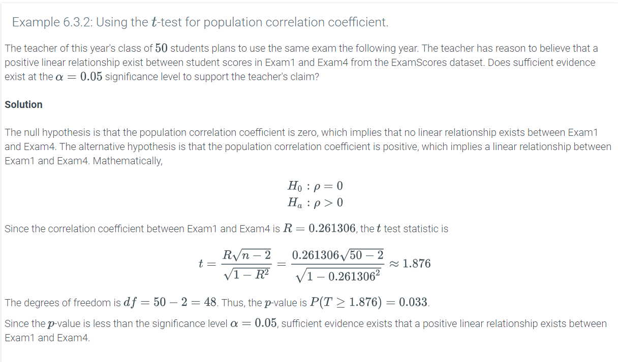

Python-Function 6.3.2: scipy.stats.pearsonr(x,y).

The Pearson correlation coefficient function pearsonr(x,y) takes in two arrays or DataFrames x and y and outputs the Pearson correlation coefficient and the corresponding two-tailed p-value. The function requires the scipy.stats library.

The code below uses the Exam1 and Exam4 columns of the ExamScore dataset and outputs the correlation coefficient and the two-tailed p-value obtained.

|  |
| --- |
| **import** pandas as pd  **import** scipy.stats as st  scores = pd.read_csv("http://data-analytics.zybooks.com/ExamScores.csv")  st.pearsonr(scores['Exam1'],scores['Exam4']) |
| (0.26130551001268937, 0.066807681266337585) |

Note that this two-tailed p-value (0.067) is twice the one-tailed p-value obtained in the example above (0.033).

### Coefficient of determination

Another quantity that shows how well a regression equation represents the data is the coefficient of determination. The ***coefficient of determination***, denoted by R2, gives the ratio of the variance in the response variable explained by the predictor variable. Conceptually, the coefficient of determination is a measure of how closely the regression line follows the pattern of the data. The farther the actual data points are from the regression line, the less useful the line actually is in predicting the value of the response variable.

The coefficient of determination is obtained by the following equation as illustrated in the animation below.

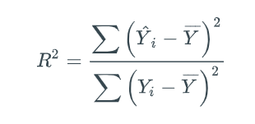

where Y^i is the estimated value of Yi and Y¯ is the mean of the Yis.

Since the coefficient of determination is the square of the correlation coefficient, 0≤R2≤1.

Python-Practice 6.3.1: Coefficient of determination.

Another way to find the regression coefficients is to use the statsmodels package. The code ols('y ~ x', data=dataframe).fit() where y is the dataframe column that represents the response variable and x is the dataframe column that represents the predictor variable. The output gives other quantities including the coefficient of determination.

|  |
| --- |
| # The necessary packages are imported  **import** pandas as pd  **from** statsmodels.formula.api **import** ols  # The ExamScores dataset is loaded  scores = pd.read_csv('http://data-analytics.zybooks.com/ExamScores.csv')  # Creates a linear regression model  results = ols('Exam4 ~ Exam1', data=scores).fit()  # Prints the results  **print**(results.summary()) |
| OLS Regression Results  ==============================================================================  Dep. Variable: Exam4 R-squared: 0.068  Model: OLS Adj. R-squared: 0.049  Method: Least Squares F-statistic: 3.518  Date: Fri, 21 Jun 2019 Prob (F-statistic): 0.0668  Time: 14:09:42 Log-Likelihood: -173.00  No. Observations: 50 AIC: 350.0  Df Residuals: 48 BIC: 353.8  Df Model: 1  Covariance Type: nonrobust  ==============================================================================  coef std err t P>|t| [0.025 0.975]  ------------------------------------------------------------------------------  Intercept 57.7627 10.052 5.746 0.000 37.552 77.973  Exam1 0.2266 0.121 1.876 0.067 -0.016 0.469  ==============================================================================  Omnibus: 3.859 Durbin-Watson: 1.723  Prob(Omnibus): 0.145 Jarque-Bera (JB): 2.809  Skew: 0.428 Prob(JB): 0.245  Kurtosis: 3.784 Cond. No. 753.  ============================================================================== |

The explained and unexplained variance can be obtained from the analysis of variance table created using the code below.

|  |
| --- |
| # The necessary packages are imported  **import** pandas as pd  **import** statsmodels.api as sm  **from** statsmodels.formula.api **import** ols  # The ExamScores dataset is loaded  scores = pd.read_csv('http://data-analytics.zybooks.com/ExamScores.csv')  # Creates a linear regression model  results = ols('Exam4 ~ Exam1', data=scores).fit()  # Creates an analysis of variance table  aov_table = sm.stats.anova_lm(results, typ=2)  # Prints the analysis of variance table  **print**(aov_table) |
| sum_sq df F PR(>F)  Exam1 217.166351 1.0 3.517655 0.066808  Residual 2963.333649 48.0 NaN NaN |

In the output, the explained variance is given by the sum of squares for Exam1, which is 217.166351, while the unexplained variance is given by the sum of squares for the Residual, which is 2963.333649. Using these values, the value for R2 can also be computed as follows.

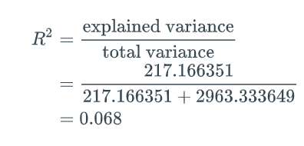

Suppose a teacher wants to see whether Exam4 scores can be predicted using Exam1 scores. The value for R2 means that only 6.8% of the variance in Exam4 scores can be explained by the variance in Exam1 scores. The low value for R2 suggests that Exam1 is not a good predictor for how well a student would do in Exam4.

# **Interpreting SLR models**

### Interpreting regression parameters

The estimates for the population regression parameters, b0 and b1, can be interpreted as follows:

* b0 represents the ***estimated simple linear regression***Y***-intercept***, which is the fitted value of Y when X=0.
* b1 represents the ***estimated simple linear regression slope***, which is the change in the fitted value of Y per unit change in X.

The Y-intercept, b0, has a practical meaning for datasets in which the predictor variable X can take on a value of 0 or values near 0. The measurement unit of b0 is the same as the measurement unit of the response Y variable. Ex: In an experiment where the response variable is blood pressure and the predictor variable is drug dose, b0 has a practical meaning because a dose of 0 means that the patient did not take the drug. On the other hand, in a linear model where the house price is the response variable and the house size is the predictor variable, b0 has no practical meaning because a house cannot have an area of 0.

The slope, b1, always has a practical meaning. The measurement unit of b1 is measurement unit of Y per measurement unit of X. Ex: In a linear model where house price (measured in dollars) is the response variable and house size (measured in square feet) is the predictor variable, b1 is measured in dollars per square foot.

The animation below uses the Reaction dataset that records the reaction times (in milliseconds) of 6 adults after consuming alcohol (in standard drink units). Reaction time is the response variable and alcohol consumption is the predictor variable. The code and output below are used to obtain the sample linear regression equation in the animation.

**import** pandas as pd

**import** scipy.stats as st

df = pd.read_csv('http://data-analytics.zybooks.com/Reaction.csv')

**print**(st.linregress(df['Drinks'],df['Reaction']))

LinregressResult(slope=6.0000000000000009, intercept=3.9999999999999964,

rvalue=0.97281665268828232, pvalue=0.0010983582017795293, stderr=0.71414284285428509)

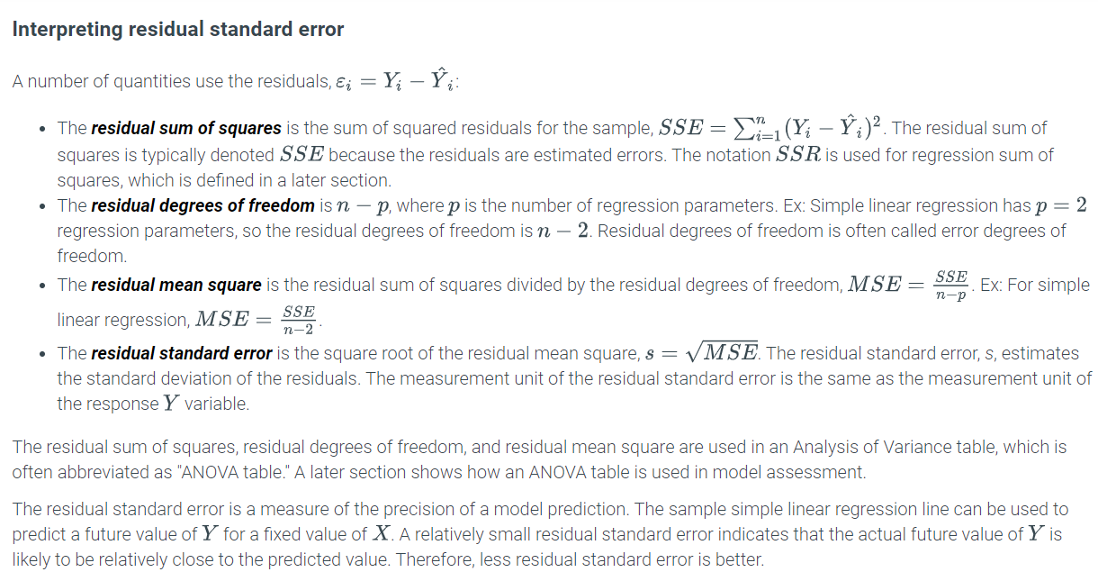

# **6.5 Testing SLR parameters**

### Population and sample regression lines

The sample regression parameter estimators, b0 and b1, are the values of the population regression parameters, β0 and β1, that minimize the sum of squared errors for the model 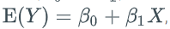, where β0 is the intercept parameter and β1 is the slope parameter. The estimator, b1, is an unbiased estimate of β1, which means that under repeated sampling, the expected value of b1 equals β1. However, the value of b1 for a particular sample will generally not be equal to β1. The value of b1 differs from β1 because of sampling variation, as illustrated in the following animation.

### Testing the linear regression slope parameter

The estimator b1 is a single number used to estimate β1. If β1 were equal to 0, then no linear relationship would exist between Y and X. However, in such a circumstance, as illustrated in the animation above, sampling uncertainty could lead to a non-zero estimator, b1. To determine whether b1 is sufficiently far from 0 to reject the possibility that β1=0 in the population, the t-test can be used.

Procedure 6.5.1: t-test for the slope parameter.

1. Set the null hypothesis, H0:β1=0, versus the alternative hypothesis, Ha:β1≠0.
2. Use statistical software to find the t-statistic, which is b1 divided by the standard error of b1.
3. Use statistical software to find the p-value that corresponds to the t-statistic. The p-value is the probability of observing a t-statistic at least as far from 0 as the one observed, if the null hypothesis were true. The reference t-distribution has n−p degrees of freedom, where n is the sample size and p is the number of regression parameters (typically the number of predictor variables plus one for the intercept).
4. Make a decision based on a previously selected significance level, typically 0.05:
   * If the p-value is less than the significance level, reject the null hypothesis, H0:β1=0, in favor of the alternative hypothesis, Ha:β1≠0. Conclude that β1 is statistically significantly different from 0, which means that a statistically significant linear relationship exists between Y and X.
   * If the p-value is greater than or equal to the significance level, fail to reject the null hypothesis, H0:β1=0, in favor of the alternative hypothesis, Ha:β1≠0. Conclude that β1 is not statistically significantly different from 0, which means that a statistically significant linear relationship does not exist between Y and X.

Feedback?

Python-Function 6.5.1: ols(), fit(), and summary().

The ols() function performs ordinary linear regression, and the fit() function fits the data to the regression line. These functions require the statsmodels.formula.api library to be imported. ols() takes two parameters. The first parameter is in the form 'Y ~ X', where Y is the response variable and X is the predictor variable. The second parameter is the dataset that contains the variables.

The summary() function returns a summary including estimates for the parameters, t-statistics, p-values, and confidence intervals.

All of the above functions require the statsmodels.formula.api library to be imported.

|  |
| --- |
| **import** pandas as pd  **import** statsmodels.formula.api as smf  scores = pd.read_csv('http://data-analytics.zybooks.com/ExamScores.csv')  model = smf.ols('Exam4 ~ Exam2', scores).fit()  **print**(model.summary()) |
| OLS Regression Results  ==============================================================================  Dep. Variable: Exam4 R-squared: 0.101  Model: OLS Adj. R-squared: 0.082  Method: Least Squares F-statistic: 5.405  Date: Wed, 25 Oct 2017 Prob (F-statistic): 0.0244  Time: 21:59:27 Log-Likelihood: -172.10  No. Observations: 50 AIC: 348.2  Df Residuals: 48 BIC: 352.0  Df Model: 1  Covariance Type: nonrobust  ==============================================================================  coef std err t P>|t| [0.025 0.975]  ------------------------------------------------------------------------------  Intercept 62.3017 6.204 10.042 0.000 49.828 74.776  Exam2 0.1788 0.077 2.325 0.024 0.024 0.333  ==============================================================================  Omnibus: 4.604 Durbin-Watson: 1.676  Prob(Omnibus): 0.100 Jarque-Bera (JB): 3.507  Skew: 0.509 Prob(JB): 0.173  Kurtosis: 3.805 Cond. No. 459.  ============================================================================== |

Example 6.5.1: Testing a simple linear regression slope.

The ExamScores dataset is a record of 4 exam scores for 50 students. Y=Exam4 is the response variable and X=Exam2 is the predictor variable. The teacher believes that a linear relationship exists between Exam4 scores and Exam2 scores. Does sufficient evidence exist to support the teacher's claim at the α=0.05 significance level? Use the partial output below.

coef std err t P>|t| [0.025 0.975]

------------------------------------------------------------------------------

Intercept 62.3017 6.204 10.042 0.000 49.828 74.776

Exam2 0.1788 0.077 2.325 0.024 0.024 0.333

#### Solution

The null hypothesis is that no linear relationship exists between Exam4 scores and Exam2 scores. The alternative hypothesis is that a linear relationship exists between scores from both exams. Mathematically,

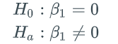

The t-statistic is the estimate for the slope parameter divided by the standard error for the estimate. That is,

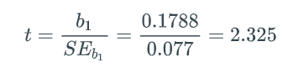

The p-value is P(t≤−2.325 or t≥2.325)=0.024.

Since the p-value is less than the significance level (0.024<0.05), the null hypothesis is rejected. Thus, statistically significant evidence exists to support the teacher's claim that exam 4 scores and exam 2 scores are linearly dependent.

### Confidence intervals for regression parameters

The slope estimator, b1, provides a single number to estimate β1. To quantify sampling uncertainty about a single number used to estimate β1, one can calculate an interval around the number. A ***confidence interval for the slope*** is an interval around b1 that quantifies sampling uncertainty when b1 is used to estimate β1. The confidence interval is given by

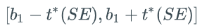

where SE is the standard error, and t∗ depends on the degrees of freedom and the confidence level of interest, and can be found from a t-distribution table. Although far less common, the confidence interval for the intercept can also be calculated.

where SE is the standard error, and t∗ depends on the degrees of freedom and the confidence level of interest, and can be found from a t-distribution table. Although far less common, the confidence interval for the intercept can also be calculated.

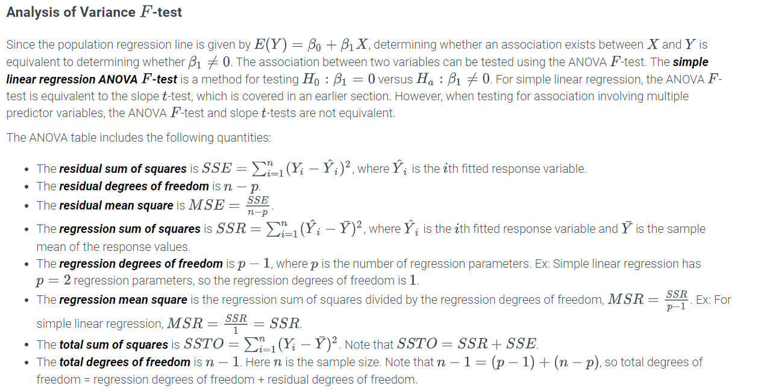

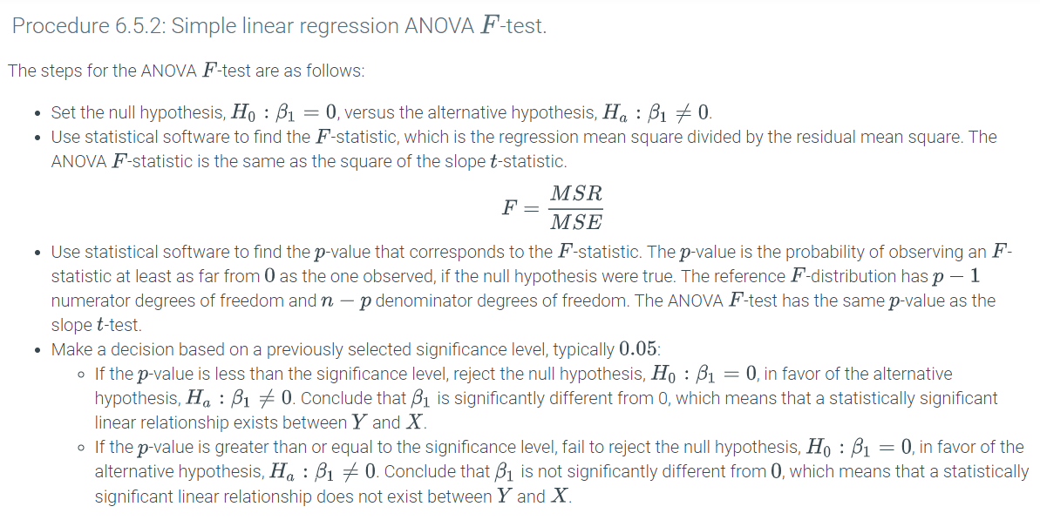

Python-Practice 6.5.1: Using ANOVA to test the correlation between two variables.

The ols() function takes two parameters, 'Y ~ X1' where Y is the response variable and X1 is a predictor variable, and a data frame. The sm.stats.anova_lm command takes in a linear model and an ANOVA type as parameters and outputs an ANOVA table. The different types of ANOVA are beyond the scope of this material. To give the correct output, the parameter for the ANOVA type, denoted as typ, is set to 2.

In the code below, Exam4 is the response variable and Exam1 is the predictor variable.

|  |
| --- |
| **from** statsmodels.formula.api **import** ols  **import** statsmodels.api as sm  **import** pandas as pd  df=pd.read_csv("http://data-analytics.zybooks.com/ExamScores.csv")  mod = ols('Exam4 ~ Exam1',df).fit()  **print**(sm.stats.anova_lm(mod, typ=2)) |
| sum_sq df F PR(>F)  Exam1 217.166351 1.0 3.517655 0.066808  Residual 2963.333649 48.0 NaN NaN |

Example 6.5.3: Using the ANOVA table and performing the F-test for simple linear regression.

The teacher of a statistics class with 50 students believes that scores in first exam predict how well students do in fourth exam. The ANOVA table where Exam4 is the response variable and Exam1 is the predictor variable is given below.

sum_sq df F PR(>F)

Exam1 217.166351 1.0 3.517655 0.066808

Residual 2963.333649 48.0 NaN NaN

1. Find the regression mean square MSR and the residual mean square MSE.
2. Perform an ANOVA F-test to determine whether sufficient evidence exists to support the teacher's belief at the α=0.10 significance level.

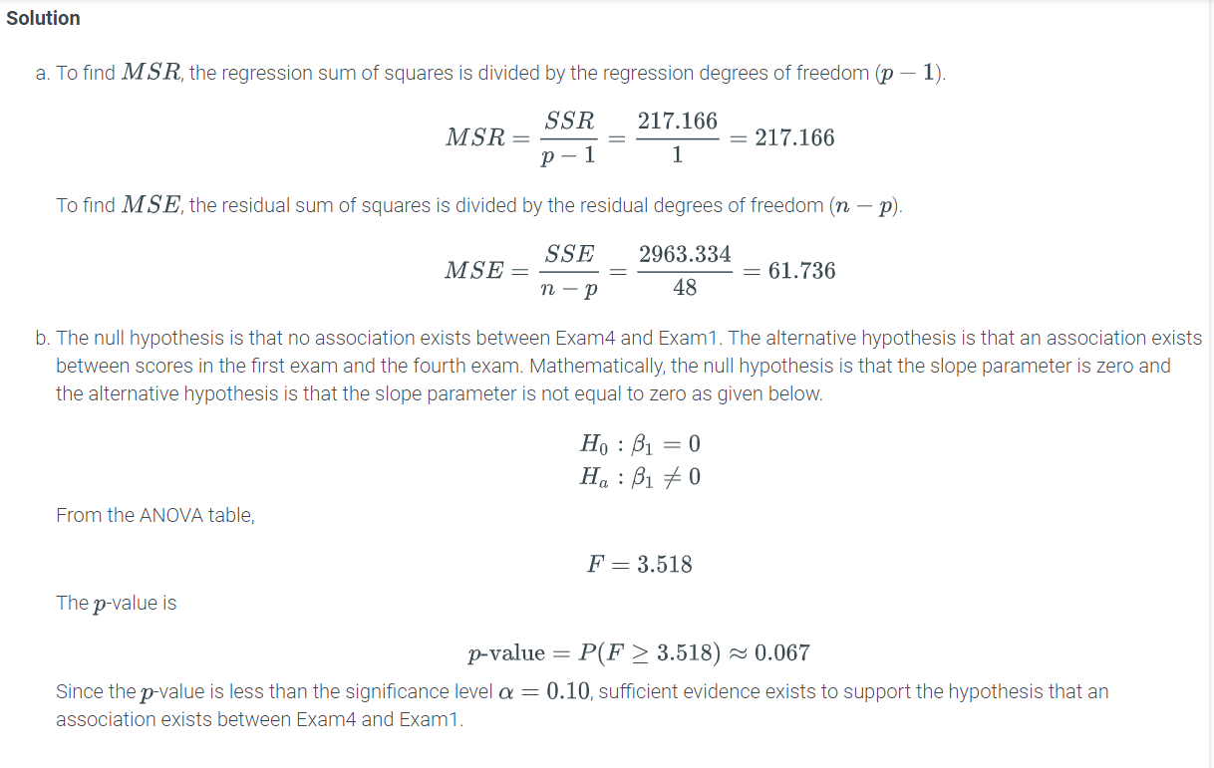

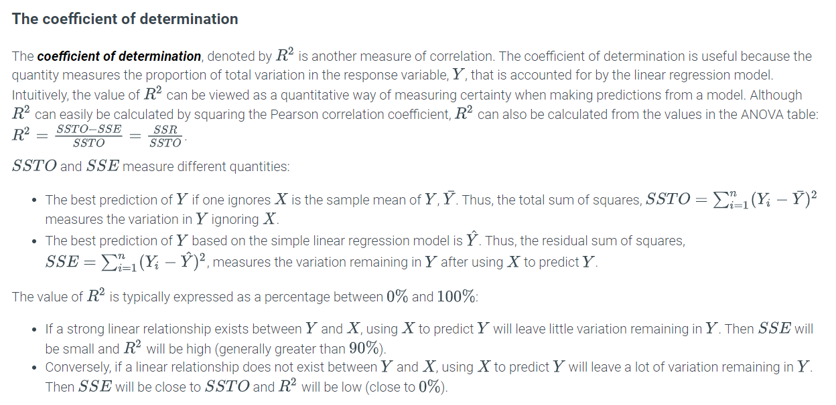

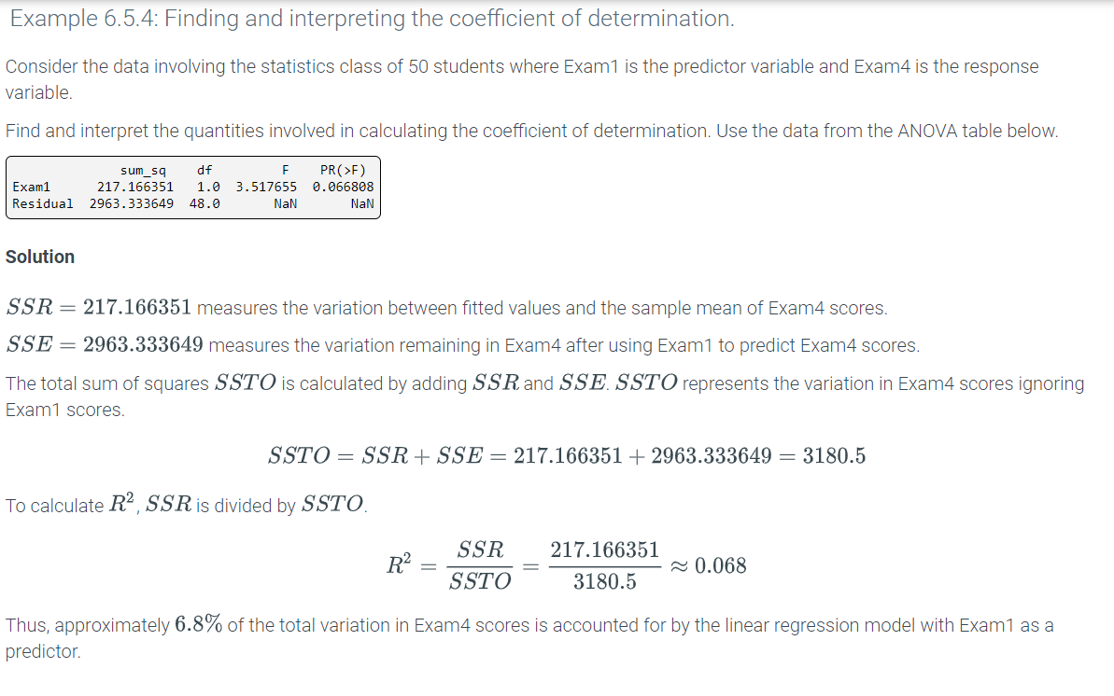

### Introduction to multiple regression

A ***multiple regression*** is a way to model the linear relationship between one quantitative response variable and more than one predictor variable. Ex: A multiple regression model can be used to model the linear relationship between the quality of a car component and manufacturing inputs, such as machine speed and cutting angle. Y=Quality is the response variable, while X1=Speed and X2=Angle are predictor variables represented in the figure below. The ***response variable*** is the variable being modeled or predicted, while the ***predictor variables*** are the variables used to predict the response.

Figure 7.1.1: A 3D scatterplot and plane representing a multiple regression model for car quality with two predictor variables X1= speed and X2= angle.

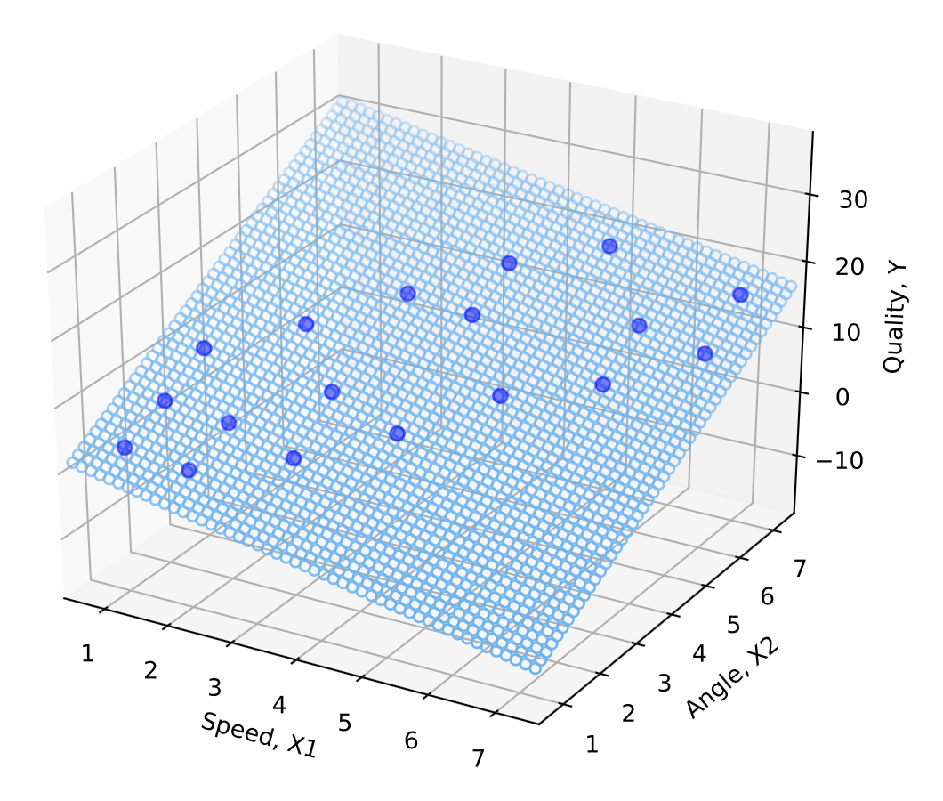

A multiple regression model has two parts. The first part is the population linear regression function, which represents the expected value of Y given a particular set of values for X1,X2,…,Xn. The ***population linear regression function*** is E(Y)=β0+β1X1+β2X2+…+βnXn, where β0,β1,β2,…,βn are regression parameters. The second part is the regression error term, ϵ, which represents the difference between the actual value of Y and the expected value of Y given a particular set of values for X1,X2,…,Xn.

The ***multiple regression model*** is Y=β0+β1X1+β2X2+⋯+βnXn+ϵ, which is the sum of the population regression function and the regression error term.

Python-Practice 7.1.1: 3D scatterplot.

The mplot3d toolkit of matplotlib allows plotting of 3D objects such as scatterplots and 2D projections.

**from** mpl_toolkits.mplot3d **import** Axes3D

**import** matplotlib.pyplot as plt

**import** pandas as pd

df = pd.read_csv("http://data-analytics.zybooks.com/Cars.csv")

fig = plt.figure()

ax = fig.add_subplot(111, projection='3d')

ax.scatter(df['Speed'], df['Quality'], df['Angle'], c='b', marker='o')

ax.set_xlabel('Speed, X1')

ax.set_ylabel('Angle, X2')

ax.set_zlabel('Quality, Y')

plt.savefig("3Dscatterplot.png")

The 3D scatterplot output is shown below.

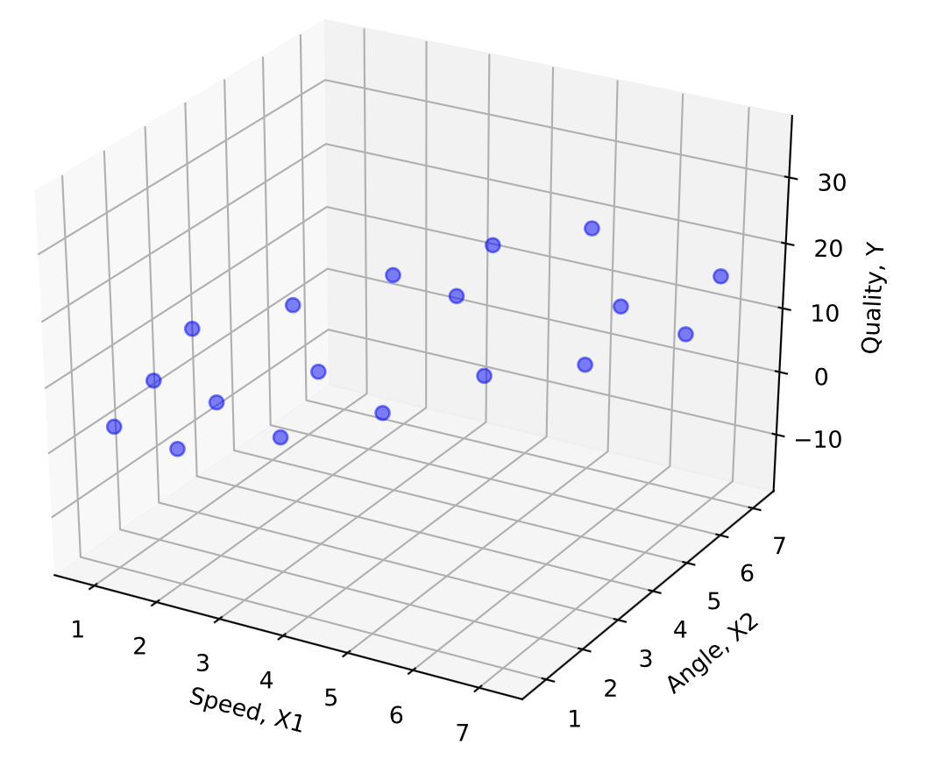

### Estimating the multiple regression model

Once a population linear regression model Y=β0+β1X1+β2X2+…+βnXn+ϵ is proposed, the next step is to estimate the model using sample data to find a sample multiple regression function. The most common method to estimate the model is called "least squares." Intuitively, the least squares method finds the values of the regression parameters, β0,β1,…,βn that minimize the sum of squared regression errors. The ***sample multiple regression function*** is Y^=b0+b1X1+b2X2+…+bnXn, where Y^ is the fitted response value and b1,b2,…,bn are the estimates for β0,β1,…,βn that minimize the sum of squared errors. The "hat" notation in Y^ is a statistical convention that denotes a sample estimate.

Python-Practice 7.1.2: Multiple regression using Python.

The [body fat](https://static-resources.zybooks.com/static/fat.csv) dataset gives the amount of body fat, the triceps skinfold circumference, the midarm circumference, and the thigh circumference of 20 research subjects. Suppose a researcher wishes to use multiple regression to model the linear relationship between the amount of body fat for an individual and these body measurements. Let Y = body fat be the response variable and X1 = triceps skinfold circumference, X2 = midarm circumference, and X3 = thigh circumference be the three predictor variables.

Similar to simple linear regression, ols(), fit(), and summary() are used to perform multiple regression, fit the data to the regression line, and display a summary. All of these functions require the statsmodels.formula.api module to be imported.

To perform multiple regression, the predictor variables are joined with + in the ols() function. Finally, the fit() method is used.

|  |
| --- |
| **import** pandas as pd  **import** statsmodels.formula.api as sms  fat = pd.read_csv('https://static-resources.zybooks.com/static/fat.csv')  # Response variable  Y = fat['body_fat_percent']  # Generates the linear regression model  # Multiple predictor variables are joined with +  model = sms.ols('Y ~ triceps_skinfold_thickness_mm + midarm_circumference_cm + thigh_circumference_cm', data = fat).fit()  # Prints the summary  **print**(model.summary()) |
| OLS Regression Results  ==============================================================================  Dep. Variable: Y R-squared: 0.801  Model: OLS Adj. R-squared: 0.764  Method: Least Squares F-statistic: 21.52  Date: Mon, 15 Jul 2019 Prob (F-statistic): 7.34e-06  Time: 18:46:57 Log-Likelihood: -44.312  No. Observations: 20 AIC: 96.62  Df Residuals: 16 BIC: 100.6  Df Model: 3  Covariance Type: nonrobust  =================================================================================================  coef std err t P>|t| [0.025 0.975]  -------------------------------------------------------------------------------------------------  Intercept 117.0847 99.782 1.173 0.258 -94.445 328.614  triceps_skinfold_thickness_mm 4.3341 3.016 1.437 0.170 -2.059 10.727  midarm_circumference_cm -2.1861 1.595 -1.370 0.190 -5.568 1.196  thigh_circumference_cm -2.8568 2.582 -1.106 0.285 -8.330 2.617  ==============================================================================  Omnibus: 1.200 Durbin-Watson: 2.243  Prob(Omnibus): 0.549 Jarque-Bera (JB): 0.830  Skew: -0.085 Prob(JB): 0.660  Kurtosis: 2.016 Cond. No. 1.15e+04  ==============================================================================  Warnings:  [1] Standard Errors assume that the covariance matrix of the errors is correctly specified.  [2] The condition number is large, 1.15e+04. This might indicate that there are  strong multicollinearity or other numerical problems. |

The values in the coef column in the output correspond to the β population regression parameters of the multiple regression model. The Intercept coef is β0. The subsequent entries in the coef column correspond to β coefficients of each predictor variable in the order entered in the ols() function. Thus, Y^=117.0847+4.3341X1−2.1861X2−2.8568X3.

### Fitted values and residuals

A ***multiple regression fitted value***, Y^i=b0+b1X1i+b2X2i+b3X3i+⋯+bnXni, is the predicted value of Y for the ith sample values of X1,X2,X3,… based on the sample multiple regression function. Ex: The first sample observation in the body fat example has predictor values X1=19.5,X2=29.1,X3=43.1. The first regression fitted value based on the sample multiple regression function Y^=117.085+4.334X1−2.186X2−2.857X3 is Y^1=117.085+4.334(19.5)−2.186(29.1)−2.857(43.1)=14.8.

A ***multiple regression residual***, ei=Yi−Y^i, is the ith estimated regression error based on the sample multiple regression function. Ex: The first sample observation in the body fat example has response Y=11.9. The first regression residual is e1=Y1−Y^1=11.9−14.8=−2.9.

Python-Practice 7.1.3: Multiple regression residuals.

The model object generated by statsmodels also contains the fitted values and residuals for each sample. To display the fitted values, the fittedvalues property of the model is called.

|  |
| --- |
| **import** pandas as pd  **import** statsmodels.formula.api as sms  fat = pd.read_csv('https://static-resources.zybooks.com/static/fat.csv')  # Response variable  Y = fat['body_fat_percent']  # Generates the linear regression model  # Multiple predictor variables are joined with +  model = sms.ols('Y ~ triceps_skinfold_thickness_mm + midarm_circumference_cm + thigh_circumference_cm', data = fat).fit()  # Prints a list of the fitted values for each sample  **print**(model.fittedvalues) |
| 0 14.854990  1 20.218841  2 20.986682  3 23.127320  4 11.757607  5 22.243718  6 25.714317  7 22.270641  8 19.594818  9 20.548382  10 24.595555  11 24.992309  12 15.009401  13 13.672305  14 11.811948  15 23.727468  16 22.973604  17 26.785902  18 18.526280  19 20.487912  dtype: float64 |

To display the residuals, the resid property of the model is called.

|  |
| --- |
| # Prints a list of the residuals for each sample  **print**(model.resid) |
| 0 -2.954990  1 2.581159  2 -2.286682  3 -3.027320  4 1.142393  5 -0.543718  6 1.385683  7 3.129359  8 1.705182  9 -1.248382  10 0.804445  11 2.207691  12 -3.309401  13 4.127695  14 0.988052  15 0.172532  16 -0.373604  17 -1.385902  18 -3.726280  19 0.612088  dtype: float64 |

### Assumptions of the multiple regression model

A multiple regression model is considered valid only if the following assumptions can be made about the population. Since population regression errors are not observable, the sample residuals ei=Yi−Y^i are used to determine whether each assumption is violated.

* Mean of zero: The mean of each residual for each set of values for the predictor variables is zero. Equivalently, this assumption says that the response variable is a linear function of each of the predictor variables.
* Independence: The residuals are independent. This condition can be difficult to assess. A common way to determine independence is by plotting residuals with respect to the time in which the data is collected. If a trend exists, then the independence assumption is potentially violated.
* Normality: The residuals of each set of values for the predictor variables form a normal distribution. If the plotted points lie reasonably close to the diagonal line on the plot then one can conclude that the normality assumption holds.
* Constant variance: The residuals of each set of values for the predictor variables should have equal or similar variance. A common term for this condition is homoscedasticity. If the variance does not remain constant throughout the plot, then the model exhibits heteroscedasticity.

### Assumptions of the multiple regression model

A multiple regression model is considered valid only if the following assumptions can be made about the population. Since population regression errors are not observable, the sample residuals ei=Yi−Y^i are used to determine whether each assumption is violated.

* Mean of zero: The mean of each residual for each set of values for the predictor variables is zero. Equivalently, this assumption says that the response variable is a linear function of each of the predictor variables.
* Independence: The residuals are independent. This condition can be difficult to assess. A common way to determine independence is by plotting residuals with respect to the time in which the data is collected. If a trend exists, then the independence assumption is potentially violated.
* Normality: The residuals of each set of values for the predictor variables form a normal distribution. If the plotted points lie reasonably close to the diagonal line on the plot then one can conclude that the normality assumption holds.
* Constant variance: The residuals of each set of values for the predictor variables should have equal or similar variance. A common term for this condition is homoscedasticity. If the variance does not remain constant throughout the plot, then the model exhibits heteroscedasticity.

### Using graphs to validate multiple regression assumptions

The following residual plots can be used to assess whether a model that predicts Y= percentage body fat using predictor variables X1= triceps skinfold thickness, X2= midarm circumference, and X3= thigh circumference satisfies the multiple regression assumptions. The sample size of 20 is smaller than is typically useful, but is used nevertheless for illustrative purposes.

Residual plots can be used to visually evaluate the assumptions of linearity and homoscedasticity. A residual plot with a non-linear shape suggests violation of the linearity assumption.

Figure 7.2.1: A nonlinear dataset (left) and a dataset with no evidence of nonlinearity (right).

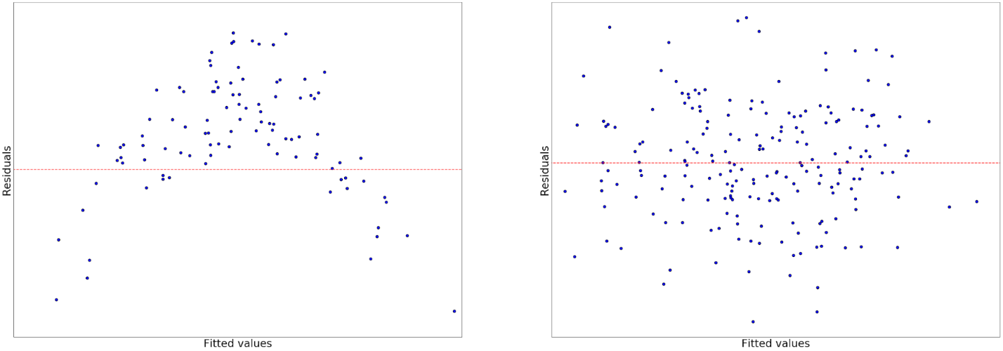

Feedback?

A residual plot with a fan-shaped distribution of data points suggests that some data points have a smaller variance than others. Since the variance is not constant, such a plot suggests violation of the homoscedasticity assumption.

Figure 7.2.2: A heteroscedastic dataset (left) and a homoscedastic dataset (right).

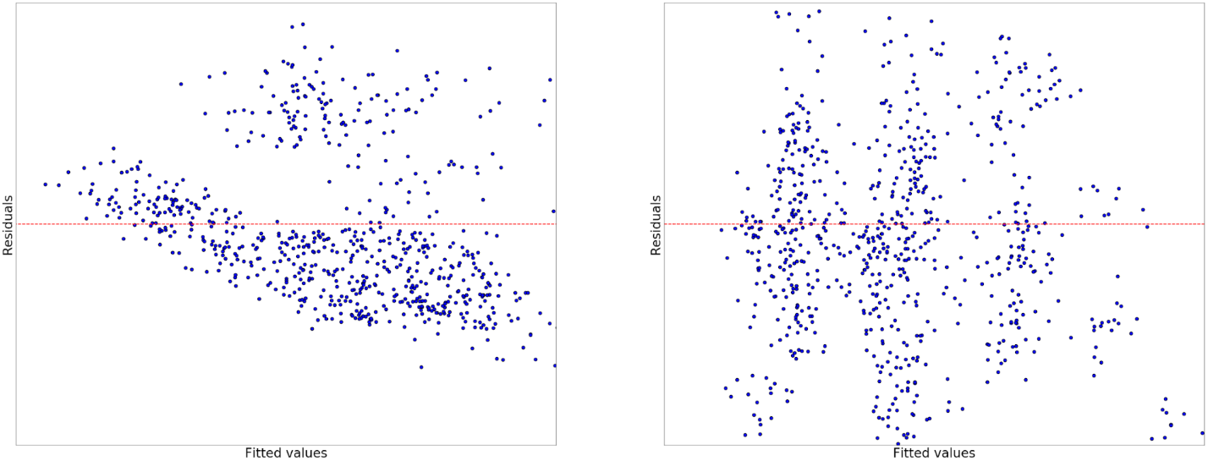

Feedback?

Python-Practice 7.2.1: Residual plots.

**import** pandas as pd

**import** statsmodels.formula.api as sms

**import** matplotlib.pyplot as plt

fat = pd.read_csv('https://static-resources.zybooks.com/static/fat.csv')

# Response variable

Y = fat['body_fat_percent']

# Generates the linear regression model

# Multiple predictor variables are joined with +

model = sms.ols('Y ~ triceps_skinfold_thickness_mm + midarm_circumference_cm + thigh_circumference_cm', data = fat).fit()

plt.figure(figsize = (20, 16))

plt.tight_layout()

plt.subplot(2, 2, 1)

plt.scatter(x = fat['triceps_skinfold_thickness_mm'], y = model.resid, color = 'blue', edgecolor = 'k')

xmin = min(fat['triceps_skinfold_thickness_mm'])

xmax = max(fat['triceps_skinfold_thickness_mm'])

plt.hlines(y = 0, xmin = xmin, xmax = xmax, color = 'red', linestyle = '--')

plt.xlabel('$X_1$', fontsize = 16)

plt.ylabel('Residuals', fontsize = 16)

plt.xticks(fontsize = 12)

plt.yticks(fontsize = 12)

plt.title('$X_1$ vs. residuals', fontsize = 24)

plt.subplot(2, 2, 2)

plt.scatter(x = fat['midarm_circumference_cm'], y = model.resid, color = 'blue', edgecolor = 'k')

xmin = min(fat['midarm_circumference_cm'])

xmax = max(fat['midarm_circumference_cm'])

plt.hlines(y = 0, xmin = xmin, xmax = xmax, color = 'red', linestyle = '--')

plt.xlabel('$X_2$', fontsize = 16)

plt.ylabel('Residuals', fontsize = 16)

plt.xticks(fontsize = 12)

plt.yticks(fontsize = 12)

plt.title('$X_2$ vs. residuals', fontsize = 24)

plt.subplot(2, 2, 3)

plt.scatter(x = fat['thigh_circumference_cm'], y = model.resid, color = 'blue', edgecolor = 'k')

xmin = min(fat['thigh_circumference_cm'])

xmax = max(fat['thigh_circumference_cm'])

plt.hlines(y = 0, xmin = xmin, xmax = xmax, color = 'red', linestyle = '--')

plt.xlabel('$X_3$', fontsize = 16)

plt.ylabel('Residuals', fontsize = 16)

plt.xticks(fontsize = 12)

plt.yticks(fontsize = 12)

plt.title('$X_3$ vs. residuals', fontsize = 24)

plt.subplot(2, 2, 4)

plt.scatter(x = model.fittedvalues, y = model.resid, color = 'blue', edgecolor = 'k')

xmin = min(Y)

xmax = max(Y)

plt.hlines(y = 0, xmin = xmin, xmax = xmax, color = 'red', linestyle = '--')

plt.xlabel('Fitted values', fontsize = 16)

plt.ylabel('Residuals', fontsize = 16)

plt.xticks(fontsize = 12)

plt.yticks(fontsize = 12)

plt.title('Fitted values vs. residuals', fontsize = 24)

plt.show()

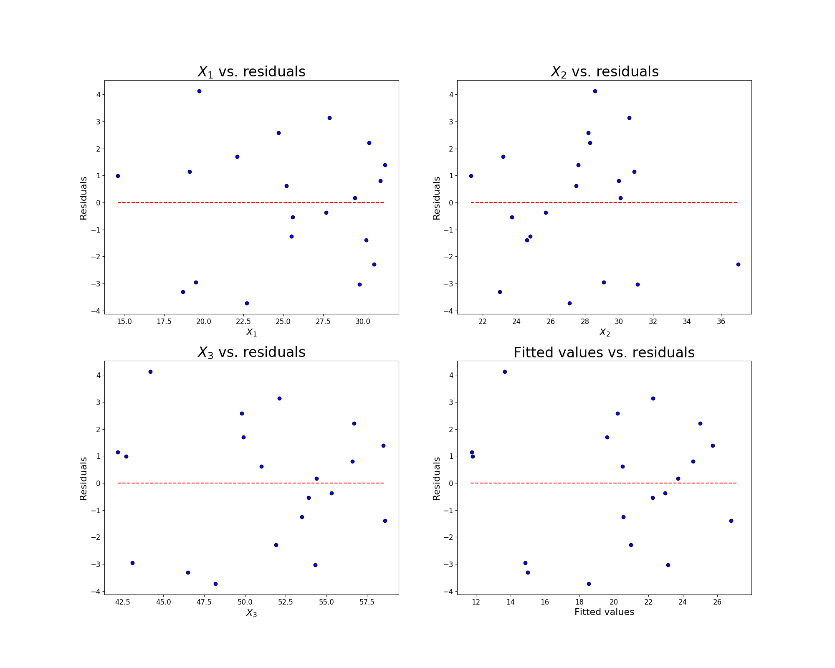

[Run example](https://trinket.io/library/trinkets/f4d6e33f38)

Feedback?

A Q-Q plot can be used to visually evaluate the assumption of normality. A Q-Q plot in which the points deviate significantly from the diagonal line suggests violation of the normality assumption.

Figure 7.2.3: Q-Q plots of datasets with non-normally distributed residuals (left) and normally distributed residuals (right).

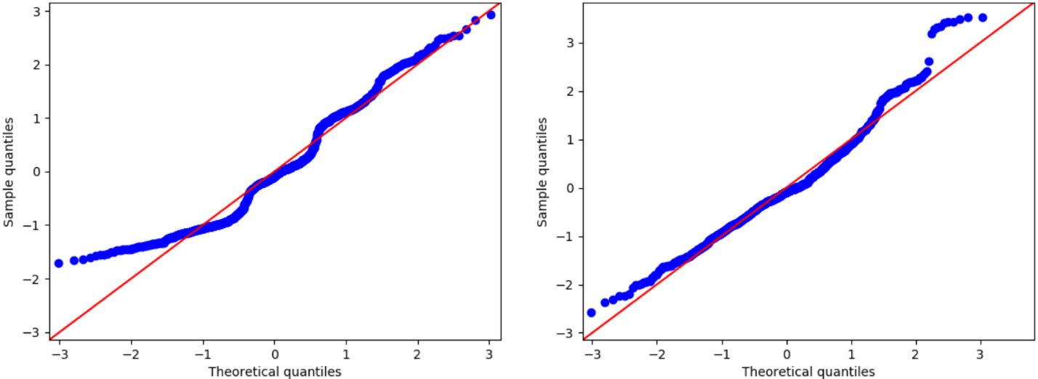

Feedback?

Python-Practice 7.2.2: qqplot().

The qqplot method is used to generate a Q-Q plot.

|  |
| --- |
| **import** pandas as pd  **import** statsmodels.graphics.gofplots as smg  **import** statsmodels.formula.api as sms  **import** matplotlib.pyplot as plt  fat = pd.read_csv('https://static-resources.zybooks.com/static/fat.csv')  # Response variable  Y = fat['body_fat_percent']  # Generates the linear regression model  # Multiple predictor variables are joined with +  model = sms.ols('Y ~ triceps_skinfold_thickness_mm + midarm_circumference_cm + thigh_circumference_cm', data = fat).fit()  plt.figure(figsize = (8 ,5))  plt.subplot(1, 2, 1)  fig = smg.qqplot(model.resid, line = '45', fit = 'True')  plt.xlabel('Theoretical quantiles')  plt.ylabel('Sample quantiles')  plt.title('Q-Q plot of normalized residuals')  plt.show() |

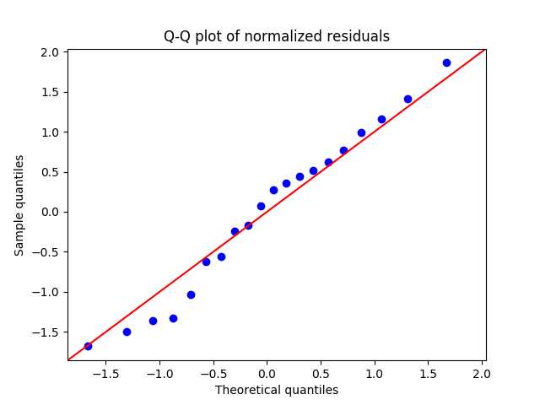

[Run example](https://trinket.io/library/trinkets/3fcf9fdec4)

Care must be taken when checking the multiple regression assumptions graphically:

* Assessing whether a particular plot supports an assumption is subjective. One should question an assumption when a clear non-random pattern exists in a plot, but not be overly concerned with weak patterns.
* Checking assumptions graphically requires a reasonably large sample size, typically at least 30.
* Ideally, all four assumptions should hold for a model to be valid.
* That said, multiple regression models are reasonably robust to mild violations of the assumptions.
* Severe violations of the assumptions can be addressed through more complex models, some of which are considered in a later section.

### Issues with multiple regression models

Individual data observations can have a relatively strong influence on multiple regression models because of the presence of outliers and high-leverage observations.

An ***outlier*** is an observation in a multiple regression analysis that has an extreme residual. For an outlier to be extreme, the observation's Y value is either much larger than predicted by the model or much smaller than predicted by the model.

A ***high leverage observation*** is an observation in a multiple regression analysis that has an extreme combination of predictor values. An extreme combination of values might be particularly high or low values for all the predictors or a combination of predictor values that is relatively unusual. A high leverage observation has the potential to be highly influential on the results of the multiple regression analysis.

Another potential problem is the presence of multicollinearity. ***Multicollinearity*** occurs when two or more predictors in a multiple regression model are so highly correlated that the estimated model becomes unstable meaning that the regression parameter estimates become unreliable with inflated standard errors. Interpreting a multiple regression model in the presence of multicollinearity can be challenging. However, estimation and prediction for a multiple regression model in the presence of multicollinearity is relatively unaffected.

### Coefficient of multiple determination

In the simple linear regression chapter, the coefficient of determination was defined as the percent variance in the response variable explained by the predictor variable. A similar quantity called the coefficient of multiple determination exists for models with two or more predictor variables. The ***coefficient of multiple determination***, denoted by R2, measures the ratio of total variance in the response variable, Y, that is explained by the predictor variables X1,…,Xn.

The coefficient of determination is given by the formula

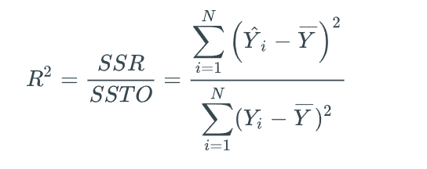

where SSR denotes the regression sum of squares or the variance explained by the predictor variables X1,…,Xn, SSTO denotes the total sum of squares or the total variance, and N is the sample size.

Python-Practice 7.3.1: Coefficient of multiple determination.

Consider the [body fat](https://static-resources.zybooks.com/static/fat.csv) dataset and a model where the response variable Y is percent body fat and the predictor variable X1 is triceps skinfold thickness in millimeters. The model is constructed using the code below.

R-squared: 0.711, which means that 71.1% of the variance in percent body fat can be explained by the variance in triceps skinfold thickness.

|  |
| --- |
| **import** pandas as pd  **import** statsmodels.api as sm  **from** statsmodels.formula.api **import** ols  **from** statsmodels.stats.anova **import** anova_lm  fat = pd.read_csv('https://static-resources.zybooks.com/static/fat.csv')  # Response variable  Y = fat['body_fat_percent']  m01 = ols('Y ~ triceps_skinfold_thickness_mm', data = fat).fit()  **print**(m01.summary()) |
| OLS Regression Results  ==============================================================================  Dep. Variable: Y R-squared: 0.711  Model: OLS Adj. R-squared: 0.695  Method: Least Squares F-statistic: 44.30  Date: Mon, 15 Jul 2019 Prob (F-statistic): 3.02e-06  Time: 21:16:05 Log-Likelihood: -48.058  No. Observations: 20 AIC: 100.1  Df Residuals: 18 BIC: 102.1  Df Model: 1  Covariance Type: nonrobust  =================================================================================================  coef std err t P>|t| [0.025 0.975]  -------------------------------------------------------------------------------------------------  Intercept -1.4961 3.319 -0.451 0.658 -8.470 5.477  triceps_skinfold_thickness_mm 0.8572 0.129 6.656 0.000 0.587 1.128  ==============================================================================  Omnibus: 1.783 Durbin-Watson: 1.928  Prob(Omnibus): 0.410 Jarque-Bera (JB): 1.511  Skew: -0.600 Prob(JB): 0.470  Kurtosis: 2.389 Cond. No. 136.  ============================================================================== |

Adding another predictor variable, midarm circumference X2, to the model increases the value of R2 to 0.786 or 78.6%. In other words, using both triceps skinfold thickness and midarm circumference, instead of just triceps skinfold thickness, improved the model's ability to predict a person's percent body fat. The addition of X2 made the model more accurate and increased the explained variance by 78.6%−71.1%=7.5%.

|  |
| --- |
| m12 = ols('Y ~ triceps_skinfold_thickness_mm + midarm_circumference_cm', data = fat).fit()  **print**(m12.summary()) |
| OLS Regression Results  ==============================================================================  Dep. Variable: Y R-squared: 0.786  Model: OLS Adj. R-squared: 0.761  Method: Least Squares F-statistic: 31.25  Date: Mon, 15 Jul 2019 Prob (F-statistic): 2.02e-06  Time: 21:16:05 Log-Likelihood: -45.050  No. Observations: 20 AIC: 96.10  Df Residuals: 17 BIC: 99.09  Df Model: 2  Covariance Type: nonrobust  =================================================================================================  coef std err t P>|t| [0.025 0.975]  -------------------------------------------------------------------------------------------------  Intercept 6.7916 4.488 1.513 0.149 -2.678 16.261  triceps_skinfold_thickness_mm 1.0006 0.128 7.803 0.000 0.730 1.271  midarm_circumference_cm -0.4314 0.177 -2.443 0.026 -0.804 -0.059  ==============================================================================  Omnibus: 1.363 Durbin-Watson: 2.371  Prob(Omnibus): 0.506 Jarque-Bera (JB): 0.873  Skew: 0.068 Prob(JB): 0.646  Kurtosis: 1.985 Cond. No. 304.  ============================================================================== |

Adding thigh circumference X3 to a model with two predictor variables further increases the value of R2 to 0.801 as shown in the output below.

|  |
| --- |
| m = ols('Y ~ triceps_skinfold_thickness_mm + midarm_circumference_cm + thigh_circumference_cm', data = fat).fit()  **print**(m.summary()) |
| OLS Regression Results  ==============================================================================  Dep. Variable: Y R-squared: 0.801  Model: OLS Adj. R-squared: 0.764  Method: Least Squares F-statistic: 21.52  Date: Mon, 15 Jul 2019 Prob (F-statistic): 7.34e-06  Time: 21:16:05 Log-Likelihood: -44.312  No. Observations: 20 AIC: 96.62  Df Residuals: 16 BIC: 100.6  Df Model: 3  Covariance Type: nonrobust  =================================================================================================  coef std err t P>|t| [0.025 0.975]  -------------------------------------------------------------------------------------------------  Intercept 117.0847 99.782 1.173 0.258 -94.445 328.614  triceps_skinfold_thickness_mm 4.3341 3.016 1.437 0.170 -2.059 10.727  midarm_circumference_cm -2.1861 1.595 -1.370 0.190 -5.568 1.196  thigh_circumference_cm -2.8568 2.582 -1.106 0.285 -8.330 2.617  ==============================================================================  Omnibus: 1.200 Durbin-Watson: 2.243  Prob(Omnibus): 0.549 Jarque-Bera (JB): 0.830  Skew: -0.085 Prob(JB): 0.660  Kurtosis: 2.016 Cond. No. 1.15e+04  ============================================================================== |

Alternatively, the value of R2 for the model above with three predictor variables can be computed from the analysis of variance table.

|  |
| --- |
| X = fat[ [ 'triceps_skinfold_thickness_mm',  'midarm_circumference_cm', 'thigh_circumference_cm']]  model = ols('Y ~ X', data = fat).fit()  **print**(sm.stats.anova_lm(model, typ=2)) |
| sum_sq df F PR(>F)  X 396.984612 3.0 21.515712 0.000007  Residual 98.404888 16.0 NaN NaN |

The variance explained by X1, X2, and X3 is 396.984612 and the total variance is 396.984612+98.404888=495.3895. Thus,

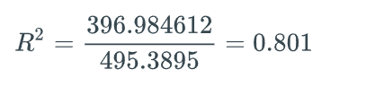

### Adjusted coefficient of multiple determination

The ***adjusted coefficient of multiple determination***, denoted by Radj2, is an adjustment to R2 that allows alternative models for the same response variable to be compared. The formula for the adjusted coefficient of multiple determination is given by

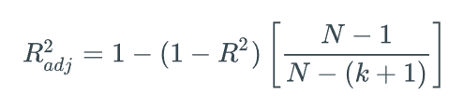

where N is the sample size and k is the number of predictor variables.

The value of Radj2 only tends to increase when a worthwhile predictor is added to the model. In general, a model with a higher Radj2 value is preferable to a model with a lower value. However, Radj2 should not be used in isolation, but rather in conjunction with other criteria such as whether the model provides useful answers to the research questions and gives relatively precise predictions. These issues are beyond the scope of this material.

Example 7.3.1: Finding the adjusted coefficient of determination.

Consider a simple case of the body fat model with 1 predictor variable X1= triceps skinfold thickness. The coefficient of determination for this model is R2=0.711. Find the adjusted coefficient of determination using the formula above given that the sample size is 20.

#### Solution

Since the sample size is 20 and the model contains 1 predictor variable, N=20 and k=1. The formula 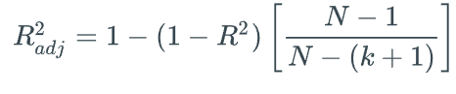is used in the calculation below.

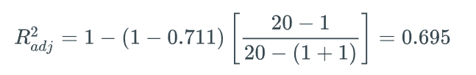The resulting adjusted coefficient of determination Radj2=0.695 is consistent with the ols output in the earlier subsection.

### Interpreting regression parameters

The parameter estimates for the sample multiple regression function, Y^=b0+b1X1+b2X2+…+bnXn, have the following interpretations:

* b0 represents the Y-intercept of a sample multiple regression function which is the fitted value of Y when X1=X2=…=Xn=0.
* b1,b2,…,bneach represent the slope with respect to a particular predictor variable of a sample multiple regression function.

The Y-intercept, b0, has a practical meaning for datasets in which X1=X2=…=Xn=0 are meaningful values and sample data exist at or near X1=X2=…=Xn=0. The measurement unit of b0 is the same as the measurement unit of the response Y variable. The Y-intercept has no practical meaning for datasets in which X1=X2=…=Xn=0 are not meaningful values or no sample data are close to X1=X2=…=Xn=0.

The other parameter estimates, b1,b2,…,bn, always have a practical meaning. The measurement unit of b1 is the measurement unit of Y per the measurement unit of X1. In other words, the estimated slope parameter for a variable represents the change in the fitted value of Y per unit change in the variable when the other predictors are fixed.

A consideration when constructing multiple regression models is *multicollinearity*, which occurs when two or more predictors in the model are so highly correlated that regression parameter estimates become unreliable with inflated standard errors. Interpreting a regression parameter in the presence of multicollinearity can be challenging and is beyond the scope of this material.

Example 7.4.1: Percent body fat.

Consider the [body fat](https://static-resources.zybooks.com/static/fat.csv) dataset and a model where the response variable Y is percent body fat and the predictor variables X1= triceps skinfold thickness (mm) and X2= midarm circumference (cm). The sample multiple regression model is given by Y^=6.792+1.001X1−0.431X2.

For each question below, state the units and practical interpretation of the quantity.

1. What is the estimate for the intercept parameter?
2. What is the estimate for the slope parameter with respect to X1?

#### Solution

1. The estimate for the intercept parameter is b0=6.792 percent body fat. However, this value does not have any practical meaning, because body measurements cannot be equal to zero.
2. The estimate for the slope parameter with respect to X1 is b1=1.001 percent per millimeter. 1.001 represents the expected change in body fat when triceps skinfold circumference increases by one unit and midarm circumference is fixed.

#### Analysis

If triceps skinfold circumference and midarm circumference were too highly correlated, then increasing triceps skinfold circumference by one unit while keeping midarm circumference fixed might be impractical. This difficulty in interpreting regression parameters in the presence of multicollinearity means that multicollinearity is generally avoided when parameter interpretation is important for the application at hand.

Python-Practice 7.4.1: Multiple regression models.

Consider the [body fat](https://static-resources.zybooks.com/static/fat.csv) dataset and a model where the response variable Y is percent body fat and the predictor variables X1= triceps skinfold thickness (mm) and X2= midarm circumference (cm). The model is constructed using the code below.

|  |
| --- |
| **import** pandas as pd  **from** statsmodels.formula.api **import** ols  fat = pd.read_csv('https://static-resources.zybooks.com/static/fat.csv')  Y = fat['body_fat_percent']  m12 = ols('Y ~ triceps_skinfold_thickness_mm + midarm_circumference_cm', data = fat).fit()  **print**(m12.summary()) |

R-squared measures the proportion of total variation in Y that is accounted for by the multiple regression model, which is 0.786. Adj. R-squared is an adjustment to R-squared that allows alternative models for the same response variable to be compared. F-statistic and Prob (F-statistic) tests whether no linear regression relationship exists between Y and the the set {X1,X2}.

|  |
| --- |
| OLS Regression Results  ==============================================================================  Dep. Variable: Y R-squared: 0.786  Model: OLS Adj. R-squared: 0.761  Method: Least Squares F-statistic: 31.25  Date: Mon, 15 Jul 2019 Prob (F-statistic): 2.02e-06  Time: 23:19:26 Log-Likelihood: -45.050  No. Observations: 20 AIC: 96.10  Df Residuals: 17 BIC: 99.09  Df Model: 2  Covariance Type: nonrobust |

The coef column in the table below are the estimates for the parameters, which are b0=6.7916, b1=1.0006, and b2=−0.4314. Thus, the equation for the model is Y^=6.7916+1.0006X1−0.4314X2. The std err column contains standard errors of the regression parameter estimators, which measure the precision of the estimators. The t column contains individual t-statistics for the regression parameter estimators, equal to each estimate divided by its standard error. The next column contains individual p-values for the regression parameter estimators, equal to the sum of the tail areas beyond the t-statistic. The last two columns give the lower and upper bounds of the 95% confidence interval.

|  |
| --- |
| =================================================================================================  coef std err t P>|t| [0.025 0.975]  -------------------------------------------------------------------------------------------------  Intercept 6.7916 4.488 1.513 0.149 -2.678 16.261  triceps_skinfold_thickness_mm 1.0006 0.128 7.803 0.000 0.730 1.271  midarm_circumference_cm -0.4314 0.177 -2.443 0.026 -0.804 -0.059 |

### Interpreting residual standard error

As with simple linear models, several quantities in multiple regression models use the residuals ϵi=Yi−Y^i. These quantities are restated below for review. Recall that Yi is the actual value of the response variable, Y^i is the fitted value of Yi, and Y¯ is the sample mean of the response values.

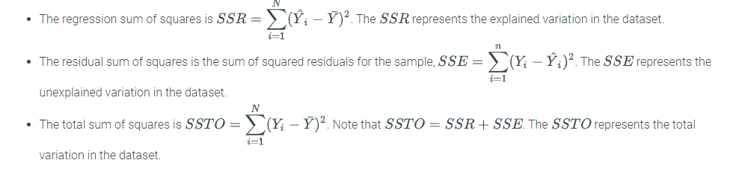

Intuitively, the magnitude of the residuals indicate the strength of the model. The closer the residuals are to zero, the more effective the model is in predicting the values of the dependent variable. Since residuals can be positive or negative and the mean of the residuals is zero, computing the square root of the mean squared residual is sometimes more useful.

The ***residual mean square error*** (***residual standard error***), denoted by RMSE, is the square root of the mean squared residual, which estimates the standard deviation of the residuals. The residual standard error is obtained using the formula

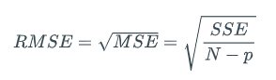where N is the sample size and p=n+1 is the number of regression parameters.

The measurement unit of the residual standard error is the same as the measurement unit of the response Y variable. The residual standard error is a measure of the precision of a model prediction. The sample multiple regression function can be used to predict a future value of Y for fixed values of X1,X2,…,Xn. A relatively small residual standard error indicates that the actual future value of Y is likely to be relatively close to the predicted value. Therefore, less residual standard error is better.

Python-Practice 7.4.2: Analysis of variance table.

The mean standard error and standard residual error can be obtained using an analysis of variance table. Consider the [body fat](https://static-resources.zybooks.com/static/fat.csv) dataset and a model where the response variable Y is percent body fat and the two predictor variables are X1= is triceps skinfold thickness (mm) and X2= midarm circumference (cm).

|  |
| --- |
| **import** pandas as pd  **import** statsmodels.api as sm  **from** statsmodels.formula.api **import** ols  fat = pd.read_csv('https://static-resources.zybooks.com/static/fat.csv')  Regression = fat[['triceps_skinfold_thickness_mm', 'midarm_circumference_cm']]  Y = fat['body_fat_percent']  m12 = ols('Y ~ Regression', fat).fit()  **print**(sm.stats.anova_lm(m12, typ=2)) |
| sum_sq df F PR(>F)  sum_sq df F PR(>F)  Regression 389.455334 2.0 31.249317 0.000002  Residual 105.934166 17.0 NaN NaN |

In the output, the sum_sq column gives the SSR and SSE, which are 389.455334 and 105.934166 respectively. 389.455334 is the variation in percent body fat explained by the variation in triceps skinfold thickness and midarm circumference. 105.934166 is the variation in percent body fat unexplained by the variation in triceps skinfold thickness and midarm circumference.

The mean square residual can be obtained by dividing SSE=105.934166 by N−p=20−3=17, which is also given by the residual degrees of freedom dfE in the df column. Using these values yields the mean square residual below.



### Hypothesis tests for multiple regression

In a multiple regression model, if a parameter is zero, then the corresponding predictor is redundant. To keep the model as simple, interpretable, and generalizable as possible, predictors with a regression parameter of zero should be removed.

Consider the model Y=β0+β1X1+β2X2+…+βnXn+ϵ. Two types of hypothesis tests are available to determine whether the estimator is sufficiently close enough to zero to warrant the removal of the corresponding predictor variable.

Table 7.5.1: Hypothesis tests for multiple regression.

|  |  |  |
| --- | --- | --- |
| Test | Research question | Null and alternative hypotheses |
| Overall F-test | Determine whether a linear relationship exists with at least one predictor variable | H0:β1=β2=…=βn=0 Ha: At least one βi≠0 for i=1,2,…,n. |
| Individual t-test | Determine whether a single variable has an effect | H0:βi=0 for some i=1,…,n Ha:βi≠0 |

Feedback?

Example 7.5.1: A closer look at the percent body fat model.

Consider the [body fat](https://static-resources.zybooks.com/static/fat.csv) model with response variable Y= percent body fat and three predictor variables X1= triceps trifold thickness, X2= midarm circumference, and X3= thigh circumference.

For each of the questions below, determine the appropriate hypothesis test, and state the null and alternative hypotheses.

1. Is a model with at least one predictor variable useful in predicting a person's percent body fat?
2. Is triceps trifold thickness significantly related to percent body fat?

#### Solution

1. Overall F-test. The null hypothesis is that the model is not useful and thus all slope parameters β1,β2,β3 are equal to zero. That is, H0:β1=β2=β3=0. If at least one predictor is useful in predicting a person's percent body fat, then at least one of slope parameters should be non-zero. That is, Ha: At least one βi≠0 for i=1,2,3.
2. t-test. The null hypothesis is that triceps trifold thickness is not significantly related to percent body fat. Thus, H0:β1=0 and Ha:β1≠0.

### Overall **F**-test

The overall F-test considers *all* the regression parameters other than the intercept parameter, β0. The ***multiple regression overall***F***-test*** is a method for testing H0:β1=β2=…=βn=0 versus Ha: At least one βi≠0 for i=1,2,…,n.

Overall F-test

The steps for the overall F-test are as follows:

* Set the null hypothesis, H0:β1=β2=…=βn=0, versus the alternative hypothesis, Ha: At least one βi≠0 for i=1,2,…,n.
* Use statistical software to find the F-statistic, which is the regression mean square divided by the residual mean square.
* Use statistical software to find the p-value that corresponds to the F-statistic. The p-value is the probability of observing an F-statistic at least as far from 0 as the one observed, if the null hypothesis were true.
* Make a decision based on a selected significance level, typically 0.05:
  + If the p-value is less than the significance level, reject the null hypothesis, H0:β1=β2=⋯=βp−1=0, in favor of the alternative hypothesis, Ha: At least one βi≠0 for i=1,2,…,n. Conclude that at least one βk is significantly different from 0, which means that a significant linear relationship exists between Y and the set {X1,X2,…,Xn}.
  + If the p-value is greater than or equal to the significance level, fail to reject the null hypothesis, H0:β1=β2=…=βn=0, in favor of the alternative hypothesis, Ha: At least one βi≠0 for i=1,2,…,n. Conclude that no βk is significantly different from 0, which means that a significant linear relationship does not exist between Y and the set {X1,X2,…,Xn}.

Example 7.5.2: Performing the overall F-test on the percent body fat model.

Consider the [body fat](https://static-resources.zybooks.com/static/fat.csv) model with response variable Y= percent body fat and three predictor variables X1= triceps trifold thickness, X2= midarm circumference, and X3= thigh circumference. Does a linear relationship exist with at least one variable?

OLS Regression Results

==============================================================================

Dep. Variable: Y R-squared: 0.801

Model: OLS Adj. R-squared: 0.764

Method: Least Squares F-statistic: 21.52

Date: Mon, 15 Jul 2019 Prob (F-statistic): 7.34e-06

Time: 18:46:57 Log-Likelihood: -44.312

No. Observations: 20 AIC: 96.62

Df Residuals: 16 BIC: 100.6

Df Model: 3

Covariance Type: nonrobust

=================================================================================================

coef std err t P>|t| [0.025 0.975]

-------------------------------------------------------------------------------------------------

Intercept 117.0847 99.782 1.173 0.258 -94.445 328.614

triceps_skinfold_thickness_mm 4.3341 3.016 1.437 0.170 -2.059 10.727

midarm_circumference_cm -2.1861 1.595 -1.370 0.190 -5.568 1.196

thigh_circumference_cm -2.8568 2.582 -1.106 0.285 -8.330 2.617

==============================================================================

Omnibus: 1.200 Durbin-Watson: 2.243

Prob(Omnibus): 0.549 Jarque-Bera (JB): 0.830

Skew: -0.085 Prob(JB): 0.660

Kurtosis: 2.016 Cond. No. 1.15e+04

==============================================================================

Warnings:

[1] Standard Errors assume that the covariance matrix of the errors is correctly specified.

[2] The condition number is large, 1.15e+04. This might indicate that there are

strong multicollinearity or other numerical problems.

[Run example](https://trinket.io/library/trinkets/6e27514cdb)

#### Solution

The null hypothesis is that no relationship exists between any of the predictor variables X1, X2, and X3 and the response variable Y. The alternative hypothesis is that a relationship exists with at least one variable.

Mathematically, the null and alternative hypotheses are

H0:β1=β2=β3=0  
Ha: At least one βi≠0 for i=1,2,3

The overall F-statistic is F=21.52 with a corresponding p-value of 7.34⋅10−6. Since this p-value is close to 0, sufficient evidence exists to reject the null hypothesis, which suggests that at least one of X1, X2, and X3 is linearly related to Y.

### Individual t-test

An individual t-test considers *one* of the regression parameters. A ***multiple regression individual***t***-test*** is a method for testing H0:βi=0 versus Ha:βi≠0. Ex: The body fat example has three regression parameters other than the intercept parameter. One individual t-test could test H0:β1=0. Other t-tests could be H0:β2=0 and H0:β3=0.

Individual t-test

The steps for an individual t-test are as follows:

* Set the null hypothesis, H0:βi=0, versus the alternative hypothesis, Ha:βi≠0.
* Use statistical software to find the t-statistic, which is bi divided by the standard error of bi.
* Use statistical software to find the p-value that corresponds to the t-statistic. The p-value is the probability of observing a t-statistic at least as far from 0 as the one observed, if the null hypothesis were true. The reference t-distribution has n−p degrees of freedom.
* Make a decision based on a selected significance level, typically 0.05:
  + If the p-value is less than the significance level, reject the null hypothesis, H0:βi=0, in favor of the alternative hypothesis, Ha:βi≠0. Conclude that βi is significantly different from 0, which means that a significant linear relationship exists between Y and Xi when the remaining predictor variables in the model are fixed. Thus, Xi should not be dropped from the model.
  + If the p-value is greater than or equal to the significance level, fail to reject the null hypothesis, H0:βi=0, in favor of the alternative hypothesis, Ha:βi≠0. Conclude that βi is not significantly different from 0, which means that a significant linear relationship does not exist between Y and Xi when the remaining predictor variables in the model are fixed. Thus, a new model should be investigated in which Xi has been dropped from the model but the remaining predictor variables are retained.

Example 7.5.3: Performing the t-test on the percent body fat model.

Consider the [body fat](https://static-resources.zybooks.com/static/fat.csv) model with response variable Y= percent body fat and two predictor variables X1= triceps trifold thickness and X2= midarm circumference. At the α=0.01 significance level, does midarm circumference have a statistically significant effect on percent body fat according to the output below?

OLS Regression Results

==============================================================================

Dep. Variable: Y R-squared: 0.786

Model: OLS Adj. R-squared: 0.761

Method: Least Squares F-statistic: 31.25

Date: Tue, 16 Jul 2019 Prob (F-statistic): 2.02e-06

Time: 00:12:50 Log-Likelihood: -45.050

No. Observations: 20 AIC: 96.10

Df Residuals: 17 BIC: 99.09

Df Model: 2

Covariance Type: nonrobust

=================================================================================================

coef std err t P>|t| [0.025 0.975]

-------------------------------------------------------------------------------------------------

Intercept 6.7916 4.488 1.513 0.149 -2.678 16.261

triceps_skinfold_thickness_mm 1.0006 0.128 7.803 0.000 0.730 1.271

midarm_circumference_cm -0.4314 0.177 -2.443 0.026 -0.804 -0.059

==============================================================================

Omnibus: 1.363 Durbin-Watson: 2.371

Prob(Omnibus): 0.506 Jarque-Bera (JB): 0.873

Skew: 0.068 Prob(JB): 0.646

Kurtosis: 1.985 Cond. No. 304.

==============================================================================

[Run example](https://trinket.io/python3/3d8398f74c)

#### Solution

The null hypothesis is that no relationship exists between the response variable Y and the predictor variable X2. The alternative hypothesis is that a relationship exists.

Mathematically, the null and alternative hypotheses are

H0:β2=0  
Ha:β2≠0

The t-statistic for the midarm circumference estimate is −2.443 with a corresponding p-value of 0.026. Since this p-value is greater than the significance level α=0.01, insufficient evidence exists to reject the null hypothesis, which suggests that percent body fat and midarm circumference are not linearly related.

# **One-way analysis of variance (one-way ANOVA)**

### Comparing three or more populations

The unpaired t-test determines whether a statistically significant difference exists between the means of two populations. However, many situations require that means be compared among three or more populations. Ex: A researcher wants to classify iris species based on sepal length by using a method called k-means clustering. As a first step, the researcher checks whether the mean sepal length differs among three species of iris: *setosa*, *virginica*, and *versicolor*. A possible method to compare the means is to perform three unpaired t-tests: one between *setosa* and *versicolor*, another between *setosa* and *virginica*, and finally between *versicolor* and *virginica*. Although the details are beyond the scope of the material, the probability of rejecting the null hypothesis that no significant difference in population means exists, when using multiple t-tests is 14%. Thus, a different approach is needed.

One-way analysis of variance (one-way ANOVA) controls for the errors associated with comparing multiple population means. ***One-way analysis of variance (one-way ANOVA)*** determines whether a statistically significant difference exists among the means of three or more populations. Equivalently, ANOVA tests for an association between a categorical predictor variable and a response variable. Ex: In the iris study, the predictor variable is the type of species and the response variable is sepal length. Data scientists and statisticians often refer to a categorical predictor variable as a factor and a possible value of a factor as a level. A factor can be a continuous variable partitioned into intervals commonly referred to as bins. Ex: The factor in the iris example, iris type, has three levels: *setosa*, *virginica*, and *versicolor*. If the factor only has two levels, then ANOVA is equivalent to a two-sample t-test with equal variances.

### One-way ANOVA

A model can certainly have multiple predictor variables. However, the material on ANOVA will only cover models with one predictor variable. A ***one-way ANOVA*** compares the means of three or more groups of one predictor variable.

The one-way ANOVA hypothesis test follows the same process as previously discussed tests. The null hypothesis for a one-way ANOVA is that all of the group means are equal. Caution should be exercised when stating the alternative hypothesis because the negation of the null hypothesis does not say that all group means are unequal. Instead, the alternative hypothesis should state that two groups with unequal means exist. The rest of the hypothesis test involves finding the F-statistic and the p-value to make a decision based on a significance level.

The underlying assumptions for the one-way ANOVA are given below.

Assumptions for one-way ANOVA

* *Independence. Samples should be independent and drawn randomly.*
* *Normality. The underlying distribution of the populations from which the samples are drawn should be approximately normal.*
* *Homogeneity. The variances of the population distributions should be equal.*

Procedure 8.1.1: One-way ANOVA.

Given k groups taken from independent populations,

1. Set the null and alternative hypotheses

H0:μ1=μ2=…=μkHa:μi≠μj, for some i≠j

where μ1 and μ2 are means from independent populations.

1. Use statistical software to find the test-statistic

F=between-group variancewithin group variance

1. Use statistical software to find the p-value that corresponds to F.
2. Make a decision given a previously selected significance level α, typically 0.05.
   * If the p-value is less than the significance level, sufficient evidence exists to reject the null hypothesis H0 in favor of the alternative hypothesis Ha.
   * If the p-value is greater than or equal to the significance level, insufficient evidence exists to reject the null hypothesis H0.

Python-Practice 8.1.1: ANOVA.

The f_oneway() function performs a one-way ANOVA. The function takes a number of lists of data as parameters, and returns the F-statistic and the p-value. The scipy.stats and statsmodels.formula.api libraries must be imported to use f_oneway().

|  |
| --- |
| # The Exam Score dataset includes scores obtained in 4 exams in a class.  # Perform a hypothesis test to determine if the mean scores of the exams  # are different. Use the 5% level of significance.  **import** pandas as pd  **import** scipy.stats as st  scores = pd.read_csv('http://data-analytics.zybooks.com/ExamScores.csv')  # Statistics of each exam  exam1_score = scores[['Exam1']]  exam2_score = scores[['Exam2']]  exam3_score = scores[['Exam3']]  exam4_score = scores[['Exam4']]  **print**(st.f_oneway(exam1_score, exam2_score, exam3_score, exam4_score)) |
| F_onewayResult(statistic=array([ 3.85696089]), pvalue=array([ 0.01034867])) |

If the data is labeled according to group, ols() can also be used to generate an ANOVA table, which also gives the F-statistic and the corresponding p-value.

|  |  |
| --- | --- |
| **import** statsmodels.api as sm  **import** pandas as pd  **from** statsmodels.formula.api **import** ols  df = pd.read_csv('http://data-analytics.zybooks.com/ExamScoresGrouped.csv')  mod = ols('Scores ~ Exam',data=df).fit()  aov_table = sm.stats.anova_lm(mod, typ=2)  **print**(aov_table) | sum_sq df F PR(>F)  Exam 2400.735 3.0 3.856961 0.010349  Residual 40666.220 196.0 NaN NaN |

Below is the code to generate the box plots for grouped data.

**import** pandas as pd

**import** seaborn as sns

df = pd.read_csv('http://data-analytics.zybooks.com/ExamScoresGrouped.csv')

sns.boxplot(x="Exam", y="Scores", data=df)

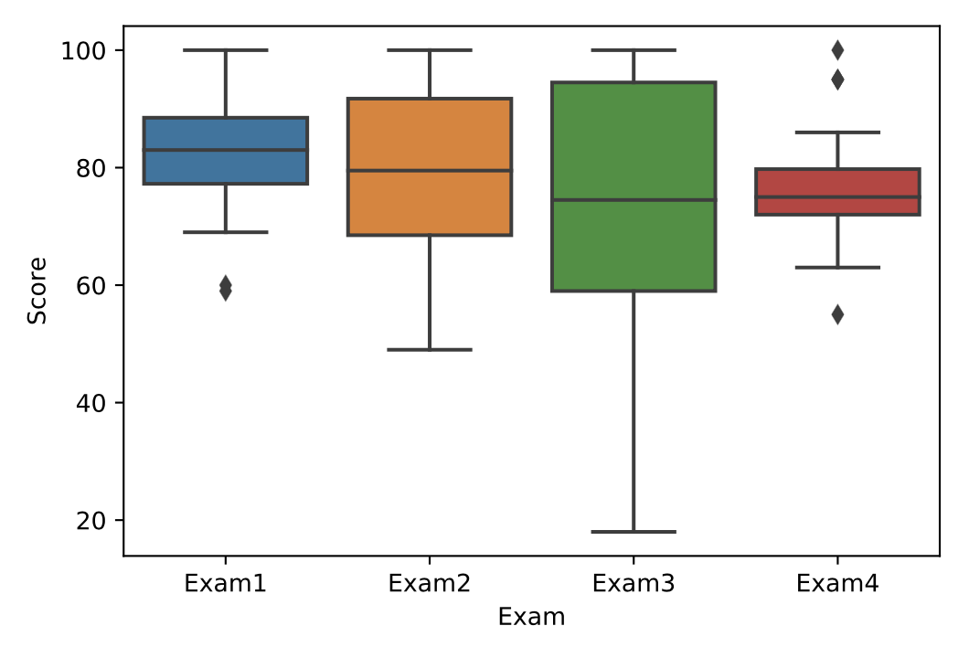

Example 8.1.1: Mean of exam scores.

A teacher believes that the exams created for the class varies in difficulty because of the differences in mean exam scores. Does sufficient evidence exist at the α=0.01 level to support the teacher's belief that the exams scores have different means? Use the ANOVA table below.

sum_sq df F PR(>F)

Exam 2400.735 3.0 3.856961 0.010349

Residual 40666.220 196.0 NaN NaN

#### Solution

The null hypothesis is that the mean exam scores are all the same. The alternative hypothesis is that the means of at least two exam scores are different. Mathematically,

H0:μ1=μ2=μ3=μ4

Ha:μi≠μj for some i≠j

The p-value that corresponds to F=3.857 is P(F≥3.857)=0.0103. Since the p-value is greater than the significance level (0.0103>0.01), the null hypothesis is not rejected. That is, at the α=0.01 significance level, insufficient statistical evidence exists to support the claim that the mean exam scores are different.

#### Analysis

The alternative hypothesis to an F test is that at least two of the means are unequal. Although the means of all exam scores could be all be statistically different, the F test cannot determine which of the exams have statistically different means.

### Post-hoc tests

If the null hypothesis is not rejected, then no further work is necessary. However, if the null hypothesis is rejected, further analysis is required because the F-test does not determine which groups have different means. ***Post-hoc analysis*** determines which groups have different means, which group has the highest or lowest mean, and other relationships between the groups.

The ***Tukey Honestly Significant Difference (HSD)*** procedure gives the 95% confidence intervals for the mean difference between pairwise groups and determines which mean difference is statistically significant.

If 0 falls in the confidence interval, then the difference between the means is not statistically significant. In other words, the null hypothesis that the means of the two groups are the same should not be rejected.

Python-Practice 8.1.2: Tukey's HSD.

The MultipleComparison() function take the data frame column that contains the values and the data frame column that contains the levels as inputs and builds the models. The tukeyhsd() function displays the 95% Tukey's confidence intervals. The statsmodels.stats.multicomp library must be imported to use these functions.

|  |
| --- |
| **import** pandas as pd  **from** statsmodels.stats.multicomp **import** (pairwise_tukeyhsd, MultiComparison)  df = pd.read_csv('http://data-analytics.zybooks.com/ExamScoresGrouped.csv')  mod = MultiComparison(df['Scores'], df['Exam'])  **print**(mod.tukeyhsd()) |
| Multiple Comparison of Means - Tukey HSD,FWER=0.05  ==============================================  group1 group2 meandiff lower upper reject  ----------------------------------------------  Exam1 Exam2 -3.3 -10.7652 4.1652 False  Exam1 Exam3 -9.36 -16.8252 -1.8948 True  Exam1 Exam4 -6.2 -13.6652 1.2652 False  Exam2 Exam3 -6.06 -13.5252 1.4052 False  Exam2 Exam4 -2.9 -10.3652 4.5652 False  Exam3 Exam4 3.16 -4.3052 10.6252 False  ---------------------------------------------- |

[Run example](https://rcoderunner.zybooks.com/index.html?code=import%20pandas%20as%20pd%0Afrom%20statsmodels.stats.multicomp%20import%20(pairwise_tukeyhsd%2CMultiComparison)%0Adf%20%3D%20pd.read_csv(%27http%3A%2F%2Fdata-analytics.zybooks.com%2FExamScoresGrouped.csv%27)%0Amod%20%3D%20MultiComparison(df%5B%27Scores%27%5D%2C%20df%5B%27Exam%27%5D)%0Aprint(mod.tukeyhsd())&language=python)

Feedback?

Example 8.1.2: Determining which exams have statistically different means.

Suppose the ExamScores dataset is tested at a significance level of α=0.05. Thus, a post-hoc test should be performed to determine which two means are statistically equal because the null hypothesis that the means are statistically the same is rejected. Which two groups have statistically different means? Use the output below of the Tukey's HSD test.

Multiple Comparison of Means - Tukey HSD,FWER=0.05

==============================================

group1 group2 meandiff lower upper reject

----------------------------------------------

Exam1 Exam2 -3.3 -10.7652 4.1652 False

Exam1 Exam3 -9.36 -16.8252 -1.8948 True

Exam1 Exam4 -6.2 -13.6652 1.2652 False

Exam2 Exam3 -6.06 -13.5252 1.4052 False

Exam2 Exam4 -2.9 -10.3652 4.5652 False

Exam3 Exam4 3.16 -4.3052 10.6252 False

----------------------------------------------

#### Solution

The output above shows that the confidence interval for the comparison between the means of Exam1 and Exam3 does not contain 0. Thus, sufficient statistical evidence exist to support the claim that the means of Exam1 and Exam3 are different.

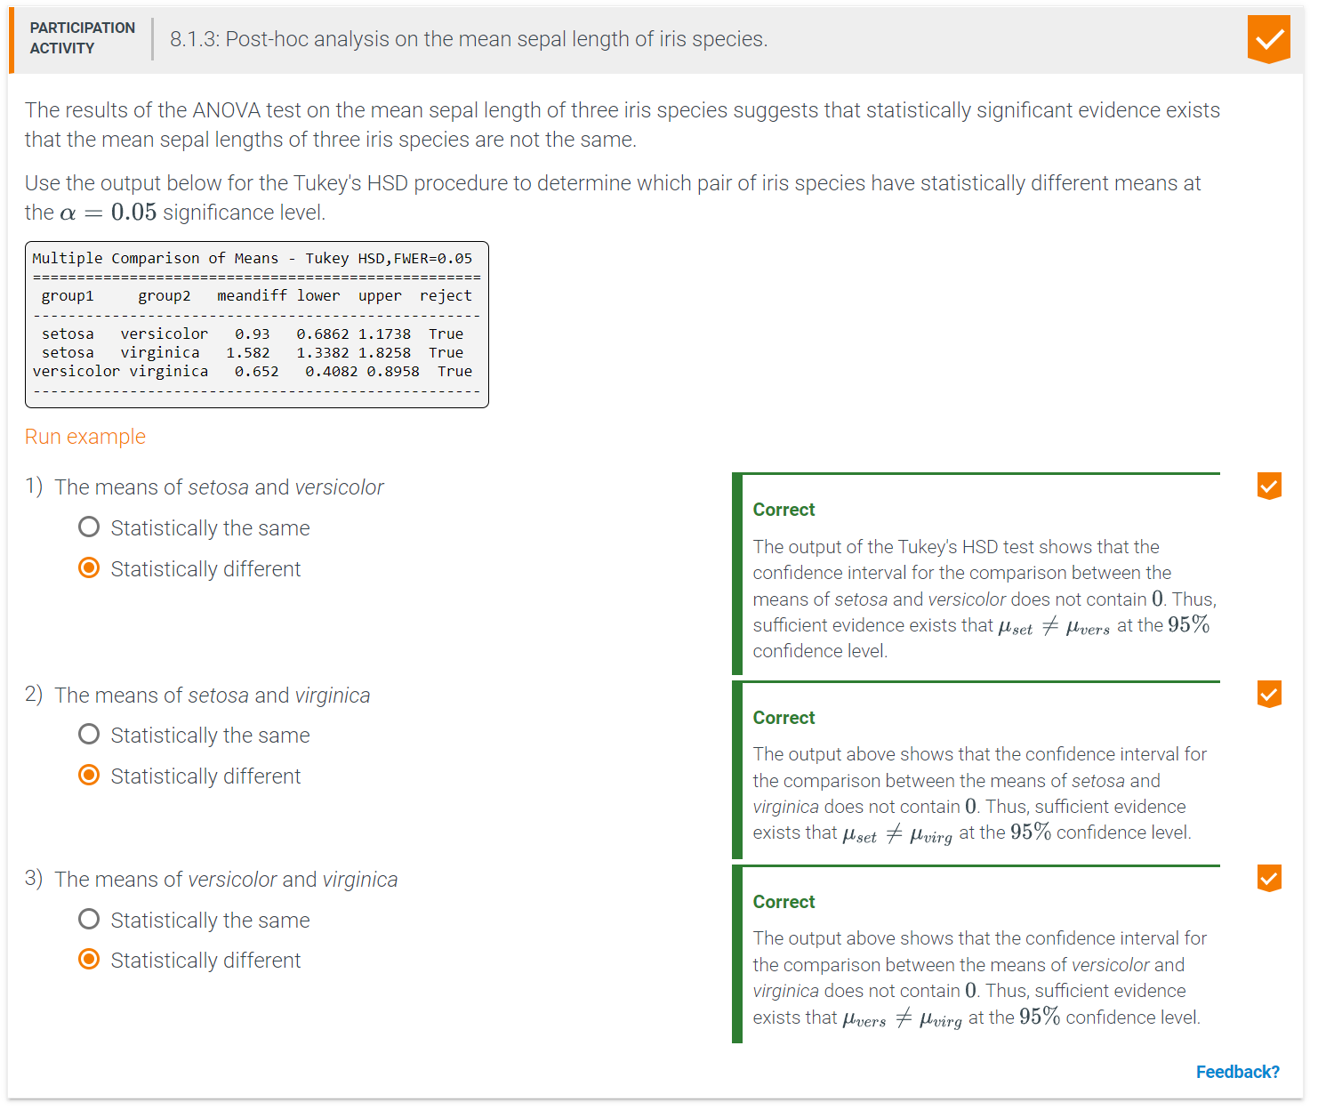

# **Chi-square tests for categorical variables**

### Chi-square goodness-of-fit test

The chi-square distribution can be used to test how close the distribution of a population is to a theoretical distribution. The chi-squared test statistic measures how different the observed counts are compared to the expected counts, assuming the null hypothesis is true. Specifically,

χ2=∑i=1n(Oi−Ei)2Ei.

The difference in observed and expected counts is squared to account for the fact that some of the absolute differences will be positive and some will be negative. Squaring the differences ensures that all terms will be positive. Dividing by the expected count is necessary to scale the differences as a percentage. Ex: If the expected count is 5, a squared difference of 10 is 200% of the expected count (10/5=2). A squared difference of 10 is much less relative to an expected count of 500 (10/500=0.02).

The alternate hypothesis for a chi-squared test is always two-sided, meaning that the proportions are not equal. Thus, if the null hypothesis is rejected, no conclusion can be made on which proportion is larger.

Chi-square test of goodness-of-fit

* Set the null and alternative hypothesis

H0: The random variable follows the expected distribution.

Ha: The random variable does not follow the expected distribution.

Equivalently, the null hypothesis is that the random variable does not follow the expected distribution, in which case, the alternative hypothesis is that the random variable does follow the expected distribution.

* Use to find the test statistic,

χ2=∑i=1n(Oi−Ei)2Ei.

* Use to find the p-value. If the null hypothesis is true, the χ2 test statistic has a chi-squared distribution with degrees of freedom equal to k−1 where k is the number of categories
* Make a decision given a previously selected significance level α, typically 0.05
  + If the p-value is less than the significance level, sufficient evidence exists to reject the null hypothesis, H0, in favor of the alternative hypothesis, Ha. Sufficient evidence exists to conclude that the distribution does not follow the expected distribution.
  + If the p-value is greater than or equal to the significance level, insufficient evidence exists to reject the null hypothesis, H0, in favor of the alternative hypothesis, Ha. Insufficient evidence exists to conclude that the distribution does not follow the expected distribution.

Example 8.2.1: Counting water birds.

A biologist keeps track of the composition of a population of birds on a lake. Last week, 50% of the birds were ducks, 23% were geese, 12% were cranes, 10% were swans, and 5% were coots. This week, the biologist counted 61 ducks, 17 geese, 11 cranes, 15 swans, and 6 coots. Is the composition of the population the same as last week at the α=0.05 significance level?

American Coot. Source: Wikipedia. User: Baird, Mike1

#### Solution

The null hypothesis is that no difference exists between populations from last week and this week. Thus, the expected number of each type of bird is the percent from last week times the total number of birds this week, which is 110.

|  |  |  |
| --- | --- | --- |
| Type | Expected | Observed |
| Ducks | 55 | 61 |
| Geese | 25.3 | 17 |
| Cranes | 13.2 | 11 |
| Swans | 11 | 15 |
| Coots | 5.5 | 6 |

The test statistic is

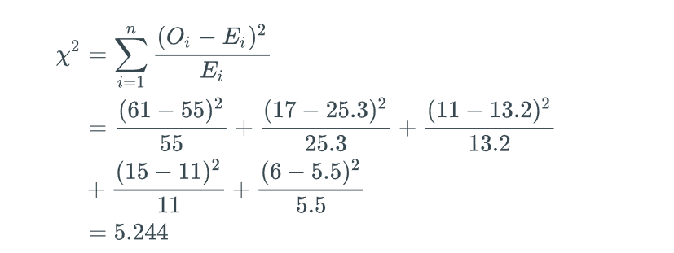The distribution has k−1=4 degrees of freedom. Using technology to calculate the p-value for χ2=5.244 gives P(χ2>5.244)=0.263.

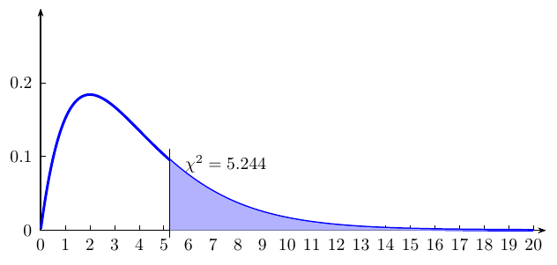

Since 0.263>0.05, insufficient evidence exists to reject the null hypothesis, and the counts of birds this week are consistent with the expected distribution.



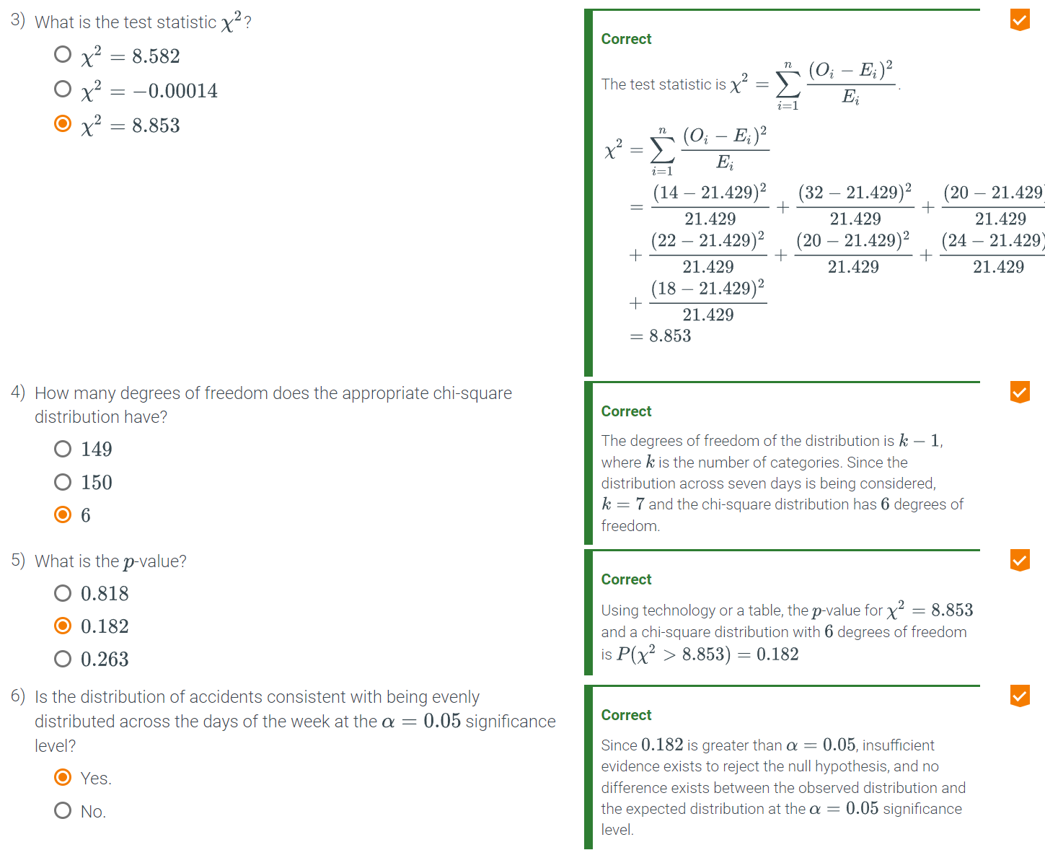

Python-Practice 8.2.1: Using a chi-square goodness-of-fit test.

The chisquare object from the scipy.stats library can be used to perform a chi-square goodness of fit test. Ex: a biologist is counting birds on the lake and comparing the distribution to last week's counts. The observed and expected counts are given in the table below.

|  |  |  |
| --- | --- | --- |
| Type | Expected | Observed |
| Ducks | 55 | 61 |
| Geese | 25.3 | 17 |
| Cranes | 13.2 | 11 |
| Swans | 11 | 15 |
| Coots | 5.5 | 6 |
| **from** scipy.stats **import** chisquare  # Calculates the chi-square statistic and $p$-value for alpha = 0.05 for the given observed and expected counts  statistic, pvalue = chisquare([61, 17, 11, 15, 6], f_exp=[55, 25.3, 13.2, 11, 5.5])  **print**(statistic)  **print**(pvalue) | | | 5.244137022397893  0.26315206062015767 |

### Contingency tables

A chi-square test can also be used to determine whether two or more variables are independent by comparing the distributions of the variables over two or more categories. This test is the chi-square test for independence. The expected counts used to calculate the test statistic in this case come from a contingency table. A contingency table is constructed from the values of the variables and categories along the rows and columns. An expected cell count is calculated by multiplying the row total by the column total and dividing by the overall total.

Example 8.2.2: Calculating the expected counts for a 3x2 contingency table.

A journal article by Stouffer and Tibbits (1933) (Source: Journal of the American Statistical Association)2 examines data on parole violations and punishment records involving 2,963 inmates at the Illinois State Reformatory. Punishment records include no prison time, 1-2 years in prison, or at least 3 years in prison. Violations are annotated as parole violation and no violation. The researchers examine the association between a punishment record while in prison with success or failure while on parole. Use the data in the table below to set up the contingency table necessary to determine if such an association exists.

|  |  |  |  |
| --- | --- | --- | --- |
|  | Violation | |  |
| Punishment | Parole violation | No parole violation | Total by punishment |
| None | 405 | 1422 | 1827 |
| 1-2 | 240 | 470 | 710 |
| 3 or greater | 151 | 275 | 426 |
| Total by violation | 796 | 2167 | 2963 |

#### Solution

To build the contingency table, each expected count is calculated by multiplying the corresponding row and column totals and then dividing by the overall total.

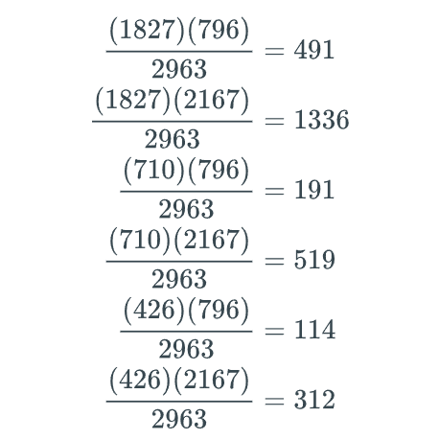

When the process is done correctly, the totals in the Observed and Expected tables will be the same.

|  |  |  |  |  |  |  |  |  |
| --- | --- | --- | --- | --- | --- | --- | --- | --- |
| Observed | | | |  | Expected | | | |
|  | Violation | |  |  | Violation | |  |
| Punishment | Parole violation | No parole violation | Total by punishment | Punishment | Parole violation | No parole violation | Total by punishment |
| None | 405 | 1422 | 1827 | None | 491 | 1336 | 1827 |
| 1-2 | 240 | 470 | 710 | 1-2 | 191 | 519 | 710 |
| 3 or greater | 151 | 275 | 426 | 3 or greater | 114 | 312 | 426 |
| Total by violation | 796 | 2167 | 2963 | Total by violation | 796 | 2167 | 2963 |

### Chi-square test for independence

For a table with r rows and c columns, the test statistic for a chi-squared test follows a chi-squared distribution with (r−1)(c−1) degrees of freedom. For larger tables, the chi-square approximation requires large sample sizes. A rule of thumb is that all expected cell counts should be at least 5.

Chi-square test of independence

* Set the null and alternative hypothesis

H0: The two variables are independent.

Ha: The two variables are not independent.

Equivalently, the null hypothesis is that no association exists between the two variables, in which case, the alternative hypothesis is that association exists between the variables.

* Use statistical software to find the test statistic,

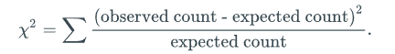

* Use statistical software to find the p-value. If the null hypothesis is true, the χ2 test statistic has a chi-squared distribution with degrees of freedom equal to (r−1)(c−1) where r is the number of categories of the first variable (rows in the table) and c is the number of categories of the second variable (columns in the table).
* Make a decision given a previously selected significance level α, typically 0.05
  + If the p-value is less than the significance level, sufficient evidence exists to reject the null hypothesis, H0, in favor of the alternative hypothesis, Ha. Sufficient evidence exists to conclude that the two variables are not independent.
  + If the p-value is greater than or equal to the significance level, insufficient evidence exists to reject the null hypothesis, H0, in favor of the alternative hypothesis, Ha. Insufficient evidence exists to conclude that the two variables are not independent.

Example 8.2.3: Cats as part of the family.

The table below gives the ages of a sample of cat owners, and whether the cat owner thinks of the cat as part of the family. (Source: Pew Research Center)3

|  |  |  |
| --- | --- | --- |
|  | Part of the family | Not part of the family |
| 18−29 | 82 | 18 |
| 30−49 | 214 | 68 |
| 50−64 | 149 | 40 |
| 65+ | 82 | 26 |

Are the variables age and considering a cat part of the family independent at the α=0.05 significance level?

#### Solution

The null hypothesis is that the variables are independent. The contingency tables for the observed and expected values should be constructed.

|  |  |  |  |  |  |  |
| --- | --- | --- | --- | --- | --- | --- |
| Observed | | |  | Expected | | |
|  | Part of the family | Not part of the family |  | Part of the family | Not part of the family |
| 18−29 | 82 | 18 | 18−29 | 77.614 | 22.386 |
| 30−49 | 214 | 68 | 30−49 | 218.872 | 63.128 |
| 50−64 | 149 | 40 | 50−64 | 146.691 | 42.309 |
| 65+ | 82 | 26 | 65+ | 83.823 | 24.177 |

The test statistic is

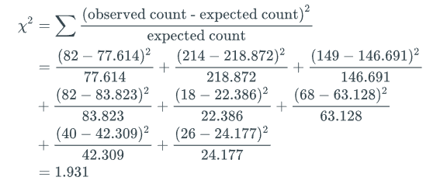

The chi-square distribution has (r−1)(c−1)=3 degrees of freedom. The p-value is 0.587. Since the p-value is greater than α=0.05, the null hypothesis cannot be rejected. Insufficient evidence exists to conclude that the variables are not independent. Typically, statistical software is used to calculated the test statistic and the p-value.

Python-Practice 8.2.2: Chi-squared test of independence.

The chi2_contingency object from the scipy.stats library can be used to perform a chi-square goodness of fit test. Conducting the chi-square test for independence requires first constructing a contingency table. An example using the parole data is shown below. Is there an association between a punishment record while in prison and success or failure while in prison?

|  |
| --- |
| **import** numpy as np  **from** scipy.stats **import** chi2_contingency  # Construct a contingency table  parole = np.array([[405,1422], [240,470], [151,275]]) |

The command for the chi-square test and corresponding output are displayed below.

|  |  |
| --- | --- |
| # Calculate the test statistic, $p$-value, degrees of freedom, and expected counts  chi2, p, df, ex = chi2_contingency(parole)  **print**(chi2)  **print**(p)  **print**(df)  **print**(ex) | 53.87860692066112  1.9971429926442894e-12  2  [[ 490.81741478 1336.18258522]  [ 190.73911576 519.26088424]  [ 114.44346946 311.55653054]] |

### Chi-square assumptions

For the chi-square approximation to be valid, every expected cell count must be sufficiently large. At least 5 is the rule of thumb. For tables with cell counts less than 5, one alternative is to combine categories of one or both variables to increase the cell sizes. Often, a logical way to combine categories exists.

Example 8.2.4: Combining categories to satisfy expected cell count assumption.

Suppose researchers wish to study the relationship between education level and voter preference by polling likely voters in a local election. The following results regarding which candidate voters are most likely to vote for are obtained in the table below.

|  |  |  |  |  |  |
| --- | --- | --- | --- | --- | --- |
|  | High school or less | Some college | Bachelor's degree | Master's degree | Doctoral degree |
| Candidate 1 | 75 | 50 | 3 | 2 | 1 |
| Candidate 2 | 60 | 45 | 2 | 3 | 1 |
| Candidate 3 | 80 | 60 | 2 | 2 | 2 |

The expected cell counts are shown below.

|  |  |  |  |  |  |
| --- | --- | --- | --- | --- | --- |
|  | High school or less | Some college | Bachelor's degree | Master's degree | Doctoral degree |
| Candidate 1 | 72.590 | 52.332 | 2.363 | 2.363 | 1.351 |
| Candidate 2 | 61.508 | 44.343 | 2.003 | 2.003 | 1.144 |
| Candidate 3 | 80.902 | 58.325 | 2.634 | 2.634 | 1.505 |

Not all expected cell counts are at least 5. Combining the last three columns of the observed table into a single column "Bachelor's degree or higher" satisfies the minimum cell count assumption. Ex: For the first candidate, combining the "Bachelor's degree," "Master's degree," and "Doctoral degree" columns of the observed table results in 3+2+1 = 6 observations. Since the row and column sums are fixed, the expected counts for the "High school" and "Some college" columns remain unchanged. All expected cell counts in the "Bachelor's degree or greater" column changed to satisfy the assumption.

|  |  |  |  |  |  |  |  |  |
| --- | --- | --- | --- | --- | --- | --- | --- | --- |
| Observed | | | |  | Expected | | | |
|  | High school | Some college | Bachelor's degree or higher |  | High school | Some college | Bachelor's degree or higher |
| Candidate 1 | 75 | 50 | 6 | Candidate 1 | 72.590 | 52.332 | 6.077 |
| Candidate 2 | 60 | 45 | 6 | Candidate 2 | 61.508 | 44.343 | 5.149 |
| Candidate 3 | 80 | 60 | 6 | Candidate 3 | 80.902 | 58.325 | 6.773 |

If a logical way to combine categories exists, categories should be combined. Ex: A survey response has five possible answers: strongly agree, agree, neutral, disagree and strongly disagree. Combining strongly agree and agree or strongly disagree and disagree makes sense. However, combining agree and disagree does not. A logical way to combine ordinal variables usually exists whereas sometimes no logical way exists for nominal variables.

Feedback?

Example 8.2.5: Combining categories to satisfy expected cell count assumption.

Sometimes, categories cannot be combined in a natural manner. Ex: Suppose data was collected from dog owners on breed of dog and whether they lived in an urban, suburban or rural area.

|  |  |  |  |  |  |  |  |
| --- | --- | --- | --- | --- | --- | --- | --- |
|  | Toy Poodle | Golden Retriever | Akita | Doberman Pinscher | German Shepherd | Great Dane | Chihuahua |
| Urban | 10 | 30 | 2 | 2 | 10 | 1 | 20 |
| Suburban | 20 | 60 | 3 | 4 | 20 | 2 | 40 |
| Rural | 5 | 30 | 6 | 8 | 20 | 6 | 5 |

The expected cell counts are shown below.

|  |  |  |  |  |  |  |  |
| --- | --- | --- | --- | --- | --- | --- | --- |
|  | Toy Poodle | Golden Retriever | Akita | Doberman Pinscher | German Shepherd | Great Dane | Chihuahua |
| Urban | 8.635 | 29.605 | 2.714 | 3.454 | 12.336 | 2.220 | 16.036 |
| Suburban | 17.155 | 58.816 | 5.391 | 6.862 | 24.507 | 4.411 | 31.859 |
| Rural | 9.211 | 31.579 | 2.895 | 3.684 | 13.158 | 2.368 | 17.105 |

Since some expected cell counts are less than 5, certain categories of the observed table should be combined. However, no obvious way to combine categories exist. In this situation, the observed columns for less popular dog breeds (Akita, Doberman Pinscher and Great Dane) can be combined into a single column labeled as "Other" as shown in the table below.

|  |  |  |  |  |  |  |  |  |  |  |  |  |
| --- | --- | --- | --- | --- | --- | --- | --- | --- | --- | --- | --- | --- |
| Observed | | | | | |  | Expected | | | | | |
|  | Toy Poodle | Golden Retriever | German Shepherd | Chihuahua | Other |  | Toy Poodle | Golden Retriever | German Shepherd | Chihuahua | Other |
| Urban | 10 | 30 | 10 | 20 | 5 | Urban | 8.634 | 29.605 | 12.336 | 16.036 | 8.388 |
| Suburban | 20 | 60 | 20 | 40 | 9 | Suburban | 17.155 | 58.816 | 24.507 | 31.859 | 16.664 |
| Rural | 5 | 30 | 20 | 5 | 20 | Rural | 9.211 | 31.579 | 13.158 | 17.105 | 8.947 |

The results from the original data and the data with combined categories should always be compared. All analyses should be considered in context. A minimum expected cell count of 5 is just a rule of thumb.

### Chi-square test of independence and test of homogeneity

The null hypothesis for a chi-square test of independence is that two variables are independent. A related test is the chi-square test of homogeneity. Mathematically, the two tests are equivalent and will always result in the same test statistic and p-value. However, the null hypothesis for the chi-square test of homogeneity is that the distribution of one variable is the same across all categories of the other variable.

Chi-square test of homogeneity

* Set the null hypothesis

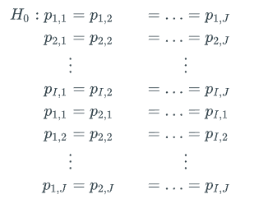

* where i=1,2,…,I represent the categories of the first variable and j=1,2,…,J represent the categories of the second variable. Fundamentally, the null hypothesis says that the distribution of one variable is the same across all sampled populations.
* Set the alternative hypothesis

Ha: At least one of the probability statements is false.

* Use statistical software to find the test statistic

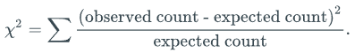

* The test statistic for the chi-square test of independence and the chi-square test of homogeneity are identical.
* Use to find the p-value. If the null hypothesis is true, the χ2 test-statistic has a chi-squared distribution with degrees of freedom equal to (r−1)(c−1) where r is the number of categories of the first variable (rows in the table) and c is the number of categories of the second variable (columns in the table).
* Make a decision given a previously selected significance level α, typically 0.05
  + If the p-value is less than the significance level, sufficient evidence exists to reject the null hypothesis, H0, in favor of the alternative hypothesis, Ha. Conclude that the distribution of one variable is not the same across categories of the other variable.
  + If the p-value is greater than or equal to the significance level, insufficient evidence exists to reject the null hypothesis, H0, in favor of the alternative hypothesis, Ha. Conclude that the distribution of one variable is the same across categories of the other variable.
* The chi-square test of homogeneity is appropriate when a sample is taken from two or more populations. In that situation, the null hypothesis says that the distribution of one variable is the same across all sampled populations. Ex: 5-year mortality rates of patients from 4 hospitals are recorded. The mortality rates from each hospital represent a population, so 5 populations exist in total. The null hypothesis should state that the probability of 5-year mortality is the same across all 4 hospitals. In contrast, the test of independence is used when two or more variables are compared within a single sample. The choice of which chi-square test is more appropriate in a given situation is not always clear. In practice, the test for independence and test for homogeneity are sometimes used interchangeably.
* Example 8.2.6: Frequency of tea drinking.
* The table below gives the frequency with which a sample of men and women drink tea (Source: Journal of Alzheimer's Disease)4 Do men and women drink tea with the same frequency at the α=0.05 significance level?

|  |  |  |
| --- | --- | --- |
|  | Men | Women |
| < 5/year | 551 | 580 |
| 5 - 10 /year | 244 | 289 |
| 1-3/month | 387 | 503 |
| 1-4/week | 452 | 618 |
| ≥ 5/week | 443 | 742 |

#### Solution

* The test for homogeneity is performed in the same way as the test for independence. The null hypothesis is that the distribution of the frequency of tea drinking is the same for men and women. The alternative hypothesis is that the distributions differ in at least one category. The contingency tables are

|  |  |  |  |  |  |  |
| --- | --- | --- | --- | --- | --- | --- |
| Observed | | |  | Expected | | |
|  | Men | Women |  | Men | Women |
| < 5/year | 551 | 580 | < 5/year | 488.477 | 642.523 |
| 5 - 10 /year | 244 | 289 | 5 - 10 /year | 230.202 | 302.798 |
| 1-3/month | 387 | 503 | 1-3/month | 384.390 | 505.610 |
| 1-4/week | 452 | 618 | 1-4/week | 462.131 | 607.899 |
| ≥ 5/week | 443 | 742 | ≥ 5/week | 511.800 | 673.200 |

* The chi-square test statistic is the same as for the test for independence.

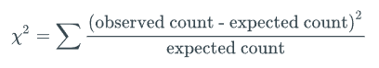

Using Python to calculate the test statistic and p-value for a chi-square distribution with (r−1)(c−1)=4 degrees of freedom, the result is

|  |  |
| --- | --- |
| z = np.array([[551, 580], [244, 289], [387, 503], [452, 618], [443,742]])  chi2, p = chi2_contingency(z)  **print**(chi2)  **print**(p) | 32.2443  1.70526e-6 |

Since the p-value is much smaller than α=0.05, the null hypothesis is rejected, and men and women do not drink tea with the same frequency distribution.

